I have changed the sign in the multiplier conditions
Monetary Sovereignty: Nature, Implementation and Implications

Abstract: Monetary sovereignty is a central concept of Modern Money Theory. The paper explores the characteristics of monetary sovereignty, the means used to implement it and some of its theoretical and policy implications. The paper shows that monetary sovereignty involves a high degree of coordination between the central bank and Treasury. The paper also argues that monetary sovereignty is not special to the United States, does not require direct monetary financing of the Treasury, does not tell us anything about the optimal size of the fiscal balance, and is not dependent on the willingness of foreigners to hold the domestic currency.

INTRODUCTION

Policymakers frequently state that the government does not have enough money to afford programs that its citizens want to see implemented, that the future financial viability of social security is bleak, and that it is time for the government to tighten its belt in order to avoid burdening our grandchildren with the servicing of the public debt. The paper argues that these assertions must be evaluated in relation to the nature of the national monetary system. It is central to make a different between monetarily sovereign and non-monetarily sovereign governments when performing economic analysis.
Monetary sovereignty means at its core that the government has control over the official monetary system of the country. In contemporary governments, the fiscal and monetary powers have been assigned respectively to the national Treasury (and Congress) and the central bank, so the implementation of monetary sovereignty involves a high degree of coordination between these two government entities. This coordination ensures that the government can always finance its activities while keeping the interest rates on the public debt under control and maintaining the stability of the payment system.
Monetary sovereignty provides financial flexibility in government finances, influences the dynamics of interest rates and exchange rates, and changes the priorities in the setting up of government policies. The risk of involuntary insolvency is no longer present and so should not play a role in shaping policy decisions. Instead, full employment, price stability, financial stability should take center stage in designing government policies, and the government should be involved in dealing with the critical issues of the time in accordance with the will of the population.
The first part of the paper presents the characteristics of monetary sovereignty. The second part shows how monetary sovereignty is implemented in practice. The third part presents some of the implications of monetary sovereignty. The paper concludes that insolvency is not a relevant threat for monetarily sovereign governments so it should not be used to shape, implement and evaluate policies. Instead, policies should be judged by their impacts on economic outcomes regardless of the size of the fiscal balance that such policies imply.

NATURE OF MONETARY SOVEREIGNTY

A monetarily sovereign government is one that sets the monetary laws used in the nation. The government sets the domestic unit of account and it uses that unit to issue debt instruments and unconvertible monetary instruments, as well as to record the imposition and payment of government dues. The following proceeds to unpack these characteristics.
A monetarily sovereign government governs the laws regarding the inner functioning of the domestic monetary system. The government determines what the final means of payment is via legal tender laws, it regulates banking and finance, and it establishes the laws about payment mechanisms. Regarding the latter aspect, contemporary monetary systems operate under a nominalist legal framework that emphasizes nominal sums as the point of reference for the payments of debts. Creditors bear the risk of inflation and debtors bear the risk of deflation so a loss/gain of purchasing power does not change the creditworthiness of debt issuers (Rosenn 1982).
A monetary system is composed of a unit of account and monetary instruments denominated in that unit. When a nation is created, one of the first acts of the national government is to decide what unit of account to use and this unit usually is also used by the domestic non-federal sectors (households, firms, non-profit organizations, and state and local governments). A government sets its own unit of account when it does not “dollarize” its country, that is, it does not use the unit of account of another country.
This first step is immediately followed by the creation of government monetary instruments denominated in the domestic unit of account. These monetary instruments are unconvertible, which implies that the domestic unit of account is not tied to a foreign unit of account or a weight of precious metal. The government uses its monetary instruments to buy goods and services priced in the domestic unit of account, to pay welfare benefits, and to service the public debt denominated in the domestic unit of account.
Beside the central role it plays in setting up and managing the monetary system, a monetarily sovereign government also imposes dues (fees, taxes, tolls, tributes, etc.) on its population. These dues usually have to be paid by the direct and/or indirect use of government monetary instruments. Modern Money Theory argues that the ability to impose and enforce such dues is central to the stability of the monetary system (Fox and Ernst 2016; Wray 2015; Desan 2014).
Given the way it organizes its finances, a monetarily sovereign government has large financial flexibility to deal with domestic issues, but it is not the only way to achieve such flexibility. Some governments may issue public debt denominated in a foreign currency and/or peg a specific exchange rate, but if their foreign reserves are large, there is no current threat to their ability to service the foreign-denominated public debt or to peg the exchange rate. However, such country must manage its domestic economy in a way to ensure that the threat of default and/or break of the peg stays low. Some countries may depend greatly on foreign trade for economic growth and development and may prefer to give up monetary sovereignty.

IMPLEMENTATION OF MONETARY SOVEREIGNTY

The previous section provides a broad characterization of monetary sovereignty. This section analyzes how monetary sovereignty is implemented in practice. Contemporary governments are involved in the monetary system through two main agencies, the Treasury and the central bank. While most analysts make a strict separation between the two by attributing fiscal operations to the Treasury and monetary operations to the central bank, monetary sovereignty blurs this distinction. The central bank is involved routinely in fiscal operations and the Treasury is involved routinely in monetary operations. The following draws on the insights from Tymoigne (2014) regarding the United States but similar coordination can be found in other countries (Sundararajan, Dattels, Bloomestein 1997; Silva and Richard 2010; Vajs 2014; Allen 2019).

Treasury’s Involvement in Monetary Policy and Beyond

The US Treasury understood the impact of fiscal operations on the money market long before the Fed was established (U.S. Treasury 1955). In the United States, the Treasury holds an account at the Fed called the Treasury’ General Account (TGA). As such daily revenues to, and outlays from, the TGA impact the quantity of reserves and so the federal funds rate (FFR) that the Federal Reserve targets. When the US Treasury spends, the Fed debits the TGA and credits reserve balances and, simultaneously, private banks credit the account of private economic units. For example, if the Treasury buys $100 worth of paper from a paper company:
Fed
ΔAssets | ΔLiabilities and Net Worth
Reserve balances: +$100
TGA: -$100

Banks
ΔAssets | ΔLiabilities and Net Worth
Reserve balances: +$100 | Account of paper company: +$100

Paper company
ΔAssets | ΔLiabilities and Net Worth
Paper: -$100
Account of paper company: +$100

Treasury
ΔAssets | ΔLiabilities and Net Worth
TGA: -$100
Paper: +$100

When the Treasury receives taxes, the Fed credits the TGA and debits reserve balances and, simultaneously, private banks debit the accounts of taxpayers. For example, if Treasury receives $25 of income tax payments:
Fed
ΔAssets | ΔLiabilities and Net Worth
Reserve balances: -$25
TGA: +$25

Banks
ΔAssets | ΔLiabilities and Net Worth
Reserve balances: -$25 | Account of taxpayers: -$25

Taxpayers
ΔAssets | ΔLiabilities and Net Worth
Account of taxpayers: -$25 | Net worth: -$25

Treasury
ΔAssets | ΔLiabilities and Net Worth
TGA: +$25 | Net worth: +$25

Therefore, on a daily basis, a fiscal deficit (revenues less than outlays) generates a net injection of reserves ($75 above) that pushes the FFR down to zero percent unless the Fed intervenes. All other rates also tend to follow because, as shown below, other interest rates are highly correlated to the FFR.
The US Treasury has helped the Fed target the FFR (and other rates at times) through cash management and public-debt management. In terms of cash management, prior to Global Financial Crisis, the Treasury collected proceeds from taxes and bonds issuances in thousands of private bank accounts called the “Treasury’s Tax and Loan accounts” (TT&Ls) and Treasury moved funds between its TT&Ls and TGA to ensure that the TGA balance stayed around $5 billion. Treasury employees met every morning with Fed employees to discuss the expected daily net cash flow on TGA and to decide on the quantity of funds to move in or out of TT&Ls. Prior to targeting the TGA, the Treasury used to be able to have an intraday overdraft on its TGA; it was unlimited from 1914 to 1935 and up to $5 billion from 1942 until 1983. The Treasury used this overdraft exclusively for monetary-policy purposes to be able to spend without having to call funds from its TT&Ls.
In terms of debt management, the Treasury changes the level and structure (proportion of short-term vs. long-term securities) of the public debt to accommodate the needs of monetary policy. A recent example was the Treasury’s involvement in monetary policy during the 2008 crisis. A massive cash and debt management operation by the Treasury started late September 2008 to help drain reserves in order to keep the FFR on target. The Fed had been neutralizing the impact of its emergency programs on reserves since December 2007 by selling Treasuries to banks. If the Fed had continued to neutralize in that fashion, it would have run out of Treasuries very quickly with the panic of September 2008.
In order to avoid running out of Treasuries, the Fed asked the Treasury to help drain reserves. First, Treasury transferred tens of billions of dollars from its TT&Ls into the TGA, thereby breaking with its policy of maintaining the TGA balance around $5 billion. Second, the Treasury issued “Supplementary Financing Program” T-bills (SFP bills) and immediately put the proceeds into a new account at the Fed (Treasury’s Supplementary Financing Account). The outstanding dollar amount of SFP bills peaked at almost $560 billion in late October/early November 2008. Combined with its cash management operations, Treasury removed up to slightly more than $600 billion worth of reserves (Figure 1). As the Discount Window was advancing reserves to banks in difficulty, the Treasury was simultaneously draining them. This coordinated operation allowed the Fed to tackle simultaneously two problems; financial stability (some banks desperately needed reserves) and monetary policy (keep the FFR close to its positive target).
<Figure 1>
Another example of monetary-policy-driven debt management involves the issuance of Treasuries when the Treasury runs a fiscal surplus. Following WWII, the strict targeting of the T-bond rate at 2.5 percent was relaxed toward the end of the war, but Treasury and Fed still did not want the rate to deviate too much from 2.5 percent. After the war, fiscal surpluses removed T-bonds from the market even though they were in high demand so the yield on 10-year T-bonds declined steadily toward 2 percent. To bring back the T-bond rate up toward 2.5 percent, more T-bonds needed to be supplied but the Fed did not hold enough so the Treasury supplied more (Tymoigne 2014). From a budgetary perspective this seems strange—a Treasury trying to raise the cost of its indebtedness and issuing securities when running a fiscal surplus—, but all this was done for monetary-policy purposes.
Beyond helping the central bank achieve its interest-rate target, the Treasury may issue securities in times of fiscal surplus in order to help banks meet their capital requirements and have default-free liquid interest-earning financial assets:
Most investor classes want substantial amounts of Government securities because of their riskless nature. While the prices of these securities may fluctuate in the market, it is known that that payment of the interest and of the principal at the time of maturity will always be made. Many investors, therefore, carry Government securities as secondary reserves which they increase or decrease in accordance with their needs. Some investors also carry Government securities because in some cases they are the only securities legally acceptable as collateral or as a deposit for a Government contract. The safety of other classes of investments varies tremendously. (Snyder in US Senate 1952, 97)
If there is a fiscal surplus, the outstanding amount of Treasuries shrinks which is a problem for financial markets because Treasuries “are a preferred savings instrument for foreign investors and are extensively used for hedging and as benchmarks for pricing other fixed-income securities” (Marshall 2002, 47). Throughout the 2000s, the Australian government concluded that it was too important of a market to let it disappear and so it decided to continue to issues Treasuries despite the fact that it had been running surpluses for almost a decade (Commonwealth of Australia 2003, 7-1ff.; 2011, 7-16).
There have been other cash and debt management techniques used by the Treasury Departments around the world, but those presented above should give the reader a sense that the public debt is not managed in the same way as private debts. While funding the Treasury is one of the reasons for the issuance of Treasuries, Treasury Departments throughout the world also manage their public debt to fulfill macroeconomic goals that are not necessarily consistent with budgetary needs and budgetary logics.

Central Bank’s Involvement in Fiscal Policy

For a government that is monetarily sovereign, the central bank always helps one way or another to finance the Treasury. The most straightforward involvement of the Fed into fiscal operations was the availability of an overdraft on TGA until the early 1980s. As stated in the previous section, in practice this overdraft facility was strictly used for monetary-policy operations, but it could be used for fiscal purposes in case of “national emergency.” However, the $5 billion cap was very limiting for that purpose and there were Congressional hearings in the 1960s that looked into the possibility of expanding that limit and making the overdraft line permanent (authorization of the overdraft had to be renewed by US Congress every two years). This went nowhere because the use of the overdraft for fiscal purposes was seen as inflationary and unsound.
Even though direct financing was discouraged and later forbidden, the Treasury uses Fed’s monetary instruments to spend. Thus, one way or another, the Treasury will be financed by the Fed because only the Fed supplies the funds that the Treasury uses. Indeed, while TT&Ls are used to receive bond and tax proceeds, they are just a tool that smooth out the impact of such proceeds on reserves. Ultimately, all the proceeds go to the TGA, which drains reserves. As a consequence, the Fed has to ensure that banks have enough reserves to implement the transfer of funds from TT&Ls to TGA. Chairman Eccles provides an insightful insider’s view on the financing of the US Treasury:
[In past Congressional hearings] there was a feeling that […] Government [borrowing] directly from the Federal Reserve bank […] took off any restraint toward getting a balanced budget. Of course, in my opinion, that really had no relationship to budgetary deficits, for the reason that it is the Congress which decides on the deficits or the surpluses, and not the Treasury. If Congress appropriates more money than Congress levies taxes to pay, then, there is naturally a deficit, and the Treasury is obligated to borrow. The fact that they cannot go directly to the Federal Reserve bank to borrow does not mean that they cannot go indirectly to the Federal Reserve bank, for the very reason that there is no limit to the amount that the Federal Reserve System can buy in the market. […] Therefore, if the Treasury has to finance a heavy deficit, the Reserve System creates the condition in the money market to enable the borrowing to be done, so that, in effect, the Reserve System indirectly finances the Treasury through the money market, and that is how the interest rates were stabilized as they were during the war, and as they will have to continue to be in the future. So it is an illusion to think that to eliminate or to restrict the direct borrowing privilege reduces the amount of deficit financing. Or that the market controls the interest rate. Neither is true. (Eccles in U.S. House, 1947, 8)
If the Treasury does not get the funds it needs to implement Congressional mandates, and if Congress passes a budget in deficit, then the budget cannot be implemented and interest rates will rise.
In terms of auctions of Treasuries, the Fed makes sure they are always successful; “bond vigilantes” have no influence. The Fed has done so in different ways; one was to buy whatever was leftover during an auction. Another has been to provide a dependable refinancing channel to the Treasury because the Fed is still allowed to participate in auctions to replace its maturing Treasuries. Finally, today the Fed participates indirectly in the financing of the Treasury through the Primary Dealer System. During an auction, primary dealers must submit a reasonable bid and the Fed ensures that they have enough funds at time of settlement by purchasing, or repoing, outstanding Treasuries. Thus, one way or another the Fed will ensure that auctions never fail and, in the process, it will be financing either directly or indirectly the Treasury.
A lot is made about the independence of the central bank. Practically, independence means that the central bank has independence of tools and goals and so it can conduct monetary policy the way it sees fit to achieve the goals it set. However, independence does not mean independent from the needs of the Treasury:
First, let’s be clear on what independence does not mean. It does not mean […] that the Fed is independent of the government. Although closely interfaced with commercial banking, the Fed is clearly a public institution, functioning within a discipline of responsibility to the “public interest.” […] Monetary judgments must be able to weigh as objectively as possible the merit of short-term expedients against long-term consequences—in the on-going public interest. (MacLaury 1977, 2)
The central bank must work fiscal operations into its daily activities. It has done so through multiple means that have varied overtime such as direct financing, allowing intraday overdraft, and supporting primarily dealers. If the Fed does not fulfill the needs of the legislative and executive branches, there will be major disruption to the payment system and democratic system, and Congress can always take back the monetary powers it granted to the Fed.

IMPLICATIONS OF MONETARY SOVEREIGNTY

Monetary Sovereignty and the Financial Balance of the Government

One of the stylized facts of macroeconomics is that the federal government deficit spends. Monetary sovereignty does not imply that large, or growing, fiscal deficits, ought to be the norm but it does explain why fiscal deficits are the norm across developed economies. To some degrees, Congress can control the size of the fiscal deficit by determining the tax structure and discretionary government spending. However, most of government spending and tax receipts are not discretionary but rather depend on the state of the economy. Tax revenues are highly procyclical because they are heavily influenced by the income earned by the domestic private sector. In an economic expansion, tax revenues rise quickly because private-sector income rises, which may lead to a surplus if the expansion lasts long enough (as it did in the late 1990s in the US). In a recession, tax revenues plummet because private-sector income falls, which rapidly reverses the fiscal balance (as it did in 2000). Regarding government expenditures, about two-third of them is set by legal requirements and some are countercyclical (Social Security, Medicare, etc.). Thus, while Reinhart and Rogoff (2009) argue that a high public debt slows economic growth, the causality is actually the reverse; slower economic growth causes higher deficits that rapidly raise the public debt (Taylor et al. 2012; Nersisyan and Wray 2011).
The implication of the cyclical and non-discretionary nature of taxes and government expenses is that the financial balance (surplus, balanced, or deficit) of the government is not under the control of the Treasury. The government ultimately as little control over the fiscal path because its spending and taxes are driven mostly by forces outside its control. This begs the question of what, if not the US government, determines the size of the fiscal balance. MMT argues that the main driver is the desire of non-federal sectors (domestic sectors and the rest of the world) to accumulate net financial wealth. The national Financial Accounts use balance sheets to analyze the three main economic sectors of an economy: the domestic private sector (DP), the government sector (G), and the rest of the world/foreign sector (F). A balance sheet is an accounting document that records what an economic unit owns and owes (Table 1). At the macroeconomic level, each sector has a balance sheet (Table 2).
<Table 1>
<Table 2>
Given that financial assets are claims of an economic sector on the two other economic sectors and financial liabilities are the claims of the two other economic sectors on an economic sector, it must be true that the sum of all financial assets and liabilities across sectors is zero. For every creditor there is a debtor and if one adds together the claims of creditors and debtors they must cancel out:
(FA_{DP} – FL_{DP}) + (FA_{G} – FL_{G}) + (FA_{F} – FL_{F}) ≡ 0
Given that this identity holds in terms of levels, it also holds in terms of changes in levels (“flows”):
Δ(FA_{DP} – FL_{DP}) + Δ(FA_{G} – FL_{G}) + Δ(FA_{F} – FL_{F}) ≡ 0
Leaving aside changes in asset prices and focusing on net changes in the quantities of financial assets and liabilities, Δ(FA – FL) represents net financial accumulation. It is the difference between a net accumulation of financial assets (ΔFA) and net increase in liabilities (ΔFL) and is called “net lending” in the Financial Accounts. If a macroeconomic sector accumulates more claims on the two other sectors than the two other sectors accumulate claims on a sector, the economic sector is a net lender. Otherwise, the sector is a net borrower. It is straightforward to note that not all sectors can be net lenders at the same time.
While they have a different focus than the Financial Accounts, a similar conclusion can be reached by combining the National Income and Product Accounts and the U.S. International Transactions Accounts (CAB_{F} is the current account balance of the foreign sector, T is taxes, G is government spending on goods and services, S is domestic private gross saving, I is domestic private gross investment):
(T – G) + (S – I) + CAB_{F} ≡ 0
Thus, at least the domestic private sector, the government sector, or the foreign sector must be in deficit if one of the sectors is in surplus. Not all sectors can record a surplus at the same time. Figure 2 illustrates the point by showing the net financial accumulation of each sector of the United States. Usually the government sector runs a deficit (i.e. is a net borrower) and the other sectors record a surplus (i.e. are net lenders). In other words, fiscal deficits are a normal state of affairs for the US government; they have been so since the Great Depression. While Figure 2 focuses on the United States, this is also the case throughout developed economies.
<Figure 2>
The previous derivation is just rearranging an accounting identity to show the interdependence of the financial balances of different macroeconomic sectors. There is no theoretical implications beyond the fact that a well-grounded macroeconomic theory must recognize this interdependence. However, a stylized fact that emerges from the data is that fiscal deficits are normal. In order to explain this state of affair, MMT uses theoretical claims by introducing desires and establishing causalities in the accounting framework. Usually the non-federal sectors desire to record a surplus so the federal sector must be in deficit. If the federal government has a financial balance that is not consistent with the desired financial balance of the non-federal sectors, national income will adjust upward or downward as the non-federal sectors change their spending level. Automatic stabilizers will move the fiscal balance to the level desired by the non-federal sectors. For example, if the non-federal sectors desire to have a surplus equivalent to five percent of GDP but the fiscal deficit represents seven percent of GDP, the domestic private sector and/or the foreign sector will spend more—consumption and/or investment and/or export will rise—and so national income will rise. The proportion of the rise in nominal income that comes from inflation or economic growth depends on how far the economy is from full employment. As nominal GDP rises, tax revenues rise and government expenditures fall until the fiscal deficit represents five percent of GDP.
The previous dynamics are complicated by the fact that the federal government may also want to reach a surplus. Proactive policies to achieve such goal will impede the ability of non-federal sectors to reach their desired surplus. A government-surplus agenda is implicitly a private-deficit agenda and/or foreign-deficit agenda. Thus, austerity policies are recessionary unless the non-federal sectors are willing to deficit spend to counter the economic drag generated by such policies; however, deficit spending by the non-federal sectors is prone to financial instability because they lack monetary sovereignty (Tymoigne and Wray 2014). On the contrary, fiscal deficits are sustainable because a monetarily sovereign government has the financial flexibility to meet the demands of such of deficits. All, this can be formalized in a very simple closed Keynesian model as follows.
Y ≡ C + I + G
C_{d} = C₀ + c(Y – T)
I_{d} = I₀
G = G₀ – gY
T = T₀ + tY
Variables with the subscript d reflect desired variables, C is domestic private consumption, Y is nominal national income. Variables with the subscript 0 are autonomous. Automatic stabilizers are represented by the dependence of G and T on aggregate income (Y). G₀ and T₀ reflect respectively spending preferences of policymakers (set in the annual budget) and taxes on non-income sources. The equilibrium level of income (Y*) is:
$$Y^{*}= \frac{1}{1-c+g+ct}\left(C_{0}+I_{0}+G_{0}-cT_{0}\right)$$
If Y is different from Y*, spending adjusts to ensure that actual and desired spending are equal. Desired net saving of the private sector is Y – T – C_{d} – I_{d}. Keeping with the Keynesian framework, aggregate private saving (S) is a residual variable. Private economic units can make decisions about their spending (C₀ and I₀) but they cannot decide what aggregate income is and so S (= Y – T – C) is not a variable over which economic units have control. At equilibrium, private surplus and government deficit are linked as follows (DEF₀ = G₀ – T₀):
S* – I₀ ≡ G* – T* = DEF₀ – (g + t)Y*
Assume the government implements austerity policies via a cut in discretionary spending (G₀ falls), then Y falls, which is reinforced by a fall in private spending (via a fall in C). As Y falls automatic stabilizers kick in, G rises and T falls automatically, and so government deficit rises until the equilibrium level of income is reached. The net impact of a change in G₀ on the fiscal position, and so net saving, depends on the strength of the automatic stabilizers.
$$\frac{∆S^{*}}{∆G_{0}}=\frac{∆{(G-T)}^{*}}{∆G_{0}}=1-\frac{g+t}{1-c+g+ct} \begin{matrix}≥0 ∀t≥1 \\ <0 ∀t<1\end{matrix}$$
Discretionary spending cut do not lower the budget deficit if automatic stabilizers are very strong (t ≥ 1). If t = 1, the fiscal position is unchanged regardless of changes in discretionary government spending; the fiscal path is driven by non-government economic decisions. If automatic stabilizers are inexistent (g = t = 0), government has full control over the fiscal path.
The requirement of very strong automatic stabilizers to get MMT-like results reflects the primitive nature of the model. This condition can be loosened significantly by extending the model to account for the impact of economic activity on investment, stock variables, among others such as a job-guarantee program (Fullwiler 2007). There is a very large literature on stock-flow consistent models in the Post Keynesian literature (Nikiforos and Zezza 2017). In terms of stock variables, one way to extend the model is to include the impact of net financial accumulation on consumption through a wealth effect. While the private sector cannot control S, overall the domestic private sector usually wishes to record a surplus in order to accumulate net financial wealth in a sustainable way, which implies that this sector may adjust its spending to reflect change in its net financial wealth. Another way to introduce stock variables is to include portfolio choices with a yield curve that is heavily influenced by monetary conditions. The simplest way to do this is to make the supply of Treasuries perfectly elastic at an exogenously set yield curve; that is, all rates on government securities are considered policy variables (e.g., Godley and Lavoie, 2007, 147). This modeling can be complicated to include the role of liquidity preference and short-term rate expectations.
None of the above means that MMT proponents are for fiscal deficits. MMT is agnostic about the fiscal position per se as long as monetary sovereignty prevails; instead, MMT proponents focuses on the implications of the fiscal position for the economy. The proper conclusion is that monetary sovereign gives one degree of freedom in the tight rules of national accounting. It allows the fiscal balance to be whatever non-federal sectors desire and usually they desire to be in surplus so the federal government must be in deficit. Such deficit is sustainable as long a monetary sovereignty prevails, and such deficit is not potentially inflationary as long as it is consistent with the desired surpluses of non-federal sectors. Government policies should not set a direct or indirect goal of achieving any specific fiscal balance. The government should let its fiscal balance move automatically to whatever it needs to be in order to accommodate the desires of the other sectors, while at the same time watching for sources of financial instability in the domestic non-federal sectors if they deficit spend.
All of this does not apply only the United States. The United States is special in the sense that the US dollar plays a central role in the international monetary system so foreigners desire to accumulate US dollars, which implies that the US fiscal deficit must be larger than it would otherwise have been. However, like any other country, the size of the US fiscal deficit is determined by the desired surplus of other sectors so the fact that there is an international demand for US dollars does not mean the US fiscal deficit can be whatever the government wants it to be. Just like any other countries, the US fiscal balance must be accommodative of the desires of other sectors. If the rest of the world ever thinks the net financial accumulation of US dollars is too large, the only way foreigners can reduce it is by buying more goods and services from US sectors (US exports rise), cutting sales of goods of services to US sectors (US imports fall), reducing their reliance on USD-denominated incomes and transfers, selling US dollars to US sectors, and/or repaying debt owed to US sectors. Thus, the US (and other monetarily sovereign countries) does not depend on foreigners to finance its fiscal deficit. Rather, the fiscal deficit accommodates the desire of foreigners to have a net accumulation of dollars. The US government fiscal balance would move to a surplus if the foreign sector wanted to record a current account deficit with the US (Wray 2019). A few countries, mostly in Scandinavia recently, have been in such unusual situation.

Public Debt and Monetary Sovereignty

The previous subsection concluded that fiscal deficits are normal and that such fiscal deficits are sustainable as long as monetary sovereignty prevails. This has implications for issues surrounding the public debt given that fiscal deficits add to the public debt. The public debt is the sum of all debts currently owed by the Treasury; it can be measured by the gross public debt (all outstanding debts owed by the Treasury) or by the public debt held by the public. The latter excludes Treasury debts held by other parts of the federal government such as the Social Security trust funds and the Medicare trust funds. In 2019, the outstanding gross public debt was $22 trillion. Until the 1930s, only major wars (War of 1812, Civil War, World War I) caused rapid increases in the US public debt. While US gross public debt fell more often than it rose, overall it did grow slowly by 0.31% of GDP per year because the size of increases was on average larger than repayments (Table 3). Since the Great Depression, the US gross public debt has increased almost every year by a dollar amount representing on average 4.22% of GDP. Major wars (World War II, Vietnam War, War on Terror) have still contributed to rapid increases in the public debt, but sustained increases have become a permanent feature with only five recorded declines in the public debt (1947-49, 1951, 1956-57). Even the celebrated surpluses of the late 1990s did not lead to a decline in the gross public debt. This trend is the mirror image of the fact that deficits have become a permanent feature of US government finances.
<Table 3>
An implication of monetary sovereignty is that the government cannot involuntarily default on the public debt because it is serviced by using monetary instruments issued by the government. The government may choose to default on the public debt but it does not have to. Cantor and Parker (1995) provide some examples of such default and note that “domestic currency defaults have usually been the result of an overthrow of an old political order—as in Russia and Vietnam—or the byproduct of dramatic economic adjustment programs aimed at curbing hyperinflation—as in Argentina and Brazil” (Ibid, 3). However, Cantor and Parker also note that this type of default is rare. If one had to estimate a default probability for debts issued by monetarily sovereign governments, it would be much lower than the historical 0.02 percent five-year median default probability used for AAA corporate bonds. It is so low that it makes a credit rating irrelevant.
Analysts who acknowledge that the US government is monetarily sovereign have long understood that there is virtually a zero probability of involuntary default on the US public debt; it is safe to assume that it will be serviced in full on time. The US government cannot be forced to default on its public debt as long as it is monetarily sovereign:
As the sole manufacturer of dollars, whose debt is denominated in dollars, the U.S. government can never become insolvent, i.e., unable to pay its bills. In this sense, the government is not dependent on credit markets to remain operational. Moreover, there will always be a market for U.S. government debt at home because the U.S. government has the only means of creating risk-free dollar-denominated assets (Fawley and Juvenal 2011, 5)
It is incorrect to analyze the finances of the US government by taking household and business finances as a point of reference. As explained above, the public debt is managed to accommodate the needs of the economy rather than to prevent government bankruptcy. If non-federal sectors want more public debt, the Treasury issues more even if it runs a surplus. If other sectors want more long-term securities instead of short-term securities, the Treasury accommodates even if the interest rate on long-term securities is higher. If other sectors want to hold less public debt, the government fiscal balance turns into a surplus.
Given that deficits are a feature of monetarily sovereign government, the public debt continuously rises overtime; however, as long as the nominal cost of public debt (i) stays low relative to the nominal growth of the economy (g), the public debt will not explode relative to the size of the economy. Usually the interest rate on the public debt is below the growth rate of the economy. Blanchard (2019) recently received a lot of attention for emphasizing this empirical fact (when the literature usually assumes that i > g is the norm), but this was recognized long before him and linked to monetary sovereignty (Fullwiler 2006; Aspromourgos et al. 2009; Wray 2015). The interest rate on the public debt is a policy variable, that is, the interest rate on the public debt is overwhelmingly influenced by monetary policy. The influence is complete for the interest rate on T-bills and very strong for T-notes and T-bonds. Thus, a rapidly growing public debt does not usually translate into large increase in the share of interest payment in government spending unless the central bank raises its policy-rate target (Figure 3).
<Figure 3>
The Treasury could coordinate with the central bank to have total control of the interest rate on the public debt by only issuing bills but, as explained previously, the Treasury has other goals in mind than budgetary concerns when it issues treasuries.
More broadly, a main driver of all interest rates (private or government) is monetary policy not fiscal policy. The financial crowding out does not exist in a monetarily sovereign country (Sharpe 2013; Borio et al. 2017; Akram and Li 2017). Figures 4 and 5 link fiscal policy and monetary policy to the interest rates. It is clear that the FFR play a major role in influencing these rates; some rates are more sensitive to risk considerations but their trend is still highly dependent on monetary policy, not fiscal policy. When the US Treasury runs very large deficits, it usually does so in periods of recession. During a recession, the Federal Reserve also lowers its policy rates to help the economy and all other interest rates follow. During World War II, when the fiscal deficit ran past 20 percent of GDP as government spending increased very rapidly, the Federal Reserve set all interest rates on the public debt low for years and private interest rates followed and stayed low for years.
<Figure 4>
<Figure 5>

Finally, one must come to recognize that the public debt will never be repaid. There is no reason to do so, and doing so would be harmful to the economy. The public debt plays a pillar role in the financial system and provides the private sector with a safe source of income, and surpluses tend to be recessionary. We have not been burdened with higher tax rates to repay the public debt created at the time of our grandparents; our children and grandchildren will not be burdened by higher tax rates to repay the public debt created today. Tax rates may be raise in the future but not with the goal of repaying the public debt. The public debt will keep rising to accommodate the needs of a growing economy and the government will keep paying it on time in full as long as it is monetarily sovereign.

Financial Constraints vs Resource Constraints
MMT makes a clear difference between financial and resource constraints because both can have an impact on the ability of the government to intervene meaningfully in the management of the domestic economy. Monetary sovereign governments that have under-employed resources face no real or financial constraints. Constraint in terms of domestic resources is potentially possible but it is not the norm. The only binding constraint on government is usually political.
Thus, at its core, monetary sovereignty implies that the national government has the ability to use its policy levers to fulfill objectives that are at least consistent with the available domestic resources. What is productively possible is always financially possible for a monetarily sovereign government. As Keynes put it: “A government which has control over the banking and currency system can always find the cash to pay for its purchases of home-produced goods” (Keynes 1940 (1972), 416). Such government cannot run out of money but it can run out of things to buy, as such, fiscal policy should be judged by its ability to solve the socio-economic issues of the times rather than by the risk of financial insolvency.
There are two intertwined aspects to the outcomes of fiscal policy, short-run outcomes and long-run outcomes (such as the poor state of infrastructures, rising income and wealth inequality, and the aging of the population). The following focuses on short run outcomes that involve promoting price stability, financial stability and full employment. A temptation may be to measure the desired non-federal surpluses to determine a target fiscal balance; this is not an appropriate way to proceed. The desired non-federal surpluses move over the business cycle and are impossible to measure properly. The only clue policymakers have is the state of the economic at a point in time. If the fiscal deficit is too large relative to the desired surpluses of the non-federal sectors, the economy will grow faster than usual and inflation may emerge; if the fiscal deficit is too small relative to the desired surpluses of the non-federal sectors, a recession may occur and financial fragility grows. In both cases, the fiscal balance will tend to self-correct through the automatic stabilizers but the federal government usually wishes to be more proactive through ad hoc one-time interventions. While this usually helps, a more effective way to proceed would be to put in place structural programs that reinforce the automatic stabilizers by directly tackling unemployment and price stability (Wray et al. 2018).
Finally, one may note that the automatic association of fiscal deficits with inflation is unwarranted (Figure 6). A fiscal deficit might be inflationary but not merely because it is a deficit; it depends on how tight the resource constraint is and it depends on the effectiveness of the measures taken to control inflation are when full employment is prevalent. Similarly, a fiscal surplus might be deflationary but not merely because it is a surplus.
<Figure 6>
At full employment, higher tax rates and other policies may be needed to tame inflation, in the same way it was needed during World War II (Keynes 1940). One may argue that raising tax rates may not be politically possible but, presumably, citizens who already agreed that more government involvement is needed will be accommodative of such an increase. Once again, the politics become all-important, not the financials.
There is one complication for economies highly dependent on imports for their energy, capital equipment, and food sources and whose currency is not accepted by the rest of the world. Such economy must find the desired foreign currency, usually the US dollar, to be able to spend on imports. As explained above, the implication in terms of fiscal balance is that the stationary-state fiscal deficit will tend to be smaller than it would otherwise have been. The ability of the government to deficit spend without generating potential inflationary pressures is smaller than it would otherwise have been. This will be all the more so that the ability to enforce tax payments is low. The government can still get involved to promote full employment but it may have to start small and promote activities that involve the use of domestic resources. As the economy builds an export capacity, reliance on imports may grow (Wray 2007).

CONCLUSION

Monetary sovereignty relates to the structure and mechanisms of government finances. Under such a framework, a government faces no financial constraint; it cannot involuntarily run of out of money. Such a government, however, does face political and potential resource constraints that limit its ability to operate in the economy. As such, the implication of monetary sovereignty is not that the government can carelessly spend, but rather that the design, implementation and evaluation of policies ought to be done without fear of insolvency but with an understanding of inflationary and political constraints. The US Government Accountability Office ought to be mandated to review policies and programs based on resources availability instead of financial sustainability. Politicians should not argue that the government does not have money, should not argue that social security needs to be fixed because of looming insolvency, should not celebrate a fiscal surplus or make it a goal to achieve such a surplus. Understanding monetary sovereignty does not make the job of achieving policy goals easier, but it does provide a clearer view of what the relevant goals are and what should be done, and not be done, to achieve them.
In a monetarily sovereign government, the legislative branch still must pass a budget in order to determine economic priorities, and promote transparency and accountability, the executive branch must still tax and issue securities for budgetary and other purposes, and the central bank and the Treasury still must routinely coordinate their operations to ensure that fiscal and monetary policies do not disturb the payment system. This is not special to the United States and it does not mean that the central bank is required to finance directly the Treasury (“monetary financing”). What monetary sovereignty implies is that the government, not bond vigilantes, has control over the cost of its public debt, that it can decide what types of securities to offer, and that the government has the financial flexibility to spend on whatever its citizens decide is the public purpose as long as the things offered for purchased are priced in the domestic currency.
Finally, understanding monetary sovereignty also removes irrational fears of fiscal deficit and the assimilation of private finances and federal public finances. Fiscal deficits are normal and sustainable. There is no automatic adverse consequences from permanent deficit spending by the federal government. Interest rates will not rise unless the central bank intervenes, demand-pull inflation will not rise unless the economy is close to full capacity, and financial insolvency is never a threat. Thus, the government financial balance is not a relevant policy objective while price stability, financial stability and full employment are relevant policy objectives. Policies should be designed to tackle the issues of the time with the consent of the public and in accordance with available resources.

REFERENCES

Akram, Tanweer and Huiqing Li. 2017. “What keeps long-term U.S. interest rates so low?” Economic Modelling, 60: 380–390.
Allen, William A. 2019. The Bank of England and the Government Debt: Operations in the Gilt-Edged Market, 1928-1972. Cambridge, UK: Cambridge University Press.
Aspromourgos, Tony, Daniel Rees, and Graham White. 2009. “Public Debt Sustainability and Alternative Theories of Interest.” Cambridge Journal of Economics, 34 (3): 433-447.
Borio, C, Piti Disyatat, Mikael Juselius, and Phurichai Rungcharoenkitkul. 2017. “Why So Low For So Long? A Long-Term View of Real Interest Rates.” BIS Working Paper, No. 685.
Blanchard, Olivier. 2019. “Public Debt and Low Interest Rates.” American Economic Review, 109 (4): 1197-1229.
Cantor, Richard, Kenneth Emery, Elena Duggar, and Pierre Cailleteau. 2008. “Sovereign Default and Recovery Rates, 1983-2007.” Moody’s Global Credit Research, March.
Cantor, Richard and Frank Parker. 1995. “Sovereign Credit Ratings.” Federal Reserve Bank of New York Current Issues in Economics and Finance, 1 (3): 1-6.
Commonwealth of Australia. 2003. Budget Strategy and Outlook 2003-04, 2003-04 Budget Paper No. 1. Canberra, ACT: Commonwealth of Australia.
———. 2011. Budget Strategy and Outlook 2011-12, 2011-12 Budget Paper No. 1. Canberra, ACT: Commonwealth of Australia.
Desan, Christine. 2014. Making Money: Coin, Currency and the Coming of Capitalism. Oxford: Oxford University Press.

Fawley, Brett W. and Luciana Juvenal. 2011. “Why Health Care Matters and the Current Debt Does Not.” St. Louis Fed’s The Regional Economist, 19 (4), October: 4-5.
Fox, David and Wolfgang Ernst (eds). 2016. Money in the Western Legal Tradition: Middle Ages to Bretton Woods. Oxford: Oxford University Press.
Fullwiler, Scott T. 2006. “Interest Rates and Fiscal Sustainability.” Center for Full Employment and Price Stability, Working Paper No. 53.
———. 2007. “Macroeconomic Stabilization through an Employer of Last Resort.” Journal of Economic Issues, 41 (1): 93-134.
Government Accounting Office. 2001. FINANCIAL AUDIT: Bureau of the Public Debt’s Fiscal Years 2000 and 1999 Schedules of Federal Debt. Washington, DC: United States General Accounting Office.
Keynes, John M. 1940. How to Pay for the War. Reprinted in Collected Writings of John Maynard Keynes, edited by Donald E. Moggridge, Volume 9, 367-439. London: Macmillan, 1972.
Maclaury, Bruce K. 1977. “Perspectives on Federal Reserve Independence - A Changing Structure for Changing Times.” In Federal Reserve Bank of Minneapolis 1976 Annual Report, 1-16. Minneapolis: Federal Reserve Bank of Minneapolis.
Marshall, David. 2002 “Origins of the Use of Treasury Debt in Open Market Operations: Lessons for the Present.” Federal Reserve Bank of Chicago Economic Perspective, First Quarter: 45-54.
Nikiforos, Michalis and Gennaro Zezza. 2017. “Stock-Flow Consistent Macroeconomic Models: A Survey.” Journal of Economic Survey, 31 (5): 1204-1239.
Reinhart, Carmen and Kenneth Rogoff. 2009. This Time is Different: Eight Centuries of Financial Folly. Princeton, NJ: Princeton University Press.
Rosenn, Keith S. 1982. Law and Inflation. Philadelphia, PA: University of Pennsylvania.
Sharpe, Timothy P. 2013. “A Modern Money Perspective on Financial Crowding-out.” Review of Political Economy, 25 (4): 586-606.
Silva, Anderson C., Baudouin J.P.G. Richard. 2010. Primary Dealer Systems: Draft Background Note. Washington, DC: World Bank Group.
Sundararajan, V., Peter Dattels, Hans J. Bloomestein (eds). 1997. Coordinating Public Debt and Monetary Management: Institutional and Operational Arrangements. Washington, D.C: International Monetary Fund.
Taylor, Lance, Christian R. Proaño, Laura de Carvalho, and Nelson Barbosa. 2012 “Fiscal Deficits, Economic Growth and Government Debt in the USA.” Cambridge Journal of Economics, 36 (1): 189-204.
Tymoigne, Eric. 2014. “Modern Money Theory and the Interrelation between the Treasury and the Central Bank: The Case of the United States.” Journal of Economic Issues, 48 (3): 641-662.
Tymoigne, Eric and L. Randall Wray. 2014. The Rise and Fall of Money Manager Capitalism. London: Routledge.
U.S. House. 1947. Direct Purchases of Government Securities by Federal Reserve Banks. Hearing before the Committee on Banking and Currency. 80th Congress, 1st Session. March 3, 4, and 5. Washington, DC: Government Printing Office.
U.S. Senate. 1952. Monetary Policy and the Management of the Public Debt: Their Role in Achieving Price Stability and High-Level Employment. Replies to Questions and Other Material for the Use of the Subcommittee on General Credit Control and Debt Management, Part 1. 82th Congress, 2nd Session. Washington, DC: Government Printing Office.
U.S. Treasury. 1955. Annual Report of the Secretary of the Treasury on the State of the Finances for the Fiscal Year Ended June 30 1955. Washington, DC: Government Printing Office.
Vajs, Stephen. 2014. “Government debt issuance: issues for central banks.” In The role of central banks in macroeconomic and financial stability, BIS papers No 76, 29-46. Basel: Bank for International Settlements.
Wray, L. Randall. 2007. “The Employer of Last Resort Programme: Could It Work For Developing Countries?” Economic and Labour Market Papers, 2007/5. Geneva: International Labour Office.
———. 2015. Modern Money Theory: A Primer on Macroeconomics for Sovereign Monetary Systems. 2nd edition. New York, NY: Palgrave.
———. 2019. “Does America Need Global Savings to Finance Its Fiscal and Trade Deficits?” American Affairs, 3 (1), Spring.
Wray, L. Randall, Flavia Dantas, Scott T. Fullwiler, Pavlina R. Tcherneva, and Stephanie A. Kelton. 2018. Public Service Employment: A Path to Full Employment. Levy Economics Institute, Research Project Report, April.
Zivney, Terry L. and Richard D. Marcus. 1989. “The Day the United States defaulted on Treasury Bills.” Financial Review, 24 (3): 475-489.

FIGURE 1
Injection (+) and ejection (-) of reserves, trillions of dollars
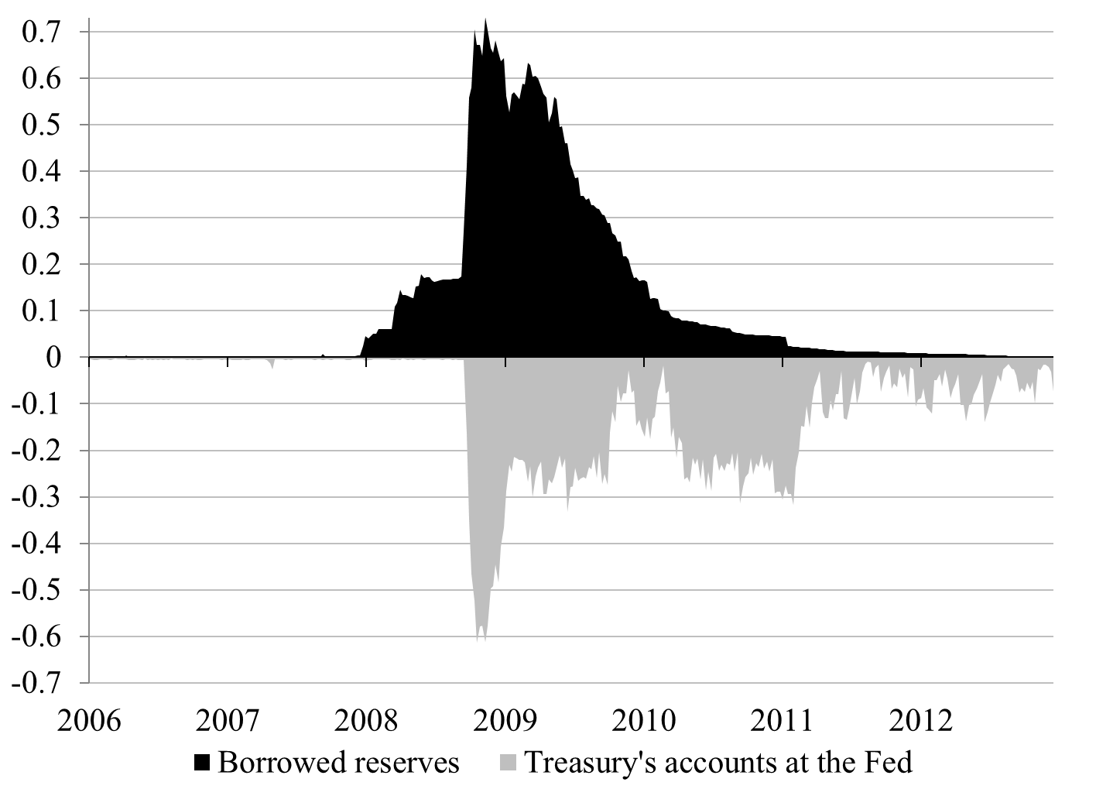
Source: Board of Governors of the Federal Reserve System (Series H.4.1)

FIGURE 2
Net Lending (+)/Net Borrowing (-), Percent of GDP.
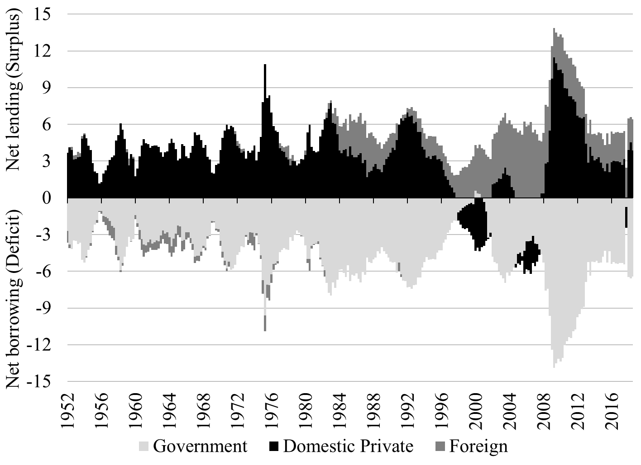
Source: Board of Governors of the Federal Reserve System (Series Z.1)

FIGURE 3
Net Interest Payment to the Private Sector and the Rest of the World Relative to Government Expenditures, Public Debt to GDP Ratio, Interest Rate on the Public Debt and Monetary Policy, Percent
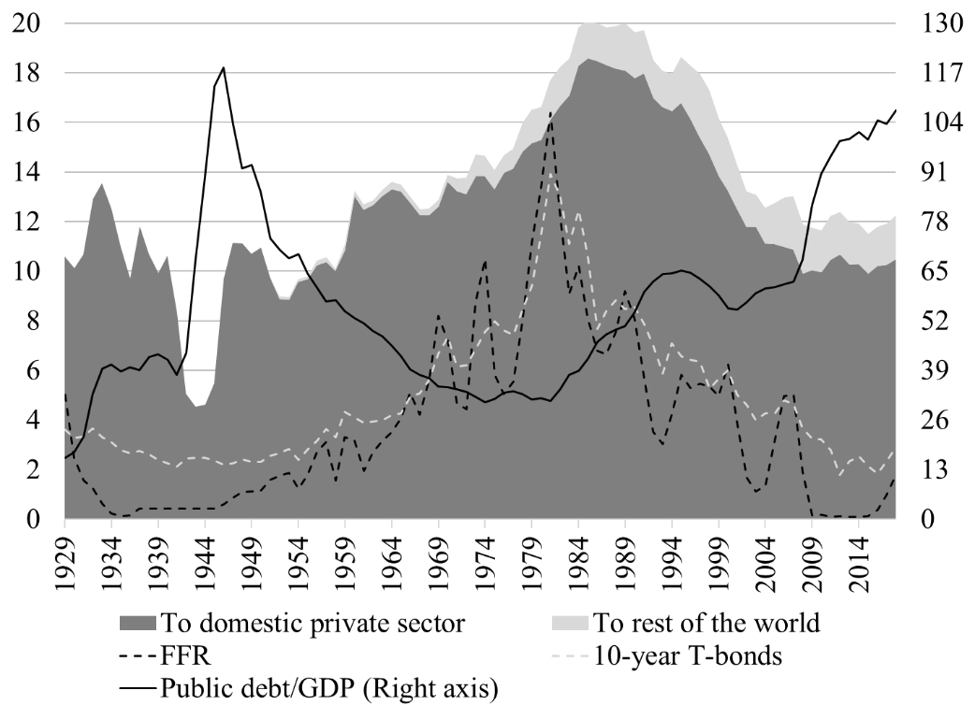
Sources: Board of Governors of the Federal Reserve System (Series H.15), Bureau of Economic Analysis, Treasury Direct.

FIGURE 4
Fiscal balance and Interest Rates, Q1 1900 to Q4 2016
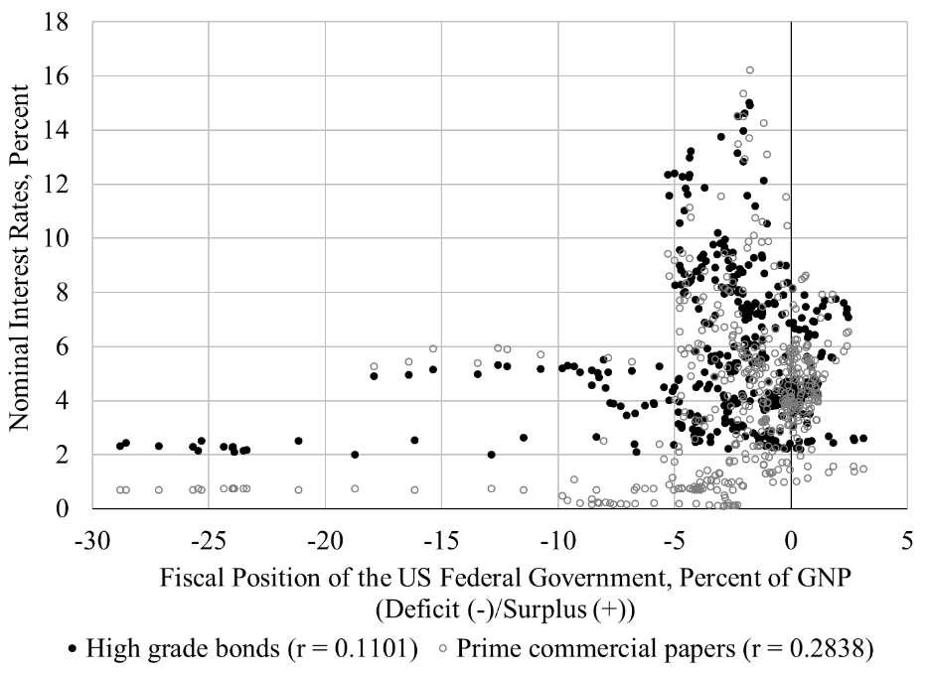
Sources: Treasury Bulletin, National Bureau of Economic Research, Monthly Receipts, Outlays, and Deficit or Surplus, Fiscal Years 1981-2017.

FIGURE 5
Monetary Policy and Nominal Interest Rates, January 1919 to December 2015
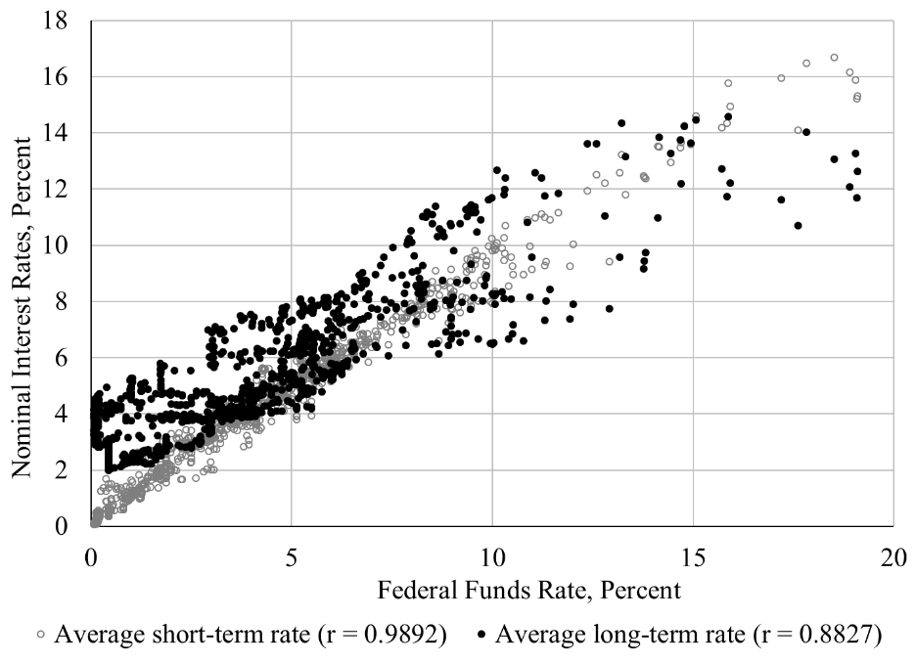
Sources: National Bureau of Economic Research.

FIGURE 6
Fiscal Balance and Inflation in the United States, Q1 1913 to Q4 2015
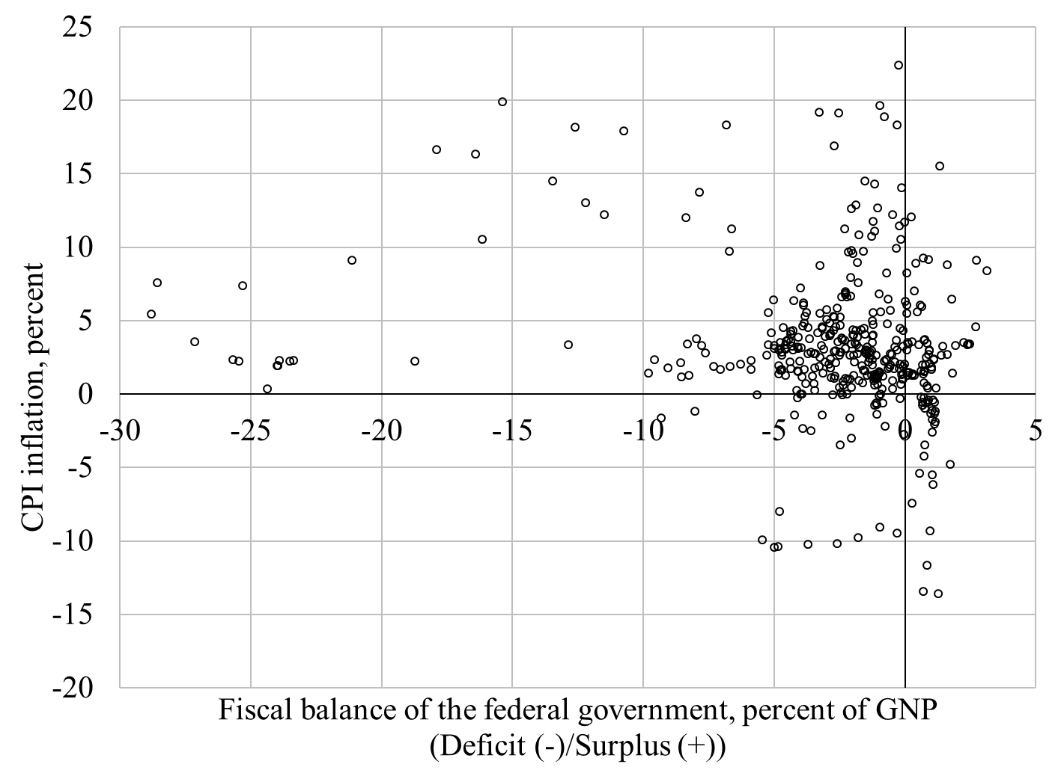
Sources: Treasury Bulletin, National Bureau of Economic Research, Monthly Receipts, Outlays, and Deficit or Surplus, Fiscal Years 1981-2017, Bureau of Labor Statistics.

TABLE 1
A Basic Balance Sheet
Assets | Liabilities and Net Worth
Financial Assets (FA)  Real Assets (RA) | Financial Liabilities (FL)  Net Worth (NW)

TABLE 2
Balance Sheet of Each Macroeconomic Sector
A_{DP} | L_{DP} |  |  | A_{G} | L_{G} |  |  | A_{F} | L_{F}
FA_{DP}  RA_{DP} | FL_{DP}  NW_{DP} |  |  | FA_{G}  RA_{G} | FL_{G}  NW_{G} |  |  | FA_{F}  RA_{F} | FL_{F}  NW_{F}
Note: DP is the domestic private sector, G is the government sector, F is the foreign sector also called the rest of the world.

TABLE 3
Annual Change of the Gross Public Debt relative to GDP: 1791-2018
 | Change is |  | Average Size of Change in Gross Public Debt
Time Period | Positive | Negative | (% of GDP)
1791 to 1930 | 66 | 74 | 0.31
1931 to 2018 | 83 | 5 | 4.22
1791 to 2018 | 149 | 79 | 1.82
Sources: Treasury Direct, Bureau of Economic Analysis.

Following the 2008 crisis, the Fed changed its monetary-policy practices by flooding the banking system with reserves and targeting a floor rate, which has removed the need for the Treasury to help implement monetary policy. In 2012, the Treasury removed all funds from TT&Ls and now directly credits the TGA when it receives proceeds from taxes and bond issuances, which has recently contributed to instability in the repo market.
The Treasury and Fed were only partly successful at achieving the monetary-policy goal as the FFR did not fall to zero but stayed substantially below target.
This assumption of a desired positive surplus reflects the stylized fact of macroeconomics, with the domestic private sector usually recording a positive net financial accumulation. Within the domestic private sector, some sectors may record surplus (usually households) while other may be in deficit (e.g., nonfinancial noncorporate firms).
MMT uses the Keynesian macroeconomic framework developed by Keynes, Kaleckiand their followers who reject fully the Neoclassical framework. As such, MMT rejects the IS-LM framework as well as most of mainstream macroeconomic developments after the 1970s. Authors such as Joan Robinson, Nicholas Kaldor, Paul Davidson, Hyman Minsky among many other Post Keynesians have developed a rich and rigorous alternative (Lavoie 2015). The economy is demand driven, economic growth is demand driven, productivity is demand driven, income effect dominates substitution effect, markets are inherently unstable, and most unemployment has its root in too low demand not in the market-structure characteristics such as price rigidities or asymmetries of information.
Economic units could also rely on capital gains to grow their net financial wealth but this is not a sustainable practice. Income is at the foundation of economic stability. The desire to growth wealth by using capital gains and leverage is a major source of financial instability (Tymoigne and Wray 2014).
The foreign sector may also engage within itself in portfolio reshuffling of USD-denominated assets, but that will not reduce the net financial accumulation of USD in the foreign sector and so will have no direct impact the fiscal balance of the US government; it will just impact the USD exchange rate and asset prices.
Fiscal surpluses did lead to a fall in the public debt held by the public (the Treasury bought back some of its securities from non-federal sectors) but intragovernmental holdings grew and more than offset the decline (Government Accounting office 2001).
Involuntary defaults have occurred for technical reasons but are analytically irrelevant. Venezuela is counted by Moody’s as having defaulted because “the person who was supposed to sign the checks was unavailable at the time” (Cantor et al. 2008, 17). The U.S. also defaulted in 1979 due to “unanticipated failure of word processing equipment used to prepare check schedules” (Zivney and Marcus 1989).
The public debt (D) follows the following law of motion: $$D_{t}= D_{t-1}+ {Def}_{t}$$ That is, every year the public debt increases by the size of the deficit. The fiscal deficit is the difference between government spending (G), taxes (T) plus interest payments (iD) $${Def}_{t}=G_{t}-T_{t}+iD_{t-1}$$ Let S be the primary balance with S > 0 denoting a primary deficit (G – T > 0): $$D_{t}= D_{t-1}(1+ i)+ S_{t}$$ Divide by GDP (Y) and assume a constant ratio of primary deficit to GDP (s = S/Y): $$d_{t}= d_{t-1}\frac{(1+ i)}{(1+g)}+ \overline{s}$$ Proceeding recursively yields: $$d_{t}=d_{0}{\left(\frac{1+i}{1+g}\right)}^{t}+\overline{s}\left(\frac{1+g}{g-i}\right)\left[1-{\left(\frac{1+i}{1+g}\right)}^{t}\right]$$ If g > i the debt-to-GDP ratio converges toward $\overline{s}\left(\frac{1+g}{g-i}\right)$ as t tends toward infinity, otherwise the debt-to-GDP ratio rises continuously.

