Law, Sovereignty and the Monetization of the European Economies: A Review of Making Money and Money in the Western Legal Tradition

Eric Tymoigne
Lewis & Clark College
0615 Palatine Hill Rd., MSC 40
Portland, OR 97219
etymoigne@lclark.edu

Law, Sovereignty and the Monetization of the European Economies: A Review of Making Money and Money in the Western Legal Tradition

Introduction
In the Treatise on Money, Keynes draws on Knapp’s The State Theory of Money to emphasize the central role of the state in setting up and managing monetary systems “for some four thousand years at least.” In the General Theory, he notes that capitalism is a monetary economy, i.e. an economy which nominal outcomes influence decisions, and he emphasizes the importance of asset liquidity, i.e. stable nominal value, for such an economy. In How to Pay for the War, Keynes provides a blueprint to deal with the inflationary pressures of full employment.
Keynes mostly does not delve into the details of how that liquidity was created and managed and how economies were monetized. Following archeological, sociological, historical, legal and economic studies of monetary history have pushed back the accuracy of Keynes’s view of the origins of monetary system to the past five thousand years at least. They have provided a wealth of information about how economies were monetized and how the liquidity of monetary instruments was created, managed, and lost through deliberate monetary management by government authorities or lack thereof. They also have illustrated how taxation and other methods presented by Keynes have been central throughout history to maintain the stability of the unit of account.
Two recent academic books by legal scholars further confirm the crucial role played by government in making and shaping monetary systems. They study extensively the monetary systems of medieval, renaissance and modern Europe. Money in the Western Legal Tradition, edited by David Fox and Wolfgang Ernst, regroups over thirty studies that analyze how monetary problems and monetary innovations have challenged and shaped legal outcomes as well as our understanding of monetary mechanics. Christine Desan’s Making Money complements the previous compendium by focusing on English monetary developments from the 5th century to the early 19th century. Her analysis is grounded in an analytical framework that emphasizes the legal, political, and financial aspects of monetary mechanics. She shows convincingly that monetary systems are made and planned; they are not a natural emergence of market exchange.
While governments were central in creating and managing monetary systems, the books note that this did not go smoothly and prolonged-multisided-cross-country power struggles are analyzed in details. Crowns of different countries competed to strengthen their monetary sovereignty and to weaken others. The Crown’s authority over the domestic monetary system was challenged by international merchants and financiers, the clergy and the nobility. Creditors and debtors battled in courts and the outcomes shaped, and were shaped by, the existing monetary system. Thus, the books do not argue that non-sovereign economic units played no role in monetary developments, but they conclude that core monetary trends were driven by decisions made by legal and political authorities instead of impersonal market forces.
Post Keynesian readers will approach these books with Keynes’s framework in mind and will be pleased to see that it does hold well against historical evidence. They will gain a deeper understanding of what makes the liquidity premium on monetary instruments the highest of all assets. They will get detailed accounts of the monetization of European economies and of the challenges that the creation and management of monetary systems pose. They will also better understand the role of reflux/redemption mechanisms for the stability of the monetary system. They will note that tax redemption was a constant through the history monetary systems while gold/silver redemption only played a partial role over a narrow timeframe. They will gain a deeper understanding of the financial nature of monetary instruments and the financial role of precious metals. They will get insights into the conditions necessary for the monetization of an economy and the central role that governments played in the monetization process. Overall, the books should encourage readers to reject the orthodox view of the nature and history of money.

On the Origins of Modern Monetary Systems: Constitutional Project vs Convergence Story
Desan notes that, going back to Locke, most economists (and other academics) contextualize the emergence of monetary systems within the problems induced by barter. As the narrative goes, the problem of double coincidence of wants generated a market-driven process that led economic units toward a medium of exchange with well-liked properties (scarce, divisible, etc.) and further led to a dematerialization of monetary instruments in order to improve the efficiency of exchange.
Academics of many disciplines have concluded that this barter-convergence narrative is unconvincing. It is circular, it leaves unanswered several important questions—such as how the unit of account was selected—and it has no historical backing (Ingham 2004; Hudson and Wunsch 2004; Wray 2004; Graeber 2011). They root the origins and evolution of modern monetary systems in legal and political developments that have occurred over at least the past five thousand years. They place the origins of monetary systems not in the inconvenience of barter but in the transformation of customary pre-legal obligations into compulsory legal obligations (Tymoigne and Wray 2005). Modern monetary systems emerged in Ancient Mesopotamia and Ancient Egypt to help religious authorities command the economy; these authorities imposed a unit of account, determined a price list, imposed dues on the population and determined the means to pay these dues (Hudson and Wunsch 2004; Nissen et al. 1993; Henry 2004). From there, modern monetary systems have evolved and adapted to include monetary innovations by governments and non-government entities.
Desan’s framework integrates this body of work and further develops the arguments by taking a legal view to conclude “money is a piece of legal engineering all the way” (Desan in Fox and Ernst 2016, 30). She notes that the convergence story presumes a polity or community that enforce contracts and property rights and that the origins of the unit of account is an important question to study. An authority sets level and structure of dues, sets the unit of account, sets monetary power in the Constitution, decides which goods can be alienated, decides which payments must be made with money. Money depends on a set of legal concepts such as credit, debt, commodity, payment, sale, contract, property so one needs to understand the legal architecture, which implies that the government should be introduced immediately in the analytical framework and models based on it (Ibid., 21). While all models are simplifications, assuming away the state is a weak hypothesis that severely limits the relevance of the model. The law was written to ensure that resources would flow to the governing authorities so Desan links the legal aspects of monetary systems to the fiscal policies of the early governing authorities. Consistent with Chartalism, the books document extensively the role of taxes and other government dues in the smooth functioning of monetary systems since the Middle Ages.

Private Contracts: From Metalism to Nominalism
The collapse of the Roman Empire led to a demonetization of Europe and its remonetization generated major debates about the proper way to set up a monetary system. The books study the legal debates surrounding nominalism and metalism and their influence on thoughts about the nature of the coinage. Nominalism argues that the nominal value of a debt is the point of reference to settle that debt, which implies that the official value of coins should be used to determine if a debt has been paid. Put differently, sums owed on running contracts cannot be adjusted upward (downward) to account for a depreciation (appreciation) of the coinage. Nominalism has existed consistently in English common law since at least the 13th century and:
By the 1450s, we see explicit indications in the reported case law that common law judges realized they were bound to follow the coinage values defined in the mint indenture when they considered the discharge of debts in private transactions. (Fox in Fox and Ernst 2016, 207)
This applied to domestic coins and foreign coins—a great variety of which circulated in domestic economies—as long as the Sovereign proclaimed them current and lawful. In 1604, the Case of Mixed Monies further confirmed that creditors must bear the risk of loss of metal due to wear and debasement by accepting current and lawful coins at their official value (Ibid., 224 ff.). England had specificities that favored the adoption of a nominalist framework:
England’s tradition set it apart from the debates occurring on the Continent, where civilian and canon law scholars found more reasons to recommend metallism. The conditions that made the sanctity of the “count” harder to maintain-multiple Sovereigns, porous borders, erratic and sometimes severe debasement-also made it hard to enforce nominalism. Both coined money and bullion circulated, offering different modes of value. The circumstances undermined the advantages that a nominalist approach offered. (Desan 2014, 137)
The count could be enforced more consistently in private transactions only when the Sovereign had a strong grip over the monetary system.
On continental Europe, jurists who developed Canon law considered coins to be “a definite weight of precious metal of a standard guaranteed by an issuing authority” (Allen in Fox and Ernst 2016, 51; Ernst in Fox and Ernst 2016, 115). The value of coins should be judged in terms of a weight of precious metal and economic transactions should involve weighing—instead of counting—coins. Weights units (lb., oz., etc.) are the true point of reference whereas monetary units (£, s., etc.) are pure veil to record accounts so “in the case of both a debasement and a return to strong money, any difference in fineness or weight had to be supplemented or deducted” (Dondorp in Fox and Ernst 2016, 252).
This metalist view of the coinage has important consequences for the drawing of private contracts and for the outcome of court disputes. From the 11th to the 13th century, canonist jurists concluded it ought to be implicitly understood by all contracting parties that, unless a specific clause states otherwise, the principal owed is not a monetary sum but a weight of precious metal. When Mr. X lends to Mr. Y a $1 coin that contains 1 oz. of gold, X pays no attention to the official value of the coin ($1), or to the purchasing power of the gold content; he is merely concerned with recovering the same quantity of precious metal (1 oz.). X considers coin-lending equivalent to lending his horse; he expects Y to return that exact same horse. In case of dispute, courts sided with X and Y had “to pay using coins of the same substance, alloy, and weight as those he had received” (Dondorp in Fox and Ernst, 258).
Metalism was challenged by changes in the official weight (reinforcement, debasement) and official count (enhancement/crying up or abatement/crying down) of the coinage. In a metalist framework, debasements burden debtors, either because the type of coins lent (or similar equivalent) no longer exists or is difficult to find, or because more debased coins are owed to reach the agreed upon quantity of metal. By the 14th century, canonists recognized this undue burden and provided some protections to debtors. They were no longer liable for unexpected debasements but still needed to compensate creditors for the natural wear (gold and silver are soft metals) and artificial wear (clipping and sweating) of the coinage (Thier in Fox and Ernst 2016, 154ff.).
Metalism was also challenged by fluctuations in the nominal and real price of precious metals. Preeminent lawyers, such as Charles Dumoulin (1500-1566) in France, regarded the metallic quality of the coinage as important to its nature and value. However, he recognized that debasements were, in part, done to offset the rise in metal prices so, if a debtor was required to provide non-debased coins, “the sum of money received by the creditor would exceed the sum due, and he would have to return those extra coins” (Dondorp in Fox and Ernst 2016, 254). Payments with non-debased coins led to an overpayment in nominal terms but also, and more importantly, an overpayment in real terms because the real price of precious metals rose.
These challenges progressively led legal thoughts and practices to move of away from metalism toward nominalism. They did so through two channels. First, jurists moved away from pure metalism toward one may called market metalism. The intrinsic value of a coin is no longer measured by its weight in precious metal but by the monetary value of that weight as determined by market prices, which implies that the reference point is no longer a weight unit but a monetary unit. Second, civil law jurists progressively gained a better understanding of the difference between financial and non-financial transactions. When Mr. X lends coins, he does not lend objects he owns; he merely lends a numerical sum. Contractual requirements changed and Mr. X now had to insert specific wordings (“coin for coin”, “in species”) to clarify his willingness to get back specific coins (Schott in Fox and Ernst 2016, 292).
By the 18th century, nominalism was fully integrated in French law and influential jurists such as Joseph Poitier (1699-1772) noted “our jurisprudence does not consider the substance and the actual coins, but only the value assigned to it by the Prince” (Dondorp in Fox and Ernst 2016, 261). The Napoleonic Code states that:
The obligation which results from a loan of money is always only the numerical sum stated in the contract. If the value of money has increased or decreased before the time of payment, the debtor must repay only the numerical sum lent in the lawful currency at the time. (Article 1895 in Rosenn 1982, 39)
Creditors bear the risk of debasement, enhancement, wear and inflation, and debtors bear the risk of reinforcement, abatement and deflation.
Desan (2014, 128) warns against a teleological view of the previous developments. Even though nominalism progressively spread through Europe, economic units still cared about the metal content of coins. Nominalism did not apply to dues owed to Sovereigns who routinely weighed coins received in payments and could refuse or discount underweighted coins. Nominalism does not prevent the inclusion of metalist clauses in private contracts. International trade was based on metalist principles so coins circulated by weight outside the Sovereigns’ areas of influence. International financiers and merchants made arbitrages across currencies when there were discrepancies between the count and the weight across countries (Redish 2000). Within the domestic economy, economic units arbitraged discrepancies between the count and the weight of coins. The rise of nominalism was not smooth and generated a lot of pushbacks, with “nominalism occasionally giving way to a negotiated and exceptional metalism”, when changes in the coinage led to large losses for one party or when fear of demonetization led creditors to refuse lawful coins (Desan 2014, 129, 132, 146ff.).

Fighting for Metalism
While proponents of metalism wanted the coinage to remain undisturbed, Sovereigns had to adjust its count and weight for reasons explained in the last section. The disruptive experiences with appreciations of the coinage (reinforcement and/or abatement) led Sovereigns to favor adjustments via depreciations (debasement and/or enhancement) (Desan 2014, 120-122); however, landed, financial and commercial interests fought depreciations and found an ally in Nicole Oresme (1320-1382) (Allen in Fox and Ernst 2016, 49ff.). They argued that the coinage is not the property of the Sovereign so debasements are fraudulent unless the king has the consent of the population (Their in Fox and Ernst 2016, 147). They wanted a stable quantity of metal and did not care for the official monetary value of coins so they tried a variety of means to protect their interests. They raised commodity prices, they fought in courts to raise the sum owed by debtors (commonly rents and annuities) in underweighted coins, they imposed metalist clauses in contracts, and they developed their own unit of account. The following reviews these methods in turn.
While authors who follow the quantity theory of money argue that there is a close unidirectional causality between depreciation and the rise in output prices, the evidence shows a delayed and much less than proportional link (Sargent and Smith 1997; Munro 2014). Figure 1 confirms a weak link for England and France. Unfortunately, at times, authors in the books tend to accept too easily the idea that depreciation and inflation are strongly linked. The few passages where it occurs is disconcerting because it comes at the same time as arguments that emphasize a scarcity of coins and the limited role of coins in domestic economic transactions. In addition, the mint equivalent was not public information so it would take time for coin users to recognize that a moderate debasement occurred; this was all the more so that new coins had uneven weights (Munro 2014). Instead, prices were adjusted upward to offset obvious wear, while depreciation occurred ex post to quell the instability coming from a worn coinage. As explained in the last section, the tax practices of the Sovereign further incentivized merchants to raise their prices to offset wear.

FIGURE 1 HERE

In terms of private contracts, creditors fought in courts not only to offset debasements and wear, but also to claim the benefits of reinforcements. They sought to adjust running rental contracts and debts in order to require payments in non-debased/intact/reinforced coins or to increase the sum due in under-weighed coins. As long as metalism prevailed, creditors were successful in courts. Debtors and tenants with limited means found it difficult to get their interests defended in court because they could not pay the court fees, could not afford to be present, and judges were biased toward creditors (Desan 2014, 218-220). As a consequence, tenants would suffer and, when riots ensued, the Sovereign would at time intervene to defuse the crisis by “allowing the payment of the next three quarters of a year’s rent in debased money” (Allen in Fox and Ernst 2016, 49). The ability to make adjustments on running contracts diminished as nominalism gained traction; creditors had to wait for the end of a contract to be able to negotiate the desired adjustments.
The most effective method used by merchants to protect themselves against the metallic unreliability of current coins was to use an alternative unit of account tied to a coin with well-liked and stable metal properties, and public authorities did yield to these concerns by setting up public banks in such a way (Meder in Fox and Ernst 2016). In the Dutch Republic, the Bank of Amsterdam kept its accounts in “bank guilder, as opposed to the current guilder, the unit of account for money outside the bank” (Roberds and Velde in Fox 2016, 345). The reference coin did not have to exist, a case of so-called “ghost/imaginary money.” The bank guilder was tied to the silver Carolus guilder that Charles V introduced in 1543 and that no longer circulated by the time the Bank of Amsterdam was set up in 1609. In 1659, the existence of two units of account was formalized by a mint ordinance that assigned official values to large coins in “current money” (that is, in terms of the official unit of account) and “bank money” (that is, in terms of the Bank’s unit of account) (Ibid, 344).

Dematerialization of Monetary Instruments
The move to nominalism met resistance, was applied unevenly through time and space, and conflicted mostly with the economic interests of creditors. It was also accompanied by a progressive dematerialization of monetary instruments via two channels. First, debasements progressively loosened the connection between precious metals and coins. Second, non-cash payment methods redeveloped to counter the scarcity of the coinage, its lack of denominational range (until the 13th century only the penny coin existed in England and 1d. was too large for petty transactions and too small for most commercial transactions), its lack of uniformity, its cumbersomeness (heavy and dangerous to transport, takes time to collect, takes time to count and/or weight), and the legal uncertainties surrounding the coinage. This dematerialization changed the views about the nature of monetary instruments and reinforced the habit of taking the official unit of account as a reference point, which in turn broadened the acceptance of nominalism among legists and the population.
The process of dematerialization in the Middle Ages should be put in context. Not only were coins not the main means to perform transactions, but also payment systems based on banks and other cashless methods are much older than coins. There are records of “merchants in Babylonia and Caldea paid by [bills of exchange] inscribed on clay bricks” (Geva 2011, 112) throughout the 9th or 8th century BC in Mesopotamia, and banking services go back to Ancient Mesopotamia (Hudson and Wunsch 2004). With this context in mind, it is incorrect to talk about the “dematerialization of money.” Modern monetary systems, that emerged around 3000 BC, were immediately immaterial; ledgers came first, coins came long after. Non-cash payment methods were common in Roman times (Harris 2008; Meder as well as Rüfner in Fox and Ernst 2016). The collapse of the Roman Empire led to collapse of trade, a collapse of the taxation system, a collapse of the coinage system, and the disappearance of banking and non-cash payment methods by the 6th or 7th centuries (Geva in Fox and Ernst 2016, 409; Desan 2014, 39, 50).
Peasants, merchants, and the Sovereign’s Treasury innovated to bypass the problems generated by making payments with coins. In their daily transactions, laypeople innovated by relying on installments, sales advances and running accounts, in the payments of consumption, wage, and rent, among others. This was especially prevalent in England (Desan 2014, 205ff.). As such, the scarcity of coins was not that much an issue for local recurring petty transactions, although, coins were needed at time of debt settlements, such as during harvests, so a scarcity of coins would create problems (Desan 2014, 223).
While banking services (deposit, payment and credit services) were at first connected to the coinage, the connections loosened as the operations of banking changed (Siekmann in Fox and Ernst 2016). Credits services came to be provided by overdraft and crediting accounts instead of merely lending coins (Geva as well as Meder in Fox and Ernst 2016). Banks issued promises to pay (banknotes) instead of mere deposit receipts (drafts) (Siekmann in Fox and Ernst 2016, 490). Banking services were provided by pawnbrokers (petty consumption credit secured by jewelry), moneychangers (deposit taking and transfers), and merchant/exchange bankers (international trade following the rebirth of long-distance trade in the Italian port cities in the 10th century) (Siekmann in Fox and Ernst 2016, 492ff.; Geva in Fox and Ernst 2016, 410ff.). Merchant bankers and moneychangers recreated local and international payment methods based on scriptural transfers of funds. In the 12th century, an intra-city ledger-based payment system (a “giro”) was developed by Genoa moneychangers in order to bypass the inconvenience of coins (Geva in Fox and Ernst 2016, 412; Meder in Fox and Ernst 2016). By the 14th century, wealthy merchants with networks throughout Europe had developed an international payment system based on bills of exchange settled at fairs (Siekmann in Fox and Ernst 2016, 492-493). Fairs are at the origins of the organized interbank clearing and settlement mechanisms that were performed mostly by Italian bankers in the 14th and 15th centuries and by German bankers in the 16th century (Geva in Fox and Ernst 2016, 410). The preferred methods of settlement were net clearing (X cancels a debt owed to Z by redeeming Z’s bills of exchange), substitution by delegation (X pays Z with bills issued by Y, then Y pays Z) or deferred payment at the next fair. Payment with coins was the last resort solution (Geva in Fox and Ernst 2016, 426).
Private banking declined throughout the 15th century because of repeated failures and a chronic shortage of reliable coins. In addition, the hostility of public authorities toward moneychangers grew because of their central role in the circulation of unlawful coins and in the illegal export of bullions and domestic coins. As confidence in private banks declined, private bank accounts circulated at a discount relative to coins (Geva in Fox and Ernst 2016, 416). Public banks emerged in the 15th century to replace private banks and were dominant until the 18th century. Public banks were crucial to the development of reliable local (giro) and international (bills of exchange) payment systems; they were also at the origins of modern private commercial banking, open-market operations and the emergence of bearer’s notes (Roberds and Velde in Fox and Ernst 2016, 323-324). Public banks had two phases of development. Pre-1650 banks were created by city-states to provide a reliable scriptural payment system fully backed by coins of stable quality, and post-1650 banks also issued bearer notes. At times, accounts at public banks traded at a premium over current coins because they were considered more liquid (contrary to the coinage, funds in accounts were always easily transferable at par) and stable (as long as the metallic peg could be maintained). Post-1650 public banks had to deal with the legal uncertainty surrounding the monetary nature of bearer notes. Monetary instruments were defined in the law as those that serve as means of final payment and there were court disputes regarding the finality or conditionality of payments with bearer notes (Rogers in Fox and Ernst 2016). This issue was not resolved until much later, when, for example, Bank of England notes became legal tenders in the early 1830s (Roberds and Velde in Fox and Ernst 2016, 472; Desan 2014, 328).
The Sovereign’s Treasury also innovated to counter problems with the coinage (Desan 2014, 174-260). In England, the tally stick was a major financial innovation that paved the way to the emergence of modern financial instruments such as bonds, bearer notes, and colonial bills of credit. Tally sticks were first issued in the 12th century as a receipt of early tax payments. By the 14th century, they were issued in anticipation of taxes and were redeemable on demand to tax farmers. The Sovereign spent by issuing tallies and bearers redeemed the tallies through tax collectors. If tax farmers had already collected coins from tax payments, tally bearers could get coins, otherwise they would get a tax credit to be applied when taxes were due. When tax season came, tax collectors sent the tallies back to the Exchequer and the receipts of tallies represented on average 53 percent of annual revenues between 1377 and 1485 (Desan 2014, 177). In the 17th century, customs farmers began to use their own coins to convert tallies on demand, and they requested that an interest be paid on tallies for providing this service to the Sovereign. However, the practice did not last long because of the rise of the public debt.
Treasury orders of repayment, the first English government securities, were issued in 1666 and rapidly gained the upper hand over tallies via two key advantages. One, while Treasury orders were not redeemable on demand, they were transferable and this transferability grew with the rise of a secondary market. Tallies only had limited transferability and circulation. Second, holders of Treasury orders received priority over Crown’s revenues. Given their disadvantages and given that Charles II had defaulted on Treasury orders in 1672, tallies were heavily discounted in the 1690s (Desan 2014, 281, 301). Treasury orders continued to be heavily discounted even after the Case of the Bankers was settled in favor of bankers in 1700. The court concluded that creditors had the right to sue the Crown without his consent and they won reparations for the 1672 default, but payments were delayed. Developing reliable means to pay the public debt took time and required developing “regular government payments, the ability to estimate tax returns realistically, the willingness to impose the needed taxes, and the capacity to administer collections and payments efficiently” (Ibid., 290).
Together, debasement, the rise of nominalism and the increasingly marginal role played by coins in transactions, meant that the official value of the coinage progressively became a common point of reference in transactions as payments took a more abstract form; the “so-called ‘metallistic’ conception of money […] was called into question” (Meder in Fox and Ernst 2016, 442). Already during Roman time, the metalist view of monetary instrument was challenged. The highly influential Roman jurist Julius Paulus, who lived through the repeated debasements of the denarius in the first part of the 3rd century AD, emphasized “the importance of public authority backing money and the fact that the value of money does not depend on its substance” (Fox in Fox and Ernst 2016, 99). Italian jurist Girolamo Butigella (1470-1515) was well ahead of his time when he concluded that the substance of a monetary instrument is irrelevant to its value and nature (Dondorp in Fox and Ernst 2016, 248). Alfred Mitchell-Innes (1864-1950) noted much later that monetary instruments are just a form of transferable promises “printed on paper or on a gold coin” (Wray in Fox and Ernst 2016, 638). As such, the “redemption of paper issues in gold coin is not redemption at all, but merely the exchange of one form of obligation for another of an identical nature” (Innes quoted in Ibid.; Desan 2014, 109).
The matter of crucial importance for the valuation of monetary instruments is the promise made by their issuer. The (private or public) issuer promises to redeem them at their official value at any time through conversion or acceptance in payments owed to the issuer. To implement the promise, some adequate redemption/reflux mechanisms must be put in place, such convertibility, taxes and debt services. If the issuer is credible, the market value is the official value of his monetary instruments. A valuable substance is a collateral available in case the issuer defaults, that is, is unable or unwilling to redeem its monetary instruments at any time at the official value; however, the fact that the collateral (gold) was readily acquirable by bearers of transferable promises (coins) was a major source of monetary disturbances (Tymoigne 2014). Desan concludes in a similar fashion that precious-metal coins are a type of secured financial instruments in which the collateral is the quantity of “silver or gold where commodity money failed” (Desan 2014, 318). She also notes that gold/silver redemption was inexistent throughout most monetary history whereas tax redemption has been common. She also concludes that the credibility of paper currency was crucially based on tax redemption even during the gold standard (Ibid., 388).

Fiscal and Monetary Sides of Monetary Systems
Outside the impact on buyers, sellers, debtors and creditors, the tension between metalism and nominalism was crystalized in the fiscal and monetary practices of European rulers and their influence on the price at which coins circulated. While nominalism and metalism are concepts related to the settlement of private contracts, they have implications for the nature of the coinage and the management of the monetary system. Metalism emphasizes the sanctity of the weight of the coinage whereas nominalism emphasizes the sanctity of the count. As nominalism spread and the relevance of the official value rose, it became more important than ever to reinforce the legitimacy of official value over intrinsic value by extending nominalist principles to dues owed to the Sovereign. However, several issues created difficulties for the consistent extension of nominalism to such dues. This leads to a final contribution of the books.

Nominalism, Tax and Monetary Stability
A central characteristic of contemporary monetary instruments is their perfect liquidity, that is, their constant nominal price through time. Reaching such a result requires understanding how to set up the proper financial characteristics of monetary instruments and how to ensure that these characteristics are enforced (Tymoigne 2014). For a monetary system to work properly, the redemption of monetary instruments “must be realizable at any point” (Meder in Fox and Ernst 2016, 443). While the books study all aspects of redemption, they put a special emphasis on the role of tax payments because of their central role throughout monetary history.
From 5th to the 10th century, the grasp of European Sovereigns on the monetary system was weak so the intrinsic value of the coinage dominated:
the state in the early Middle Ages did not possess the power to insist on the acceptance of its coins as legal tender, and often probably did not even wish to do so. This was certainly true of the Merovingian Franks, under whom the minting of coins was essentially a private and not a public activity, and the state did not accept coin in payment of taxes until it had been melted down and its fineness ascertained; in other words unit it had been transformed into bullion. […] No serious attempt was ever made to insist on money payments. (Cipolla 1967, 11-12)
Redemption channels were weak or inexistent so the collateral role of precious metals was important. Following the Carolingian monetary reform of 755, there was a trend toward a centralization of the coinage and a monetization of taxation as some European kingdoms “created more settled conditions and developed fiscal systems which promoted commercial life and the use of money” (Eagleton and Williams 2011, 65). However, decentralization reemerged in 10th-century continental Europe and continued until the 12th century. The introduction of a strong taxation system in France in the 14th century was central to its monetary stability (Redish 2000, 69).
By the end of the 10th century, Anglo-Saxon rulers were able to impose dues, to centralize monetary powers and to enforce frequent mandatory recoinage by proclaiming the existing coinage invalid (Desan 2014, 155), which promoted the domestic circulation of coins at their official value (Desan 2014, 66). In the 12th century, the ability of English rulers to tax grew further because of a political compromise (Desan 2014, 160):
Debasement eroded the real value of rents with fixed nominal values in moneys of account, hence the desire of great landowners and the Church to offer taxes in return for promises of the restoration of sound money (Allen in Fox and Ernst 2016, 48)
On continental Europe, fragmented political powers allowed Sovereigns to act more independently and to perform debasements for fiscal purposes more often (Desan 2014, 162). Debasement still needed to occur in England—the silver content of a penny coin fell by 60 percent between 1343 and 1666—but it was mild compare to continental Europe.
A strong tax system helped maintain the metallic stability of the coinage but also emphasized the “fiscal value of money” (Desan 2014, 48) over its intrinsic value, which was consistent with nominalism. A strong tax system also promoted the monetization of the economy as more dues—taxes, fees, tolls, customs, and others—came to be owed in coins instead of in kind. The monetization of the economy proceeded at a faster pace in England and, by the 12th century, monetary payments to landlords overtook in-kind payments, although landlords still calculated which would provide more purchasing power. The growing demand for coins also led to the spread of markets beyond towns from the 13th century (Desan 2014, 98-99).
Perhaps the clearest example of the centrality of taxation in the viability of a currency is the opposite experiences of some countries that set up public banks with the ability to issue banknotes. England provides a successful example, even under demanding circumstances and even if convertibility into coins is suspended, as long as the coordination with the Treasury is well managed and proper controls and accountability are put in place.
The Bank of England’s success at dealing with the temptations posed by banknote issue provided evident proof that a (largely) fiscally backed money was not only possible, but practicable. (Roberds and Velde in Fox and Ernst 2016, 488)
Similarly, the Prussia Treasury was able to issue notes to finance its war effort against Napoleon but this did not lead to inflation because several measures taken to contain it including taxation (Skiemann in Fox and Ernst 2016, 514). The case of France shows how unstable a monetary system based on unconvertible paper currency can be if “most other sources of revenue [are] exhausted” (Roberds and Velde in Fox and Ernst 2016, 479). In other words, the French government issued large quantities of banknotes without providing bearers a means to redeem them in any relevant way (Bordo and White 1993; Antipa and Chamley 2017). In the 20th century, as long as war spending was accompanied by a collapse of the taxation system, hyperinflation followed. Hyperinflation did not occur in countries that were subject to shocks, even when governments monetarily financed their deficits, if there was a tax base that allowed the deficit to fall when needed (Velde in Fox and Ernst 2016).

Nominalism, Metal and Monetary Stability
Whenever nominalism applies, the Sovereign should emphasize the count but, given the reliance on precious metal to make monetary instruments, the Sovereign could not ignore the intrinsic value of the coinage and so its weight and the market price of the metals used to make it (Desan 2014, 82-83; Redish 2000).
First, the Sovereign had to make sure that monetary systems did fulfill the purpose for which they were created (Desan 2014, 78ff.). In Antiquity and the Middle Ages, the government imposed dues on its population that could be paid in lawful and current coins, spent by issuing these coins, and then collected taxes. In order to ensure that a transfer of resources to the government occurred, rulers had to make sure that the population needed lawful and current coins to pay the dues, which meant forbidding the use of counterfeits to pay the government. Until more effective means to prevent counterfeiting existed, the use of precious metals was an adequate, albeit imperfect, solution.
Second, the use of precious metal broadened the acceptance of the coinage by providing a collateral in case the Crown defaulted on its promise to redeem coins through dues, or in case bearers did not expect to pay any dues to the Crown. One of the problems with extending nominalism to payments owed to the Sovereign was that a Sovereign had to carry the risk of loss of metal coming from natural and artificial wear. In the 16th century, the English and French Sovereigns received in tax payments large quantities of billion coins and coins in poor condition (Redish 2000, 129; Desan 2014, 80, 94). This was a problem as long as the metal quality of the coinage was relevant in the geographical areas where a Sovereign was involved. The Sovereign’s soldiers stationed in foreign countries where metalism applied needed reliable coins to be able to buy commodities and settle debts in a convenient way. The services of mercenaries, imports, and tributes to foreign governments had to be paid in high-intrinsic-value coins.
Third, the stability of the coinage required a specific relation between the count and the weight be maintained both in absolute terms (i.e. for a given coin) and in relative terms (i.e. across coins of different denominations made of the same metal and across coins of different metals) (Redish 2000). The natural and artificial wear of the coinage was an enduring problem. The longer a coin stayed in circulation, the greater the wear, and so the greater the difference between its actual and official weight. Add on the top of that changes in the absolute and relative price of metals and it is easy to understand why something had to give in the coinage in order to quell multiple discriminations among old/new, domestic/foreign, copper/silver/gold coins. If nothing was done, newly minted coins would disappear or circulate at a premium, the sale of metals to the mint would dwindle, and worn coins would prevail and make the detection of counterfeits more difficult. Thus, most depreciations were implemented to preserve the stability of the coinage rather than to offset its scarcity or for fiscal manipulations (Allen in Fox and Ernst 2016; Redish 2000; Desan 2014; Munro 2014). Figure 2 illustrates that point with the silver penny. As the price of silver rose, the Mint lowered the official weight by a quantity just sufficient to maintain the intrinsic value of the penny at 1d., which is consistent with the nominalist principle of taking the official value as a reference point. Other coins saw their official value rise given weight (especially coins used in international transactions and high-metal content coins), or the mint performed a combination of debasement and enhancement (Redish 2000, 89ff.).

FIGURE 2 HERE

While depreciation was the most common way to deal with metal-related instability, that was not the only way. For example, the Sovereign could also decide to abate the coinage to account for the loss of metal. When this was done abruptly, debtors would be burdened with the need to find more coins. This was an issue not only for private debts but also for tax debts. When Edward I halved the official value of imitation pennies on Christmas day of 1299, tax sheriffs were immediately impacted because the nominal value of their revenues in imitation pennies was halved and they were liable for the discrepancy (Desan 2014, 144ff.). If the public anticipated an abatement, the impacted coins would circulate at a discount.

Enforcing the Count…Or Not
Several issues could prevent a tax-driven monetary system to work properly. First, monetary disorders were promoted by governments when they focused on weight instead of enforcing official values. When they received coins in payments, Treasury officials were legally required to weigh them. They punished individuals holding light coins by fining bearers and by refusing or discounting coins received in tax payments. In 12th century England, they did so in two ways. One was by periodically assaying pennies in bulk and by requiring tax sheriffs to come up with the number of unblemished pennies added by officials to balance the scale. Another more common way, given that melting coins was time consuming, was to apply a blanket five-percent discount to any sum received from sheriffs. Sheriffs anticipated such extra payments by collecting coins at a discount relative to their official value (Bolton 2012, 47).
Given the tax practices of the Treasury, it is no wonder that at times it was difficult to enforce circulation at official value, even under the threat of prison, death or financial ruin, as “people disfavored coin that fell below the minimum standard, fearing their own inability to pass it along” (Desan 2014, 82-83). Even when nominalism prevailed, officials had to proclaim repeatedly that coins must be counted, not weighed, in private payments. In England, starting with Edward III in 1351, rulers throughout the centuries had to state, under threat of prison without bail, that lawful coins should “go and be current in payment, for the sum that they were coined for” as an Ordinance of Henry VII proclaimed in 1504 (Fox in Fox and Ernst 2016, 206). The repetition of the threat suggests that the problem of enforcing official value in the settlement of private contracts was common although Fox notes that “for any transaction substantial enough to require enforcement by the courts,” it is unlikely that parties could have evaded these monetary rules (Ibid., 209-210).
Second, a chronic shortage of coins made it difficult for the population to pay taxes in coins. There was no reliable elastic supply of coins because royal spending was irregular and erratic (mostly war spending) and because the mint did not supply coins on demand. This problem was all more prevalent for small coins because their higher cost of production disincentivized the mint to produce them (Desan 2014, 197-198). Those who sold metal to the mint had limited to no discretion regarding the types of coins they received in payments (Redish 2000, 112ff., 127ff.). Given the shortage of coins, the parliament allowed tax sheriffs to collect taxes in-kind (Desan 2014, 165), or, as illustrated below with the guinea, the official value could not be enforced. When the coinage was in poor condition, rulers would ignore the weight discrepancy and accept badly damaged coins at their official value as long as they were current and not deemed to be counterfeits (Desan 2014, 80ff., 94). Sometimes even known counterfeits—such as imitation pennies at the end of the 13th century—were proclaimed lawful, but that was not a sustainable policy (Desan 2014, 108ff.).
Third, some rulers did not promise to redeem their monetary instruments. Others did promise redemption but did not have the mechanisms in place to back up that promise, either because they lack what they promised to convert into or because taxation was not enforced properly because of wars, inadequate means of enforcement or other problems. The Thirty Years’ War led to heavy debasements to meet fiscal needs; the rapid increase in government spending led to severe inflation that was brought under control only when sovereigns agreed to redeem debased coins “through tax payments and other charges” (Amend-Traut in Fox and Ernst 2016, 301).
Fourth, developments in the metal markets could push the intrinsic value above the official value. If the Sovereign did not intervene, s/he lost control over the valuation of the coinage and had difficulties to implement taxes. Figure 3 illustrates that point with the guinea coin. For the first 33 years of its existence, the guinea was undervalued by the Mint; the guinea’s official value was below its intrinsic value. The Mint could have debased or enhanced the guinea but did not intervene because the guinea was not originally intended to be a domestic coin but rather to facilitate trade in Africa (Li 1963). Thus, most guineas were exported and those that circulated in England did so at a premium that fluctuated between 1s. 2d. and 1s. 10d. from 1663 to 1693 (Feavearyear 1931) and that reached 2s. in 1694. While the Mint did undervalue the guinea, the Treasury did not because it redeemed guineas in taxes at a price that tracked its market value. This means that the face/fiscal/redemption value differed from the official value of 20s. This lack of coordination between the monetary and fiscal sides of the government was not resolved until April 1696 when the official and face values were set equal to 22s. In 1697, this coordination problem occurred within the fiscal branch with a redemption value that was different for taxes and debt contracts owed to the Treasury:
In October 1697, the Treasury decided to accept guineas at 21½s. in payments for loans only, but maintained the rate of 22s. for taxes. (Sargent and Velde 2003, 295).
This ended up confusing tellers at the Exchequer and a letter had to be sent by the Board of Treasury to tell them to keep redeeming guineas at 22s. for taxes (Horsefield 1960, 82; Horton 1887, 248), which they did until February 1699 when the Treasury lowered the redemption value for tax payments to 21.5s.

FIGURE 3 HERE

By 1695, external trade deficits, uncompetitive mint prices, and unfavorable relative prices led to large outflows of silver and gold from England, which led to a rise of the prices of both metals in England (HM Treasury 1695, 1145; Desan 2014, 343). However, gold price rose much faster than silver due to the poor state of the silver coinage and speculation surrounding the guinea:
The disproportion seems to arise from two causes; the one is the badness of the silver coin, […] and from this diminution and baseness of the silver coin it is come to pass that the same, especially the half Crown, doth not pass from man to man without great difficulty, and many times and in many places is wholly refused by persons who choose to take guineas at an exorbitant rate rather than trust to their own skill in distinguishing good silver from bad or meddling with that which perhaps will not pass from them again. The other cause of the said disproportion may be a vile practice, which is vulgarly (though perhaps improperly) called stock jobbing of guineas, that is where one gives a premium or reward to another to have the refusal of a number of guineas at a limited price and within a limited time: which practice in the case of guineas, as it doth usually in the case of joynt stock, serves to put a fictitious, imaginary or too high a valuation […]. (HM Treasury 1695, 1145)
This rapid increase in the intrinsic value of the guinea created a dilemma for the Exchequer:
It remains now to be considered whether the Officers of the Exchequer and the Public Receivers [of taxes] should take or refuse guineas at the price for which they are now current. […] If the Tellers in the Exchequer and the Receivers of the Sovereign's revenue and taxes […] should continue to refuse guineas at the present current price it will in all places defer the bringing in of the said taxes and revenues; that in some places it may occasion the total loss of the Sovereign’s money […] if the King’s Receivers be permitted to take guineas at a stated price (for instance at 30s. apiece) it is likely that they may by selling at a higher price (for instance 31s. for there will always be some difference in the putting of guineas) (HM Treasury 1695, 1146)
Not raising the redemption value would create problems to collect tax revenues because taxpayers would refuse to pay in guineas and did not have readily available alternative coins to make the necessary payments given the poor state and scarcity of the silver coinage. The entire outstanding silver coinage would have been needed to pay the 1695 tax debt if the Exchequer followed its rule of discounting underweighted coins (Desan 2014, 295, 297). Raising the redemption value would bring the guinea further away from its official value, with the consequence of increasing the speculative mania and decreasing the liquidity of guineas as some bearers “were alarmed lest they might be caught with guineas on their hands if their value should fall […], perhaps with equal precipitation” (Horsefield 1960, 74). The Treasury reluctantly raised the redemption value to 25s. and 29s. in 1695; the Mint partly accommodated by enhancing the guinea to 26s.
When the silver coinage was reformed in the spring of 1696, the price of gold fell and that allowed the English government to regain control over the valuation of the guinea and to abate it to 22s. To complement the scarcity of the silver coinage, the government innovated by introducing paper currency. The Bank of England issued bearer notes convertible into coins (and later accepted in tax payments) and the Exchequer issued bills redeemable for tax payments. While these innovations were successful in England, it took many decades to fine tune paper currency because the finality of payment with notes and the ability to redeemed them on demand took some time to establish reliably (Desan 2014, 310ff., 339-341; Kleer 2015; Rogers in Fox and Ernst 2016).

Conclusion
The two books provide ample empirical and historical evidence for the “constitutional” story of money and against the “convergence story” of money. While the books focus mostly on post-10th-century Europe, the same patterns are present earlier in Greece (Peacock 2006) and Italy (Wolters 2012; Harris 2008), as well as other parts of the world such as China (Thierry 1993) and the British colonies of North America (Grubb 2008).
Modern monetary systems emerged at least 5000 years ago and were immaterial from inception. Long after, after coins appeared, nominalist proponents would emphasize the official value of the coinage while metalist proponents emphasized its physical properties. Governments have usually enforced nominalist principles and so circulation by tale but they ability to do so was contingent on their political strength and their proper management of the monetary system. Lack of political power, political instability, improper financial set up or redemption channels and adverse dynamics in the metal markets would negatively affect the liquidity of the coinage. When the balance of power tilted toward government and they promoted political and economic stability, one observed a growing monetization of the economy and dematerialization of public and private monetary instruments. When governments failed and uncertain rose, the collateral aspects of metals became prominent, and there was a trend toward the materialization of monetary instruments.
The books, together with the large body of literature that complements them, renew the call for economists to favor an alternative narrative about the origins of monetary systems. Modern monetary systems did not emerge from an impersonal process of trial and error driven by market exchanges among free and equal individuals. The emergence and evolution of modern monetary systems since 3000BC is a story of power relations with an authority that aims at redirecting some of the economic output by imposing dues on the population. In that narrative the government is a central player. The unit of account and accompanying monetary instruments have legal and political origins. Monetary systems vanished, or were greatly impaired, when the political and legal systems collapsed.
The books also promote an alternative analytical framework of monetary analysis in which liquidity, monetary outcomes and power relations based on debt play a central role. They emphasize a financial approach to the study monetary mechanics over a functional approach (Tymoigne 2014). The financial framework emphasizes the importance of redemption channels and government for the liquidity of monetary instrument and the stability of the purchasing power of the unit of account. Main research inquiries thus involves answering question such as: What was the unit of account used? Who issued monetary instruments and why? What were their face and fair nominal values and how did they change over time? What were the promises embedded in the monetary instruments? What were the means to redeem them? What were obstacles to redemption and how did that impact the liquidity of monetary instrument? How was the economy monetized? How was the scarcity of the instruments managed in order to preserve their purchasing power in addition to their liquidity? Monetary instruments are not liquid by nature, their nominal value is managed and it rests, at least in part, on asymmetric power relations based on tax debt owed to the state and private debts owed to banks. Theoretical frameworks that emphasize these aspects are on a better footing to understand our past, present and future monetary dynamics and problems.

References
Antipa, P.M. and Chamley, C. (2017) “Monetary and fiscal policy in England during the French Wars (1793-1821)” Banque de France Working Paper # 627.
Bolton, J. (2012) Money in the Medieval English Economy: 973-1489. Manchester: Manchester University Press.
Bordo, M.D. and White, E.N. (1993) “British and French finances during the Napoleonic Wars.” In Michael Bordo and Forrest Capie (eds.) Monetary Regimes in Transition, 241-273. Cambridge University Press
Cipolla, C.M. (1967) Money, Prices and Civilization in the Mediterranean World: Fifth to Seventh Century. New York: Gordian Press.
Desan, C. (2014) Making Money: Coin, Currency and the Coming of Capitalism. Oxford: Oxford University Press.
Eagleton, C. and Williams, J. (2011) Money: A History, 3rd edition. Buffalo: Firefly Books.
Feavearyear, A.H. (1931) The Pound Sterling: A History of English Money. Oxford: Clarendon Press.
Fox, D. and Ernst. W. (eds.) (2016) Money in the Western Legal Tradition: Middle Ages to Bretton Woods. Oxford: Oxford University Press.
Geva, B. (2011) The Payment Order of Antiquity and the Middle Ages: A Legal History. Portland: Hart Publishing.
Graeber, D. (2011) Debt: The First 5,000 Years. Brooklyn: Melville House Printing.
Grubb, F. (2008) “Money supply in the American colonies.” In Palgrave Macmillan (eds) The New Palgrave Dictionary of Economics. 2nd Edition. Palgrave Macmillan, London
Harris, W.V. (2008) “The nature of Roman money.” In W.V. Harris (ed.) The Monetary Systems of the Greeks and Romans, 174-207. Oxford: Oxford University Press.
Henry, J.F. (2004) “The Social Origins of Money: The Case of Egypt.” In L.R. Wray (ed.) Credit and State Theories of Money, 79-98. Northampton: Edward Elgar.
HM Treasury (1695) “Entry book: July 1695, 1-5.” Reprinted in W.A Shaw (ed.) Calendar of Treasury Books, Volume 10, 1693-1696, 1135-1148. London: His Majesty's Stationery Office, 1935. Accessed 16 April 2019 at British History Online http://www.british-history.ac.uk/cal-treasury-books/vol10/pp1135-1148.
Horsefield, J.K. (1960) British Monetary Experiments, 1650-1710. Cambridge: Harvard University Press.
Horton, S.D. (1887) The Silver Pound and England's Monetary Policy since the Restoration Together with the History of the Guinea. London: Macmillan.
Hudson, M. and Wunsch, C. (2004) Creating Economic Order. Bethesda: CDL Press.
Ingham, G. (2004) The Nature of Money. Cambridge: Polity Press.
Kleer, R.A. (2015) “A new species of money: British Exchequer bills, 1707-1711.” Financial History Review, 22 (2): 179-203.
Jastram, R.W. (1981) Silver: The Restless Metal. Hoboken: John Wiley & Sons Inc.
_____. (2009) The Golden Constant: The English and American Experience 1560-2007. Hoboken: John Wiley & Sons Inc.
Li, M.-H. (1963) The Great Recoinage of 1696-1699. London: Weidenfeld & Nicolson.

Munro, J.H. (2014) “The technology and economics of coinage debasements in medieval and early modern Europe: with special reference to the Low Countries and England.” In J.H. Munro (ed.) Money in the Pre-Industrial World Bullion, Debasements and Coin Substitutes, 15-32. London: Pickering & Chatto.
Nissen, H. J., P. Damerow, and R. K. Englund. 1993. Archaic Bookkeeping: Early Writing and Techniques of Economic Administration in the Ancient Near East. Chicago: Chicago University Press.
Peacock, M.S. (2006) “The origins of money in Ancient Greece: the political economy of coinage and exchange.” Cambridge Journal of Economics, 30 (4): 637-650.
Redish, A. (2000) Bimetalism: An Economic and Historical Analysis. Cambridge: Cambridge University Press.
Rogers, J.E.T. (1866) A History of Agriculture and Prices in England : From the Year after the Oxford Parliament (1259) to the Commencement of the Continental War (1793). Oxford: Clarendon Press.
Rosenn, K.S. Law and Inflation. Philadelphia: University of Pennsylvania.
Sargent, T., and Smith, B. (1997) “Coinage, debasements, and Gresham's laws.” Economic Theory, 10 (2): 197-226.
Sargent, T. and Velde, F.R. (2003) The Big Problem of Small Change. Princeton: Princeton University Press.
Stride, H.G. (1955) “The gold coinage of Charles II.” British Numismatic Journal, 28: 386-393
Thierry, F. (1993) “De la nature fiduciaire de la monnaie chinoise.” Bulletin du Cercle d'Etudes Numismatiques, 30 (1): 1-12, 24.
Tymoigne, E. (2014) “A financial analysis of monetary systems.” In D.P. Papadimitriou (ed.), Contributions to Economic Theory, Policy, Development and Finance, 88-113. New York: Palgrave Macmillan.
Tymoigne, E. and Wray, L.R. (2005) “Money: An Alternative Story.” In P. Arestis and M. Sawyer (eds.) A Handbook of Alternative Monetary Economics, 1-16. Northampton: Edward Elgar
Wolters, R. (2012) “The Julio-Claudians.” In W.E. Metcalf (ed.) Handbook of Greek and Roman Coinage, 335-355. New York: Oxford University Press.
Wray, L.R. (ed.) (2004) Credit and State Theories of Money: The Contributions of A. Mitchell Innes. Northampton: Edward Elgar.

France
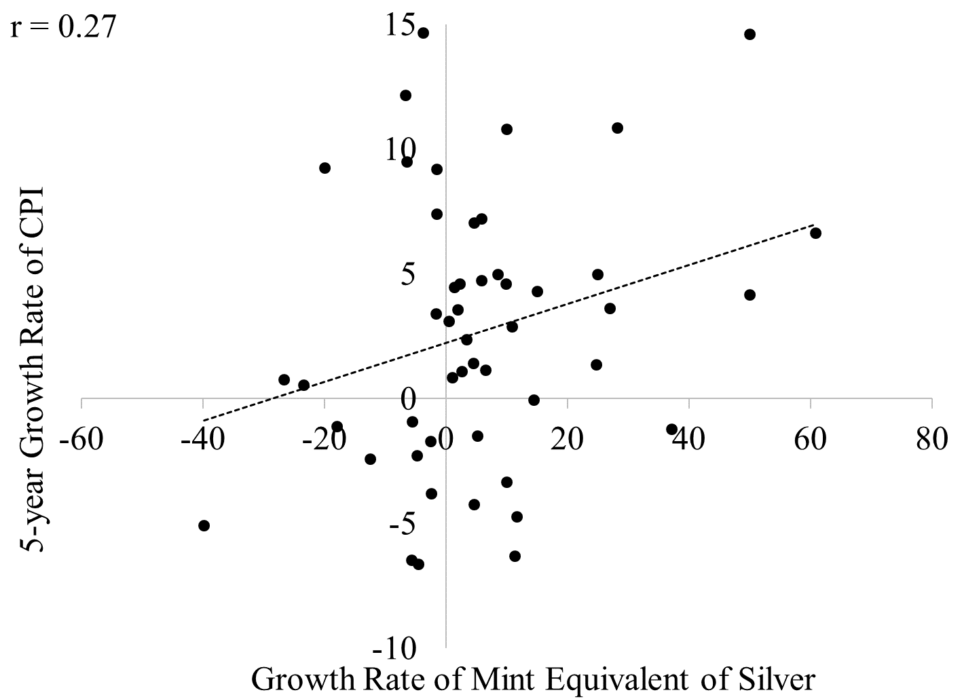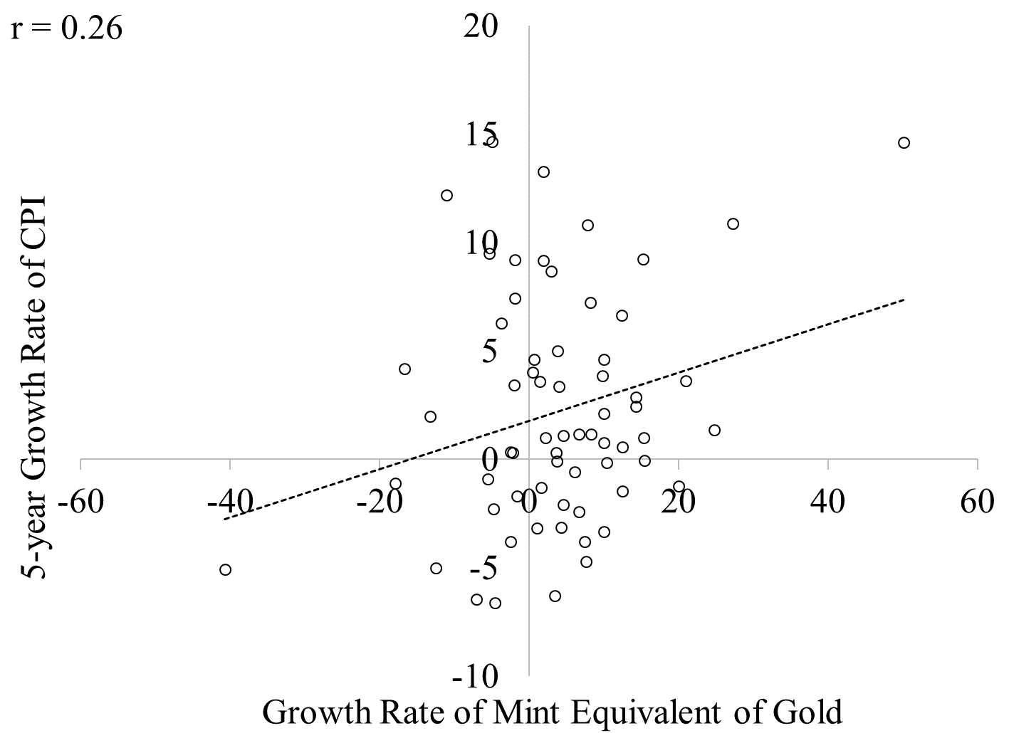

England
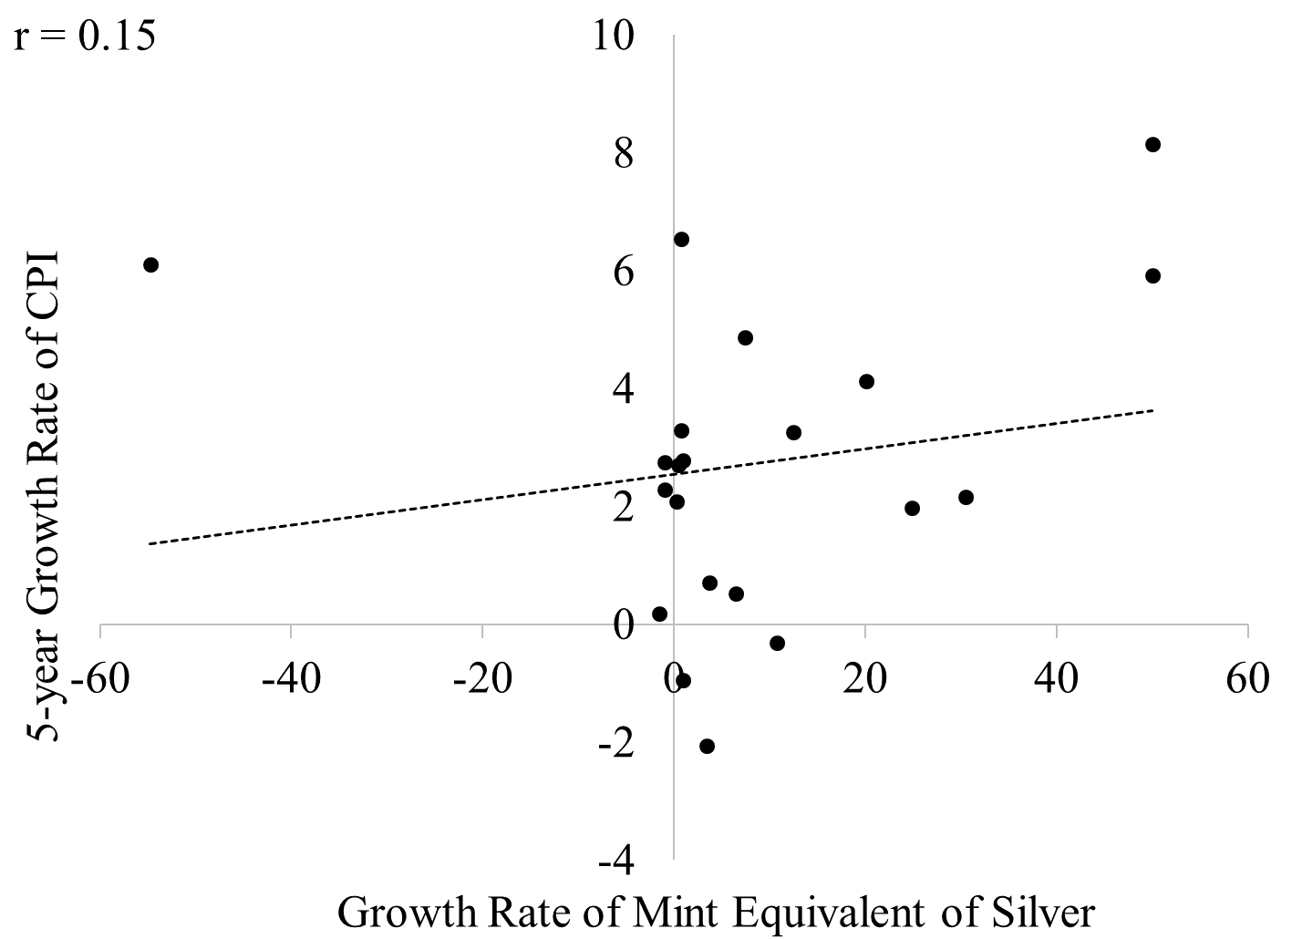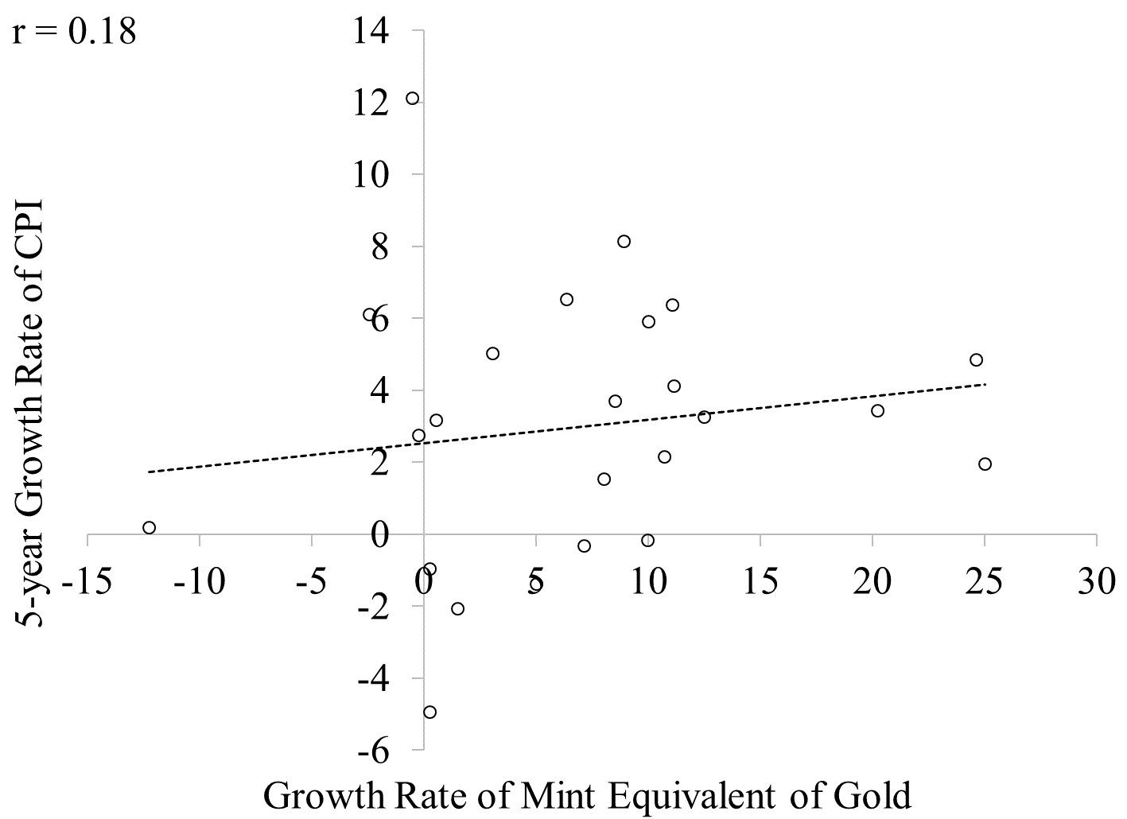
Figure 1. Impact of Depreciation and Appreciation on CPI in England and France, Percent (1265-1816 for England, 1431-1790 for France)

Sources: Redish (2000), Jastram (1981), Officer and Williamson ('The Price of Gold, 1257-present,' MeasuringWorth, 2018), Robert Allen’s Research Pages (CPI of London and Paris: https://www.nuffield.ox.ac.uk/people/sites/allen-research-pages/ )
Note: Growth rate of CPI is averaged over 5 years if a change in the mint equivalent occurred.

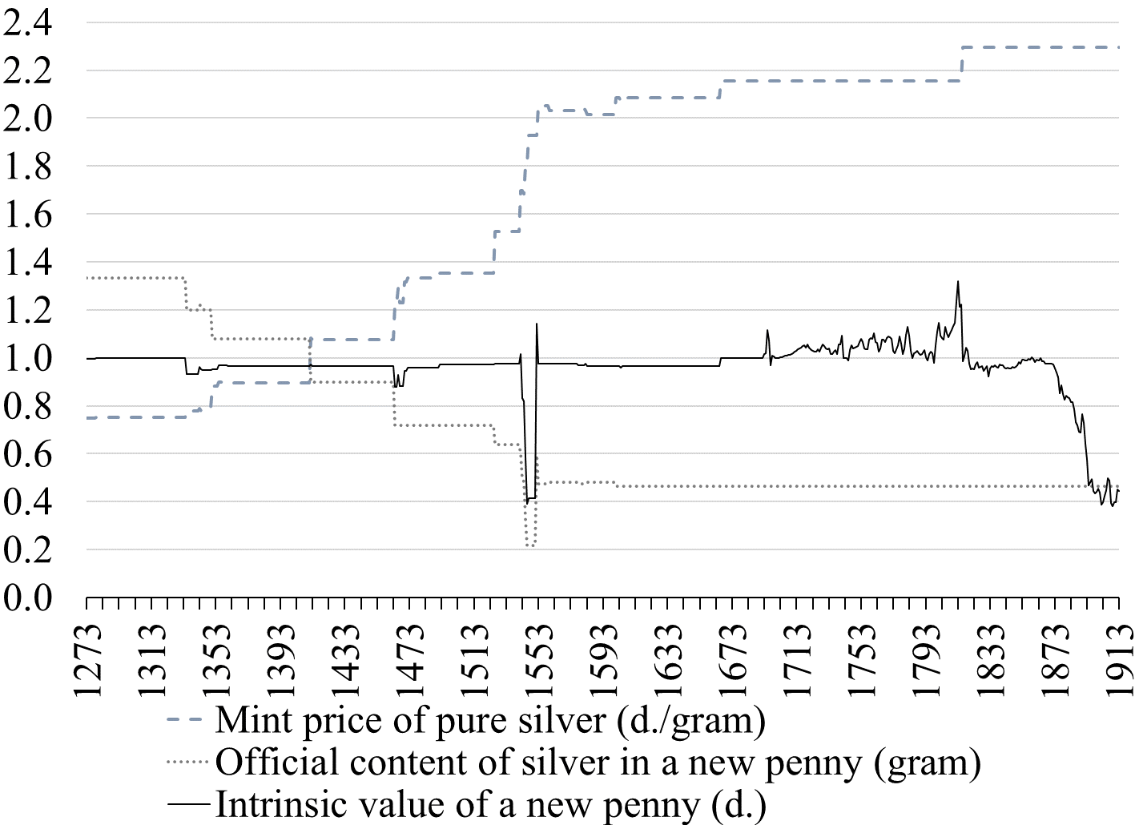
Figure 2. The sterling silver penny, 1273-1913.
Sources: Bolton (2012), Redish (2000), Jastram (1981), author’s calculations for intrinsic value.
Note: The mint price of silver is used from 1273-1692 to calculate the intrinsic value, the market price is used from 1693 when available.

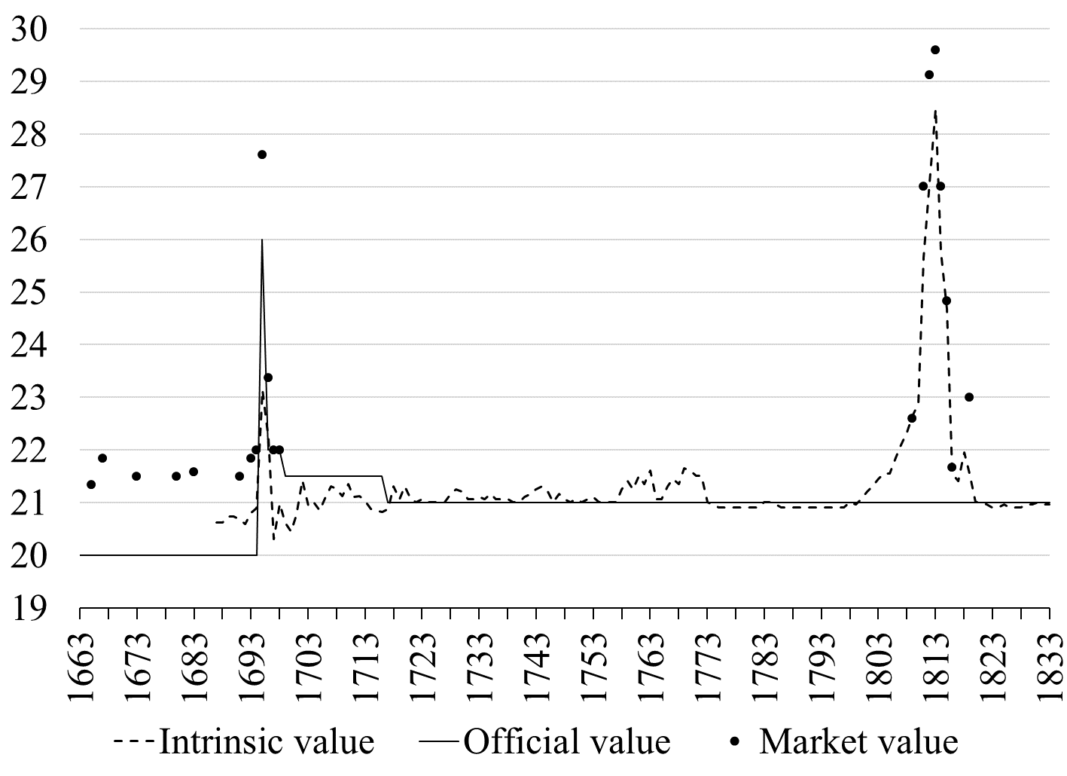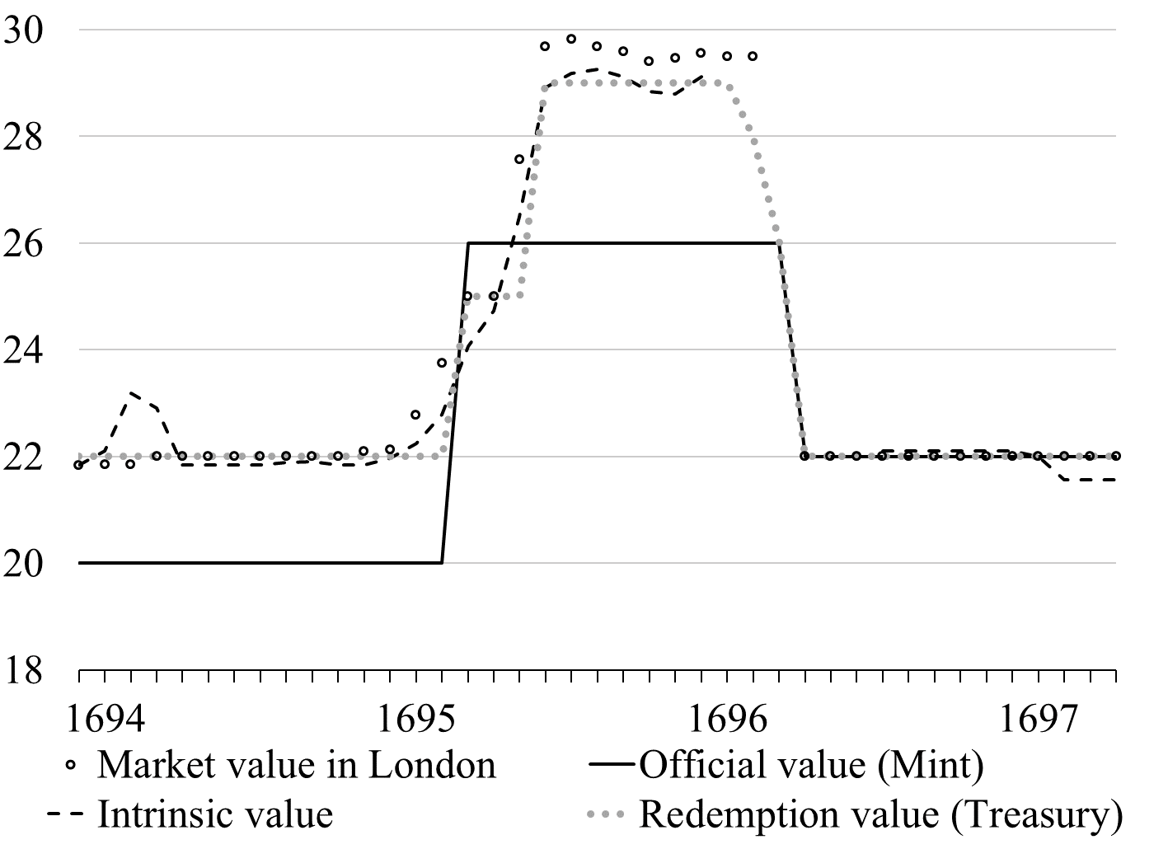
Figure 3. Values of the guinea coin, 1663 to 1833 and December 1693 to April 1697 (Shillings)
Sources: Li (1963), Cobbett’s Political Register, Redish (2000), Jastram (1981, 2009), Officer and Williamson ('The Price of Gold, 1257-present,' MeasuringWorth, 2018), Horsefield (1960), Stride (1955), Rogers (1866).
Note: Data about the market value outside the 1693-1697 period are scattered over many sources and usually limited to one random month of the year. Weekly market values are available for the 1693-1697 period (data unavailable for intrinsic value between January 1696 and June 1696 and for market value in March 1696).

Given the crude production methods of coins, instead of specifying the official weight of a coin medieval mints specified the quantity of coins to produce out of a standard weight of metal (e.g. a Troy pound that weighs approximately 373 grams) and let the weight of each coin vary slightly (Munro 2014). The mint equivalent is the official monetary value of the coins produced out of a standard weight of metal (Redish 2000). The mint equivalent can be calculated by using the official fineness (e.g., Sterling silver is 0.925 fine, Crown gold is 0.9167 fine) or pure metal. A higher mint equivalent (i.e. a depreciation of the coinage) comes from enhancement (higher official value) and/or debasement (lower weight and/or lower fineness of precious metal).
Precise scales were expensive and minting was imprecise so metal content was checked by assaying coins in bulk. In the 12th century, 240 pennies (the mint equivalent prevailing at the time) were melted into an ingot that was weighed against a Tower pound of standard silver (about 350 grams of sterling silver). Fineness could also be tested by using a touchstone but medieval touchstones could not detect decline in fineness of less than 5 to 10 percent (Munro 2014); their accuracy improved to 1 percent by the 19th century (Redish 2000).

