Secular Stagnation and the Age of Ultra Low Interest Rates
By Eric Tymoigne
Associate professor of economics at Lewis & Clark College in Portland, Ore.

Post 2007, bond bears trumpeted the doom of US Treasuries. Quantiative easing would lead to higher inflation, large fiscal deficits would take scarce saving away from investors, and the downgrading of the US public debt would make financial market participants more wary of the US government’s ability and willingness to service its debt. The combined effects of the three channels were supposed to generate a rapid rise in interest rates. Instead, under the guidance of monetary policy, interest rates fell. Long-term rates fell almost continuously and went negative to reach record low levels in August 2019. The market value of investment-grade bonds that traded at a negative yield in the United States was $17 trillion (about 30% of the total market value) and almost 70% of euro government bonds did the same. Even some European junk bonds started to trade at a negative yield in the middle of 2019. Short-term rates, that follow closely the prevailing the fed funds rate, rose in the second part of the 2010s as the Fed tightened its policy, before falling again the late 2010s.
The trend of declining interest rates is not new and low interest rates are likely to persist for a decade or more. While the COVID-19 pandemic has reversed the negative yield trend on long-term rates, the economic environment that has produced ultra-low interest rates is still present. Rising income and wealth inequalities, slow jobless recoveries, low inflation and long-term trends toward a shrinking population in developed economies point toward the persistence of a low-growth, low-interest-rates economic environment. Unless economic policies are put in place to reverse the stagnationist trends, central banks will have limited willingness and ability to raise their policy rates in any significant way and so other interest rates will tend to stay low. This has important implications for the financial stability of Money Manager Capitalism because a low-interest-rate environment is prone to promote the reliance on leverage and capital gains, aka Ponzi finance, to reach targeted rates of return. Economic stagnation also brings forward the central role governments can play to put an economy on a more sustainable and equitable growth path.
The first part of the chapter reviews the trend in interest rates over the past century and argues that monetary policy is the overwhelming determinant of this trend. Fiscal policy and credit risk are at best secondary determinants and inflation plays a role mostly through its impact on monetary policy. As such, to gain an understanding of what the future trend of interest rates will be, one must gain some insights into the underlying factors that could influence the decisions of the Federal Open Market Committee (FOMC). The second part of the paper argues that the fundamental economic trends in the economy point to a limited ability and willingness of the FOMC to raise interest rates. The third part of the paper argues that a protracted period of low interest rates and low economic growth has major negative impacts for the dynamics of Money Manager Capitalism and that the government has an important role to play to overcome such dynamics.

Interest Rates over the Past Century
Before making any prediction about the future, it is instructive to study what the past century tells us about the dynamics of interest rates. Several things are worth noticing from Figure 1. First, the downward trend in interest rates is not new. Over the past 40 years, the average rate on long-term safe debts has come down from 15% in 1981 to less than 2% in 2020. Second, interest rates on long-term safe debts are exceptionally low today; even during World War Two, such interest rates did not go below 2% on average. The last, and most important, observation is that a key driver of interest rates in the United States is monetary policy. This is actually the case in any country where the government issues its own currency and issues securities denominated in its own currency (Akram and Li 2017, Borio et al. 2017, Biefang-Frisancho Mariscal and Howells 2002, Cook and Hahn 1989, Atesoglu 2003, 2005, Roley and Sellon 1995). While operating procedures have changed overtime, monetary policy consists providing an elastic currency, which in practice means managing at least one interest rate—currently the federal funds rate (FFR) in the United States. One has to go back to the Great Depression to find a near-zero FFR. World War Two led the Fed to expand its interest-rate targeting to the entire yield curve with the rate on T-bills set at 3/8 of 1% and T-bonds purchased by the Fed at a quantity and a price consistent with the maintenance of a 2.5% yield. Following the end of the war and the 1951 Accords, monetary policy tightened and other rates followed until the early 1980s, when the FFR started its long decline to the present level. Over the past century, the relation between the FFR (taken as a proxy of US monetary policy tool for the entire period) and all other interest rates is extremely strong regardless of the term to maturity and holds through time (Figure 2).
While monetary policy plays a central role in setting the trend of interest rates, two other variables are usually emphasized when making interest-rate forecasts. The first one is the fiscal balance. The common view is that fiscal deficits push up interest rates, which crowds out private investment. A causal look at the data shows that there is no relationship between interest rates and the fiscal position of the US government. Recent theoretical and empirical work emphasize the key role played by monetary sovereignty in influencing that relation, with the relation being weak when governments are monetarily sovereign. The fiscal and monetary branches of government coordinate their operations to limit the impact of government financial operations on the payment system (Sharpe 2013, Tymoigne 2020).
Besides the fiscal balance, another often-cited variable that is supposed to influence interest rates is inflation. The relation is explained by the influential work of Irving Fisher (1930). Many empirical studies, including Fisher’s, have shown that the Fisher effect does not hold. Cooray (2002) provides a review of the empirical literature and additional references can be found in Stock and Watson (2003), Ghazali and Ramlee (2003), Koustas and Serletis (1999), Sargent (1976), and Haliassos and Tobin (1990). Figure 3 shows that, in the US, there is no relation between inflation measured by the CPI and interest rates, whatever the maturity, until the mid 1950s. After that period, interest rates are more closely related to inflation. Friedman and Schwartz (1976) and Summers (1983) argue that, perhaps, financial-market participants have “learned their Fisher.” Tymoigne (2006) provides a different explanation of the break in the relationship between interest rates and inflation. The break in the date can be explained by the change in monetary policy following the Treasury Accord of 1951 (Figure 4). By 1953, the Fed had freed itself completely from any commitment to ensure the perfect liquidity of Treasuries (Beard 1964). Following this operational change, and given the growing concerns about inflation and the spread of Monetarism in policy circles, the central bank oriented its policy toward managing inflation. As a consequence, the policy rate became correlated with the growth rate of the consumer-price index and so did other rates. The higher coefficient of correlations after 1953 do not reflect the fact that financial market participants suddenly became more preoccupied with inflation, rather they reflect the continuity of interest-rate dynamics based on the dominance of monetary-policy decisions.
Credit risk and other spread-influencing factors create variations around the trend of interest rates but are not key determinant of the trend. An important distinction to make to understand the role of credit ratings in influencing rates is between government securities and non-government securities. With monetary sovereignty, there is no difficulty to service the public debt denominated in the domestic currency, and default is a remote possibility in normal times. Cantor and Parker (1995) provide some examples of such defaults and note that “domestic currency defaults have usually been the result of an overthrow of an old political order—as in Russia and Vietnam—or the byproduct of dramatic economic adjustment programs aimed at curbing hyperinflation—as in Argentina and Brazil” (Ibid, 3). Involuntary defaults have occurred also for technical reasons. For example, Venezuela is counted as having defaulted because “the person who was supposed to sign the checks was unavailable at the time” (Cantor et al. 2008, 17). The U.S. also defaulted in 1979 due to “unanticipated failure of word processing equipment used to prepare check schedules” (Zivney and Marcus 1989). Thus, while there have been a few cases of default on the domestic-denominated public debt by monetary sovereign governments, in normal times they are benign. For analytical purposes, one can assume that the probability of default on such government securities is zero; a credit rating is irrelevant. If such a rating exists, it has no predictive power and has no influence on the interest rates of domestic-currency-denominated public debt when monetary sovereignty prevails. Thus, credit ratings have a role only in so far as they influence the interest rates on debts issued by entities that are non-monetarily sovereign, or on foreign debts issued by monetarily-sovereign governments, but such influence is secondary relative to the role of monetary policy.
Finally, contrary to credit rating agencies (CRAs) (e.g., Standard and Poor’s 2007), such default risk must be clearly differentiated from inflation risk for three reasons. First, a government usually does not promise a constant purchasing power on upcoming public debt service payments so it is not defaulting if the currency’s purchasing power falls. Equally, government security holders are not required to compensate a government for any windfall loss of purchasing power due to deflation. Nominalism applies in the law so governments are under no obligation to provide a hedge against inflation; bondholders take upon themselves the inflation risk. Governments may promise to do so via inflation-indexed securities—in which case failure to maintain purchasing power is a default event—but they do not have to do it and usually do not. Second, CRAs see tax revenues as the sound means to service the public debt but inflation raises tax revenues and so raises the ability to service the debt, which lowers the default risk. Third, the CRA view of default risk implicitly assumes that the government is responsible for inflation. Not only is there no clear link between fiscal deficits and inflation (Figure 5), but also all forms of spending can be inflationary and there are other sources of inflation than spending (such as energy cost, medical cost, overhead corporate cost structure, among others).
FIGURE 1 HERE
FIGURE 2 HERE
FIGURE 3 HERE
FIGURE 4 HERE
FIGURE 5 HERE
Given the tremendous influence of current and expected monetary policy on interest rates, any opinion about the future direction of interest rates must be made with a view of future monetary policy. One must study what could lead the Federal Open Market Committee (FOMC) to raise its FFR target. The mandate of the Fed is to promote price stability (defined as inflation around 2% ) and maximum employment (defined as employment consistent with price stability). The FOMC informs its decisions by looking at a wide range of indicators including labor market conditions, inflation and inflation expectations. Short-term and long-term outlooks for these factors are pointing to interest rates that will stay low for an extended time. While the FOMC may decide to raise its FFR temporarily, the long-term trend is for the FFR and other rates to remain very low for a very long time.
The following section argues that short-term and long-term economic forces indicate that the FOMC will have limited ability to raise rates in any significant fashion.

Secular Stagnation and Interest Rates
In 2020, loss of consumer confidence and lockdowns depressed economic activity throughout the world. While the economy has been recovering in some parts of the world, the global economy is still in recovery mode. Table 1 shows that real gross domestic product (GDP) In the United States fell by 9% in the second quarter of 2020 compared to the same quarter in 2019. Labor market conditions worsened significantly in the second quarter 2020 when the official unemployment rose steeply to 13.1%, and the employment-population ratio fell in April to its lowest level ever recorded, 51.3% of the civilian population available for work actually employed. Similarly, the capacity utilization rate fell to 65.6%, its lowest level ever recorded since data became available. The sharp drop in economic activity, driven by a large decline in private domestic consumption, led to a sharp decline in core inflation, well below the implicit 2% inflation target of the Fed. While the economy has recovered somewhat since the middle of 2020, millions of jobs lost to the pandemic have yet to be recovered. Given the worsening economic situation and the slow recovery, it is easy to understand why the FFR has fallen sharply and has stayed low, with short-term rates matching the same trend. However, long-term rates also fell sharply, reflecting expectations among market participants that the FFR will stay low in the upcoming years.
TABLE 1 HERE
While Covid-19 related economic events explain the short to medium-term interest rate dynamics, Figure 1 points to a long-term downward trend. This trend is explained by structural changes that have led to a slower and more unstable U.S. economy. Decline in the tax burden on the wealthier households, deregulation and lax enforcement, financialization and globalization of the economy and the decline in labor protections have destroyed shared prosperity. They have also led to jobless recoveries, lowered inflationary pressures and limited capital investment in the economy. As a consequence, a growing majority of households is not enjoying the fruits of an economic prosperity that has weakened overtime. Given this stagnationist trend, one may expect interest rates to stay low over the upcoming decade and beyond (Table 2).
TABLE 2 HERE
The annual growth rate of real gross national product per capita has slowed to 2% percent or less since the 1990s. At the same time, income and wealth inequalities have soared with the top 1% of the population recording a large increase in their share of income and wealth to the detriment of the rest of the population. In terms of income, the top 1% share grew from about 12% of national income in the late 1960s to about 20% of national income in the 2010s. This gain came entirely from a loss of income share of the bottom 50% of the U.S. income earners (Figure 6). While the benefits of economic expansion used to be relatively broadly shared, since the 1980s, national income gains have gone almost entirely to the top 10%. During the last economic expansion (June 2009 to February 2020), 76.9% of the national income gain went to the top 10% of income earners. In terms of wealth share, given that the bottom 50% of the U.S. population has little to no wealth, all the transfer of wealth share to the top 1% came from the 49% of the population below them. The top 1% share of wealth almost doubled from 21% in the mid-1970s to 37% of national wealth in 2016 according to the World Inequality Database.
FIGURE 6 HERE
The main effect of such a lack of shared prosperity has been the disappearance of a middle class that can earn sufficient income to sustain its consumption and home purchases, both of which are key drivers of U.S. economic growth. More broadly, low and middle class households have used debts and their savings, if any, to sustain their housing, education, casual consumption and health needs, among others. This has led to a very rapid increase in the debt-to-income ratio of the bottom 50% and middle 40% of income earners (Batsher et al. 2020). Instead of income growth, debt growth and asset-price growth have become key means to sustain economic activity, which has promoted financial instability over the past half-century. (Tymoigne and Wray 2014)
Related to growing inequalities, another factor that has led to stagnation is the growing joblessness of economic expansion over the past 40 years. Prior to the 1980s, it took less than two years to recover the jobs lost during a recession, but the past four expansions required more than two years. The jobs lost during the minor 2001 recession were regained after four years. The job losses of the Great Recession took six years to be eliminated. One has to go back to the Great Depression to see a longer period of recovery. Not only has it taken more time to recover from recessions, but also job precariousness has grown with job quality falling constantly since data became available in 1991. Jobs have become more insecure, more intermittent and have not provided the same salary and benefits as they used to.
Finally, there has been a marked decline in the growth rate of investment. This is true not only for business investment but also for public infrastructure investment. On the business investment side, profits have grown rapidly but investment growth has slowed, and a growing proportion of profit has come from financial income (Tori and Onaran 2017). On the infrastructure side, public investment has not kept up with the needs of the economy, and maintenance has been poor, leading to low quality infrastructure in the United States. The Infrastructure Report Card published by the American Society of Civil Engineers has consistently graded U.S. infrastructure around “D” for the past three decades, which has generated millions of job losses and thousands of dollars of income loss for U.S. households (American Society of Civil Engineers 2016).
Unless major changes in economic policy occur to counter the previous trends, the economy will continue to record low growth, low-inflation, growing inequalities and growing precariousness of employment for the upcoming decades. All these elements give less of an incentive to the FOMC to raise significantly its policy rate quickly. They also point toward a more unstable economy, which gives less ability to the FOMC to raise interest rates quickly without generating financial instability. While the FOMC may start raising its FFR target, it will not be able to do it quickly and permanently. Thus, unless there is a dramatic shift in the way the U.S. economy is managed, the default expectation of market participants should be that interest rates continue to stay low for the upcoming decade and more. A low-growth highly-leveraged economy can only accommodate so much in terms of interest rate hikes.

Implications
Secular stagnation and its impact on interest rates have important implications for the sustainability of our current form of capitalism—one that is heavily reliant on finance and money managers—and for the role of government in such an economic environment. Declining and low interest rates promote financial instability by forcing money managers to rely on, and spread the use of, Ponzi finance. Secular stagnation restores the importance of government in taking a lead to solve our pressing socio-economic problems and sustaining and raising economic growth.
While a low-interest-rate environment makes debt servicing easier, it creates challenges for money managers (pension funds, mutual funds and others) to meet their target rate of return on equity target. The rate of return on equity (ROE) can be split into two components, the rate of return on asset (ROA) and the leverage ratio:
Net Income/Equity = Net Income/Assets* Asset/Equity
In a world with low interest rates, ROA on financial assets is depressed for any given level of risk on assets. To offset that, money managers can buy securities that pay a higher interest rate, which means buying riskier financial assets. As the 2008 financial crisis showed, the riskiness may not be captured properly by credit ratings. Pension funds bought exotic investment-grade securities that promised higher ROA than traditional corporate bonds with similar ratings. They were able and willing to do because the rating did not account for the embedded leverage and poor quality of the assets underlying the securitization process upon with the exotic securities were based. The demand for such exotic securities in turn fueled the mortgage and securitization boom of the first part of the 2000s, with bankers pushing existing homeowners to refinance into exotic mortgages and pushing people with no income, no job and no assets to buy a home. The entire scheme could only be sustained by capital gains from home foreclosures, a giant Ponzi scheme predicated on the failure of homeowners to make their mortgage payments (Tymoigne and Wray 2014). The other way to boost ROE is to use more leverage in the financing of the acquisition of assets and, as shown in Figure 7, a very sharp increase in the use of debt within the financial sector. However, a large part of this leverage is hidden through the use of derivative and special purpose entities that promote the layering of debts.
FIGURE 7 HERE
By focusing on riskier segments of the credit market and/or using more leverage in their financial strategies, money managers have promoted the use of leverage in the rest of the economy, increased systemic financial fragility and ultimately generating financial instability. As such, it seems doubtful that a private-based retirement system, a core component of money manager capitalism, is a sustainable means to achieve financial safety for retirees while at the same time promoting financial stability for the overall economy. This is all the more so that financial investment opportunities based on long-term income growth are far fewer than the funds available to portfolio managers. A stable, low-key and reliable financial means to buy the basic retirement necessities (food, shelter, and healthcare) can be achieved through a public retirement system. This, however, only deals with one part of the problem of an aging society, the other part is to make sure that the economic system provisions itself while the population is aging. Fortunately, the economic adjustments required on the production side are manageable (Wray 2006).
Government can also play a major role in countering the destabilizing and stagnationist impact of investment-led growth. Domar (1946) extends Keynes’s static approach to the problem of economic growth and shows that investment-led growth is unsustainable because the level of net investment grows productive capacity while aggregate demand only grows by a multiple of the change in investment. Minsky complements Domar by showing that the achievement of financially sustainable long-term full employment and price stability cannot be based on promoting the growth of private investment (through tax breaks, subsidies to private business, among others). Minsky also notes that the emphasis on investment creates inflationary pressures and income inequality (Minsky 1973, 1981, 1986). Steindl (1979), Walker and Vatter (1989) and Vatter et al. (1995) build on Harrod’s, Domar’s and Minsky’s analysis by showing that the main constraint on economic growth has been too low growth in aggregate demand not a too low growth in aggregate supply (Wray 2008). They conclude that the government has a crucial role government to play, not only in stabilizing the economy, but also in putting it onto a higher growth path.
The mistaken emphasis upon physical capital· accumulation reveals […] a defect in the ruling growth models to which we have called attention: they are essentially laissez faire constructs. Acknowledgement of the long-established presence of big government is considered ancillary to long-run growth analysis. Government is allowed to intrude mainly and merely into such matters as subsidization of sectors, regulation, research, and education of the labor force. Big government as the decisive, dynamic, autonomous source of demand growth, historically coming to replace private fixed investment is, like the demand side in general, omitted from the usual model. (Walker and Vatter 1989, 344-345)
Contrary to the loanable funds approach (in which government competes for resources with private investors) and the efficient market framework (in which government intervention leads to misallocations and stifle innovations), government spending has been a necessary complementary component to economic growth and innovation. A big government and a big bank are complementary elements, not the antithesis, of a market economy (Minsky 1993).
In terms of stabilizing the economy, there has been a sharp change in the behavior of developed capitalist economies in the 20th century. The larger involvement of national governments in the economy has considerably reduced the volatility of economic growth (Taylor et al. 2012; Hein 2018; Tymoigne 2008). In the United States, following the 1930s, the economy has recorded fewer contractions; contractions have been much milder, much less lengthy, and less frequent. This is explained by the beneficial income, cash flow and portfolio effects of fiscal deficits (Minsky 1986). Fiscal deficits sustain private incomes by injecting more money in the economy than they remove through taxes, which in turn stablizes private investment by stabilizing aggregate demand. Expected sales, not interest rates, are the main driver of business investment and fiscal deficits stablize sales while having a negligible impact on the cost of credit. Fiscal deficits also lead to the injection of safe financial assets in private balance sheets, which improves their liquidity and solvency. In terms of the trend of economic growth, the US economy has been growing below potential since 1910 and, throughout the 20th century, it would have been possible to sustain a 4% growth rate by relying on growing government spending instead of trying to stimulate private domestic investment back to its pre-1910 growth rate (Vatter et al. 1995).
Overall, these authors note that economic growth and economic development is demand-led, a definite feature of Post Keynesian economics (Lavoie 2014), with government playing a big role in sustaining growth. This does not mean that government spending can grow by an unlimited percentage but rather that productive capacities, especially labor, are usually flexible enough to respond quickly, and ultimately adapt, to the requirement of growing expenditures. While this has been well understood in the Keynesian literature, both heterodox and mainstream (hysteresis effect), it rarely enters policymaking discussions except when facts stubbornly show that the economy can operate far beyond what is at the time considered full employment. For example, Greenspan noted in 1999, after years when the unemployment rate fell below the NAIRU and inflation did not accelerate much to the dismay of other FOMC members (prompting estimates of NAIRU to be revised down), that:
Let me just say very simply – this is really a repetition of what I’ve been saying in the past – that we have all been brought up to a greater or lesser extent on the presumption that the supply side is a very stable force. […] In my judgment our models fail to account appropriately for the interaction between the supply side and the demand side largely because historically it has not been necessary for them to do so. (Greenspan, FOMC meeting minutes, October 1999, pages 46–47)
The inability, or unwillingness, of policymakers to recognize the positive feedback between aggregate demand and productive capacity leads them to be too cautious, by raising interest rates prematurily and/or by conceptualizing government spending merely as a quick temporary recession fighting tool, with the result of lowering the growth path of the economy. Instead of tightening immediately as inflation rises (or even in anticipation of expected inflation), policymakers should give time to productive capacities to adapt to the growth of demand (Fontana and Palacio-Vera 2007).
There is today ample role for governments to tackle several major challenges of developed economies; their population is aging, trillions of dollars of infrastructure upgrade and expansion are needed (American Society of Civil Engineers 2021) and climate change is the major socio-economic threat. Climate change requires—in addition to a major environmental policy oriented toward restoration and conservation—an aggressive, radical and thorough transformation of our energy system centered on keeping fossil fuels in the ground starting today (Figure 8):
If we are to have a fighting chance of reaching net zero by 2050 and limiting the rise in global temperatures to 1.5 °C […] our Roadmap shows that there are still pathways to reach net zero by 2050. The […] most technically feasible, cost‐effective and socially acceptable [pathway] […] requires vast amounts of investment, innovation, skilful policy design and implementation, technology deployment, infrastructure building, international co‐operation and efforts across many other areas […] The energy sector is the source of around three‐quarters of greenhouse gas emissions today and holds the key to averting the worst effects of climate change, perhaps the greatest challenge humankind has faced. […] This calls for nothing less than a complete transformation of how we produce, transport and consume energy. […] The global pathway to net‐zero emissions by 2050 […] requires all governments to significantly strengthen and then successfully implement their energy and climate policies. […]. Major innovation efforts must occur over this decade in order to bring these new technologies to market in time. […] Clean energy innovation must accelerate rapidly, with governments putting R&D, demonstration and deployment at the core of energy and climate policy. Government R&D spending needs to be increased and reprioritised. […] There is no need for investment in new fossil fuel supply in our net zero pathway. Beyond projects already committed as of 2021, there are no new oil and gas fields approved for development in our pathway, and no new coal mines or mine extensions are required. (International Energy Agency 2021)
This sort of drastic shift in economic structure, similar to what happened during World War Two, is manageable but can only be done under the stewardship of governments. Governments, throughout the developed world especially, need to mobilize their domestic resources if a rapid transition to clean energy is to occur. Governments will be needed to meet these challenges at all levels of the economy, from research and development, to the transition from invention to innovation, to the spread of new technology in the economy by creating and promoting markets, which is something governments have done on a routine basis for many decades (Mazzucato 1995). Through such a policy, governments will help create many jobs, retrain the labor force, and put economies on a more ecologically sustainable growth path.
These increases in government spending may lead to higher fiscal deficits relative to the size of the U.S. economy. The tendency toward higher deficits, however, will be mitigated by the boost to economy growth that will raise tax revenues. In any case, a rapid increase in the domestic-currency public debt will not only promote financial stability but also be sustainable as long as interest rates on the public debt stay low relative to the growth rate of the economy. Some market participants may wonder about the impact of a higher public debt on interest rates. As explained above, for economies that are monetarily sovereign such as Japan, the United Kingdom and the United States, there’s no significant relation between the size of government deficits (or public debt) and interest rates. As usual, central banks, not bond vigilantes, will play a major role in accommodating fiscal needs by keeping interest rates low enough to make the public debt sustainable (Fullwiler 2020, Tymoigne 2020).
FIGURE 8 HERE

References
Akram, T. and Li, H. (2020) “An inquiry concerning long-term U.S. interest rates using monthly data,” Applied Economics, 52 (24): 2594-2621.
American Society of Civil Engineers (2016) Failure to Act: Closing the Infrastructure Investment Gap for America’s Economic Future. Boston: Economic Development Research Group.
American Society of Civil Engineers (2021) 2021 Insfrastructure Report Card. Reston, VA: American Society of Civil Engineers.
Atesoglu, H.S. (2003) “Monetary transmission—federal funds rate and prime rate,” Journal of Post Keynesian Economics, 26 (2): 357-362.
Atesoglu, H.S. 2005) “Monetary policy and long-term interest rates,” Journal of Post Keynesian Economics, 27 (3): 533-539.
Batsher, A.K, Kuhn, K., Schularick, M. and Steins U.I. (2020) “Modigliani Meets Minsky: Inequality, Debt, and Financial Fragility in America, 1950-2016,” New York Federal Reserve Bank, Staff Report No. 924.
Beard, T.R. (1964) “Debt management: Its relationship to monetary policy, 1951-1962,” National Banking Review, 2 (September): 61-76; reprinted in H.A. Wolf and R.C. Doenges (eds) (1968) Readings in Money and Banking, 367-384, New York: Appleton-Century-Croft.
Biefang-Frisancho Mariscal, I. and Howells, P. (2002) “Central banks and market interest rates,” Journal of Post Keynesian Economics, 24 (4): 569-585.
Borio, C, Disyatat, P., Juselius, M.I., and Rungcharoenkitkul , P. (2017) “Why so low for so long? A long-term view of real interest rates” BIS Working Paper, No. 685. Available at https://www.bis.org/publ/work685.pdf
Cantor, R., Emery, K., Duggar, E. and Cailleteau, P. 2008. “Sovereign Default and Recovery Rates, 1983-2007.” Moody’s Global Credit Research, March.
Cantor, R. and Parker, F. (1995) “Sovereign Credit Ratings,” Federal Reserve Bank of New York Current Issues in Economics and Finance, 1 (3): 1-6.
Cook, T. and Hahn, T. (1989) “The effect of changes in the federal funds rate target on market interest rates in the 1970s,” Journal of Monetary Economics, 24 (3): 331-351.
Cooray, A. (2002) “The Fisher effect: A review of the literature,” Macquarie University-Sidney, Department of Economics, Research Paper No. 6/2002.
Domar, E. (1946) “Capital expansion, rate of growth, and unemployment,” Econometrica, 14 (2): 137-147.
Fisher, I. (1930) The Theory of Interest, New York: Macmillan.
Fontana, G. and Palacio-Vera, A. (2007) “Are long-run price stability and short-run output stabilization all that monetary policy can aim for?,” Metroeconomica, 58 (2): 269-298.
Friedman, M. and Schwartz, A.J. (1976) “From Gibson to Fisher,” Exploration in Economics, 3 (2): 288-291.
Fullwiler, S.T. (2020) “When the Interest Rate on the National Debt Is a Policy Variable (and ‘Printing Money’ Does Not Apply).” Public Budgeting and Finance, 40 (3): 72-94
Ghazali, N.A. and Ramlee, S. (2003) “A long memory test of the long-run fisher effect in the G7 countries,” Applied Financial Economics, 13 (10): 763-769.
Haliassos, M. and Tobin, J. (1990) “The macroeconomics of government finance,” in B.M. Friedman and F.H. Hahn (eds) Handbook of Monetary Economics, vol. 2, 889-959, Amsterdam: North-Holland.
Hein, E. (2018) “Autonomous Government Expenditure Growth, Deficits, Debt, and Distribution in a Neo-kaleckian Growth Model.” Journal of Post Keynesian Economics, 41 (2): 316-338.
International Energy Agency (2021) Net Zero by 2050: A Roadmap for the Global Energy Sector. Paris: International Energy Agency
Koustas, Z. and Serletis, A. (1999) “On the Fisher effect,” Journal of Monetary Economics, 44 (1): 105-130.
Lavoie, M. (2014) Post Keynesian Economics: New Foundations. Northampton: Edward Elgar.
Mazzucato, M. (2015) The Entrepreneurial State: Debunking Public vs. Private Sector Myths. New York: PublicAffairs.
Meulendyke, A.-M. (1998) U.S. Monetary Policy and Financial Markets, New York: Federal Reserve Bank of New York.
Minsky, H.P. (1973) “The strategy of economic policy and income distribution,” in S. Weintraub (special ed.) The Annals: Income Inequality, 92-101, Philadelphia: American Academy of Political and Social Science
Minsky, H.P. (1981) “The breakdown of the 1960s policy synthesis,” Telos, 50 (Winter): 49-58.
Minsky, H.P. (1986) Stabilizing an Unstable Economy, New Heaven: Yale University Press.
Minsky, H.P. (1993) “On the non-neutrality of money,” Federal Reserve Bank of New York Quarterly Review, 18 (1): 77-82.
Roley, V.V. and Sellon, G.H., Jr. (1995) “Monetary policy actions and long-term interest rates,” Federal Reserve Bank of Kansas City Economic Review, 4th quarter: 73-89.
Sargent, T.J. (1976) “Interest rate and expected inflation: A selective summary of recent research,” Explorations in Economic Research, 3 (3): 303-325.
Sharpe, T.P. (2013) “A Modern Money Perspective on Financial Crowding-out.” Review of Political Economy, 25 (4): 586-606.
Standard and Poor’s (2007) Sovereign Credit Ratings: A Primer. New York: Standard and Poor’s.
Summers, L.H. (1983) “The nonadjustment of nominal interest rates: A study of the Fisher effect,” in J. Tobin (ed.) Macroeconomics, Prices, and Quantities, 201-244, Washington, DC: The Brooking Institution.
Taylor, L., Proaño Laura de Carvalho, C.R. and Barbosa, N. (2012) “Fiscal deficits, economic growth and government debt in the USA” Cambridge Journal of Economics, 36 (1): 189–204.
Tori, D. and Onaran, Ö (2017) “The effects of financialisation and financial development on investment: Evidence from firm-level data in Europe,” Greenwich Political Economy Research Center, Working Paper 44.
Tymoigne, E. (2006) Central Banking, Asset Prices and Financial Fragility. New York: Routledge
Tymoigne, E. (2010) “Minsky and Economic Policy: ‘Keynesianism’ all over again?” In Papadimitriou, D. and L.R. Wray (eds.), The Elgar Companion to Hyman P. Minsky, 47-83. Northampton: Edward Elgar.
Tymoigne, E. (2020) “Monetary Sovereignty: Nature, Implementation, Implications,” Public Budgeting and Finance, 40 (3): 49-71.
Tymoigne, E. and Wray, L.R. (2014) The Rise and Fall of Money Manager Capitalism: Minsky Half-Century from World War Two to the Great Recession. New York: Routledge.
Steindl, J. (1979) “Stagnation theory and stagnation policy,” Cambridge Journal of Economics, 3 (1): 1-14.
Walker, J.F. and Vatter, H.G. (1989), “Why has the United States Operated Below Potential Since World War II?” Journal of Post Keynesian Economics 11, 3 (1989): 327-346.
Vatter, Harold, John Walker, and Gar Alperovitz. “The Onset and Persistence of Secular Stagnation in the U.S. Economy: 1910-1990.” Journal of Economic Issues 29, 2 (1995): 591-600.
Wray, L.R. (2006) “Social Security in an aging society,” Review of Political Economy, 18 (3): 391-412.
Wray, L.R. (2008) “Demand Constraints and Big Government,” Journal of Economic Issues, 42 (1): 153-173.
Zivney, T.L. and Marcus, R.D. (1989) “The Day the United States Defaulted on Treasury Bills” Financial Review, 24 (3): 475-489

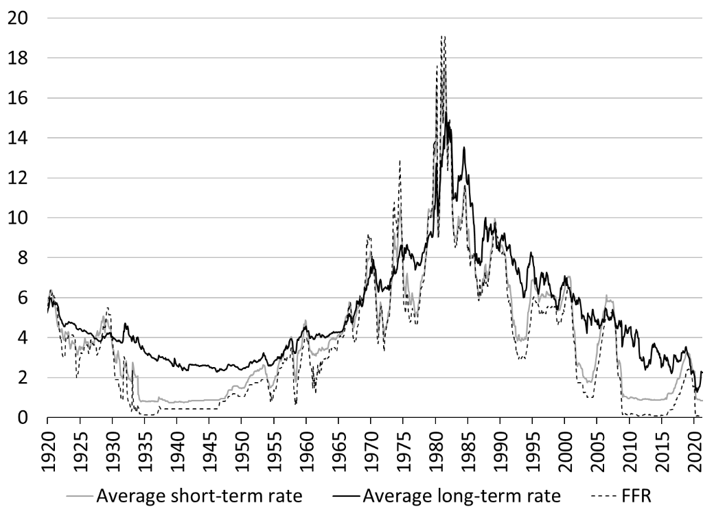
Figure 1. A century of interest rates on safe debts in the United States, percent
Sources: Board of Governors of the Federal Reserve System (series H.15), Freddie Mac, National Bureau of Economic Research
Note: The average short-term rate is composed of the rate on 3-month United States Treasury securities (UST), 1-year UST, 3-month AA commercial paper and short-term prime bank loan. The average long-term rate is composed of the rate on 10-year UST, 20-year UST, and AAA corporate bond.

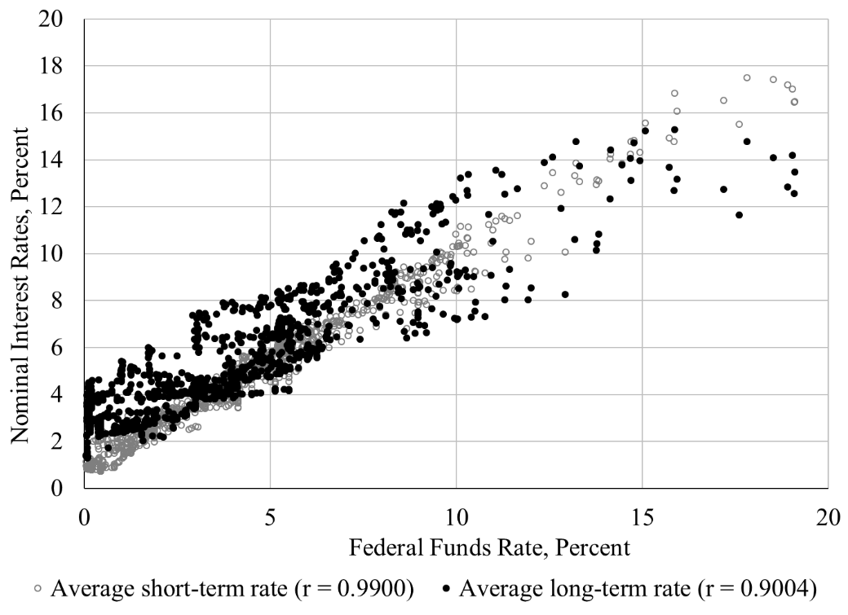
Figure 2. Monetary policy and nominal interest rates, January 1919 to June 2021
Sources: National Bureau of Economic Research (Macrohistory Database), FRED.

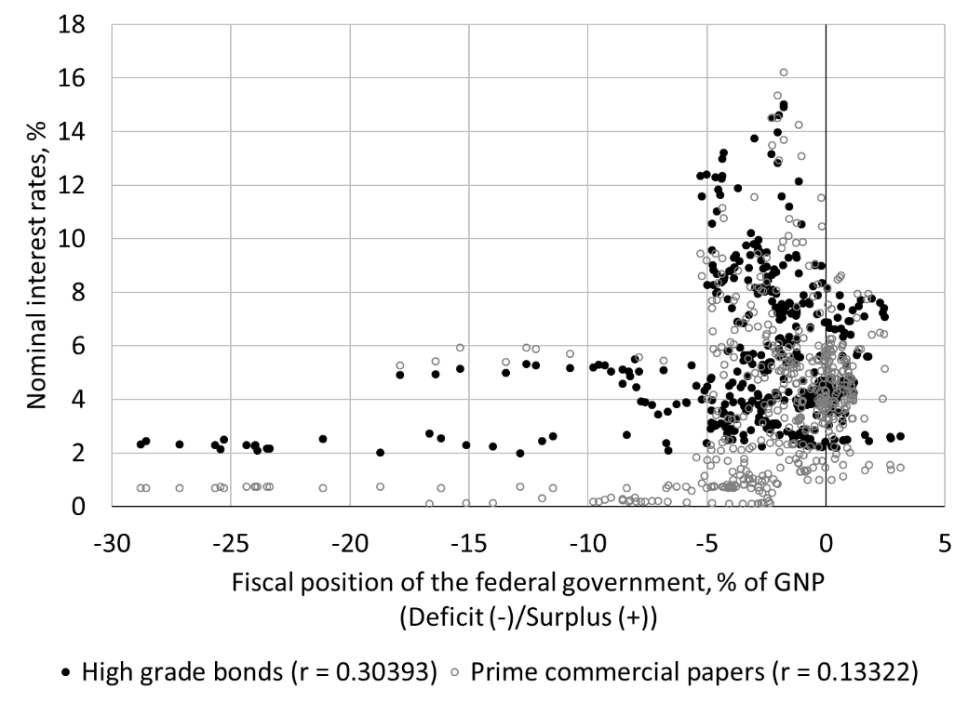
Figure 3. Fiscal Balance and Interest Rates, 1900 to 2021
National Bureau of Economic Research (Macrohistory Database, Tables from "The American Business Cycle"), Treasury Bulletin (via FRASER), FRED, Bureau of Fiscal Service (Monthly Receipts, Outlays, and Deficit or Surplus, Fiscal Years 1981-2021)

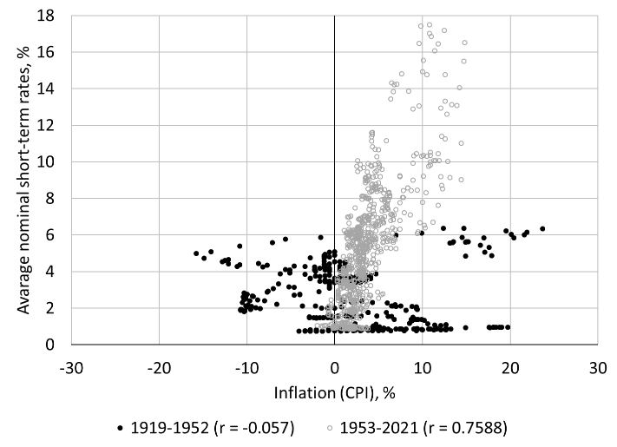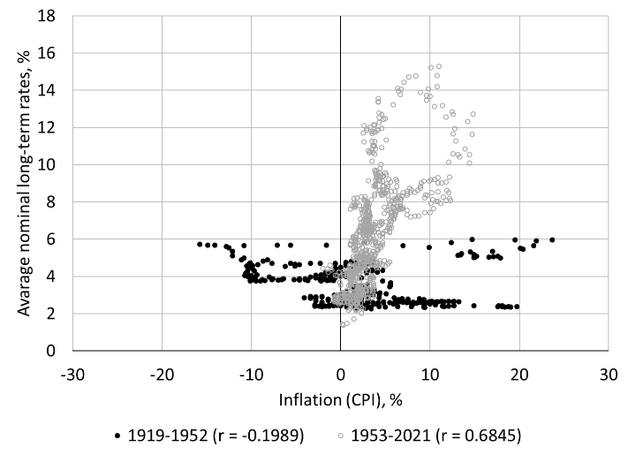
Figure 4 Inflation and interest rates, 1919 to 2021
Sources: Board of Governors of the Federal Reserve System (Series H.15), National Bureau of Economic Research (Macrohistory Database), Bureau of Labor Statistics

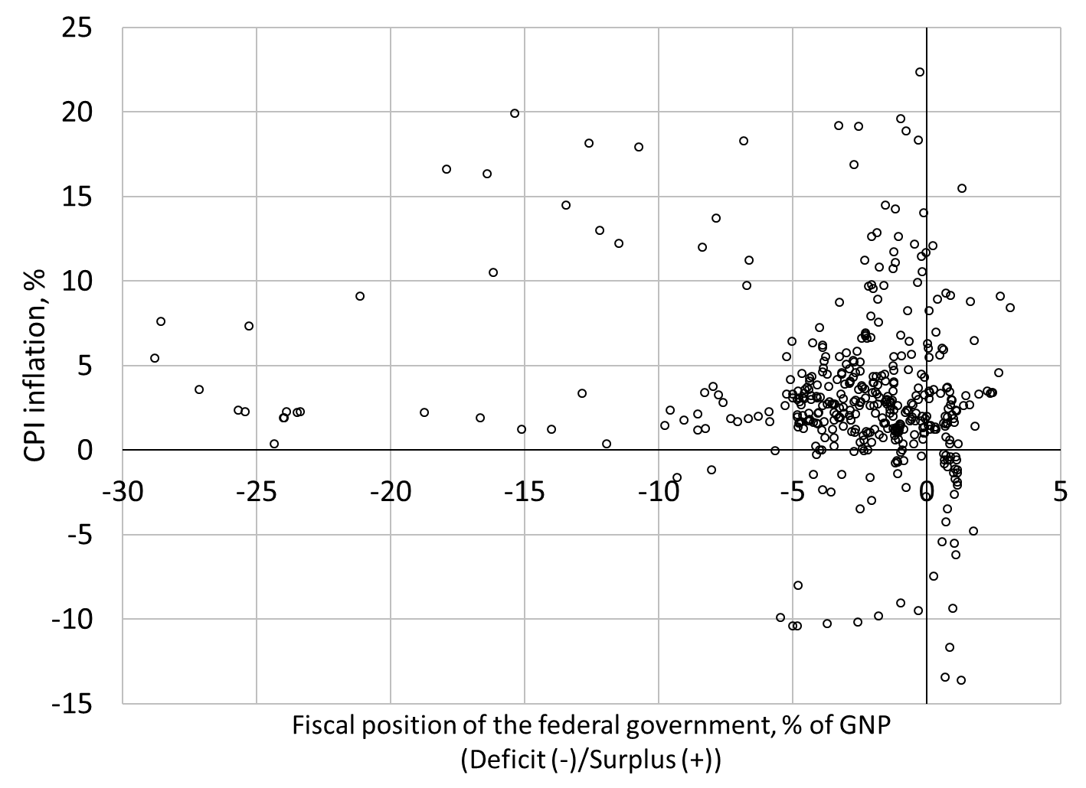
Figure 5. A century of fiscal balance and inflation, Q1 1914 to Q1 2021
Sources: See Figure 3 and Bureau of Labor Statistics.

 | 2019 |  |  |  | 2020 |  |  |  | 2021
(Percent) | Q1 | Q2 | Q3 | Q4 | Q1 | Q2 | Q3 | Q4 | Q1
Annual real GDP growth | 2.3 | 2 | 2.1 | 2.3 | 0.3 | -9.0 | -2.8 | -2.4 | 0.4
Core CPI inflation | 2.1 | 2.1 | 2.3 | 2.3 | 2.3 | 1.3 | 1.7 | 1.6 | 1.4
5-year inflation expectation | 1.8 | 1.7 | 1.5 | 1.6 | 1.4 | 0.9 | 1.2 | 1.2 | 1.3
Unemployment rate | 3.9 | 3.6 | 3.6 | 3.5 | 3.8 | 13.1 | 8.8 | 6.8 | 6.2
Employment-population ratio | 60.7 | 60.6 | 60.8 | 61.0 | 60.7 | 52.9 | 56.1 | 57.4 | 57.6
Capacity Utilization | 78.3 | 77.5 | 77.2 | 76.6 | 75.3 | 65.6 | 71.9 | 73.4 | 73.9
Table 1. Short-term economic outlook: A depressed economy
Source: Bureau of Labor Statistics, Bureau of Economic Analysis, Federal Reserve Bank of Cleveland, Board of Governors of the Federal Reserve System

Beginning of Expansion | 1954 | 1958 | 1961 | 1970 | 1975 | 1982 | 1991 | 2001 | 2009
Average Real GNP per capita growth rate (%) | 1.6 | 1.8 | 3.5 | 3.1 | 3.0 | 4.0 | 1.3 | 2.0 | 1.6
Gini index | N/A | N/A | N/A | 0.394 | 0.397 | 0.412 | 0.428 | 0.462 | 0.468
Percent of income gain going to top 10% | 27.8 | 32.3 | 32.9 | 43.0 | 45.0 | 80.0 | 73.0 | 98.3 | 76.9*
Time to recover jobs lost (months) | 23 | 18 | 20 | 18 | 19 | 28 | 32 | 47 | 76
Job quality index | N/A | N/A | N/A | N/A | N/A | N/A | 89 | 87.8 | 81.4
Table 2. Long-term economic outlook: Toward Secular Stagnation
Sources: Census Bureau, Bureau of Labor Statistics, Bureau of Economic Analysis, JQI IP Holdings LLC, and Pavlina R. Tcherneva “Reorienting Fiscal Policy: a bottom-up approach,” Journal of Post Keynesian Economics (December 2014).
*updated to 2018

Figure 6. Income shares, 1962 to 2019
Source: World Inequality Database

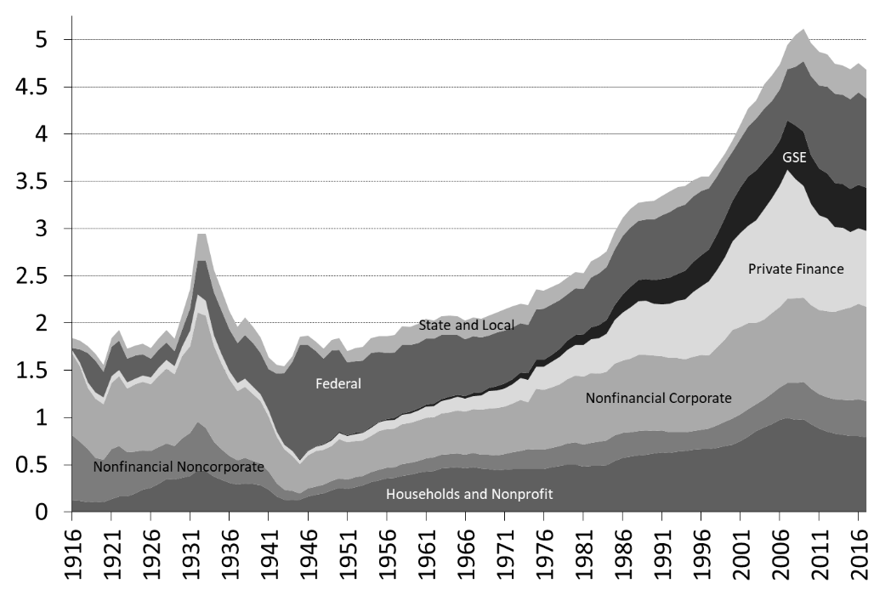
Figure 7. Liabilities to GDP in the United States, 1916-2017
Sources: Historical Statistics of the United States: Millennium Edition (Tables Ca9-19, Ce42-68, Cj265-272, Cj362-374, Cj389-397, Cj437-447, Cj748-750, Cj751-765, Cj787-796, and Cj870-889), Historical Statistics of the United States: Colonial Times to 1970 (Series X 689-697), NIPA, Flow of Funds (from 1945).
Note: The government sector excludes all financial activities of the government (retirement funds, GNMA, etc.). GSE sector includes government-sponsored enterprises and agency- and GSE-backed mortgage pools (includes, among others, GNMA and FHA pools). "Financial" excludes the GSE sector and monetary authorities (which are both part of the financial sector in the Flow of Funds accounts). Before 1945, data for financial institutions is computed from data of the Census Bureau by taking all the liabilities (excluding equity) of commercial banks, credit unions, savings institutions, life insurance stock companies, and property and life insurance companies, and by removing private banks notes, all deposits, and life insurance reserves. From 1945, the total liabilities of the financial sector excludes, net interbank liabilities of commercial banks, liabilities of monetary authorities, private and public pension fund liabilities, money market mutual funds shares, mutual funds shares and the items previously cited. The liabilities of monetary authorities are not included anywhere.

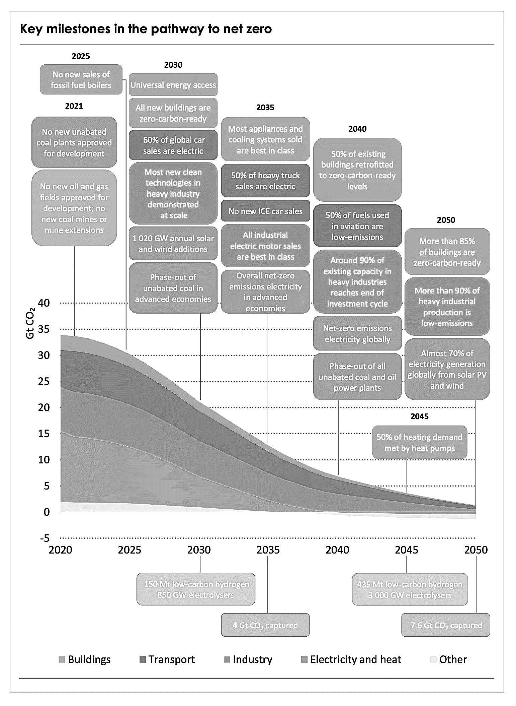
Figure 8. Roadmap to Net Zero Emission by 2050 (consistent with a +1.5c warming of the planet)
Source: International Energy Agency (2021)

For example, see Agustino Fontevecchia “PIMCO's Bill Gross Shorts Treasuries As Experts Eye Inflation” Forbes.com (April 11, 2011). Bill Gross’s position has not changed 10 years later, see Emily Graffeo “Bill Gross is shorting US Treasurys and says inflation will be as high as 4% in coming months” Business Insider (May 17, 2021).
See John Ainger “Bond World Is Backing Away From All That Negativity as 2019 Ends” Bloomberg (December 23, 2019); Eric Lascelles “Adapting Investment Strategy to the Negative Yield Environment,” RBC Wealth Management (November 20, 2019); Dhara Ranasinghe “Almost 70% of Euro Zone Bond Yields Have Sub-Zero Yields – Tradeweb,” Reuters (October 3, 2019). Laura Benitez and Tasos Vossos “Sub-Zero Yields Start Taking Hold in Europe's Junk-Bond Market,” Bloomberg (July 9, 2019).
In 1942, the Federal Reserve and the U.S. Treasury agreed on a monetary policy framework that consisted in targeting the yield curve and that required the preapproval of the Treasury to change any interest rate targets. The Treasury-Federal Reserve Accord allowed the Federal Reserve to pursue a more independent and active monetary policy focused on stabilizing money-market conditions. Open market operations developed in the 1950s and the Fed monitored the T-bill rate without explicitely targeting it. The FFR became an operating tool of monetary policy in the 1970s as the overnight interbank market developed in the 1960s (Meulendyke 1998, 35-45).

