MMT and Economic Theory: A Reply to Critiques
Eric Tymoigne
Lewis & Clark College

The fruit of a collaboration between some post Keynesian economists and a bond trader named Warren Mosler, that started following discussions on the now defunct Post Keynesian Thought listserv, the theoretical framework first developed quietly and largely ignored in a subset of the economics field in the late 1990s and early 2000s. As MMT gained growing attention around 2010, critics have attacked the framework in several ways. Some critiques have argued that MMT is not a theory because there is no mathematical model. Others have argued that there is a theory but that there is nothing new and even if there is, it is not valid and it is misleading and it pushes the logic too far (Lavoie 2013). For example, Palley notes that MMT fails “to produce a model and […] that is why they fail to advance debate. If MMT-ers did produce a model, I am convinced […] readers would also see there is ‘no there there.’” (Palley 2014, 2). Others, like Palley, have argued that “MMT often boils down to nothing more than an especially naïve sort of Keynesianism” (Selgin 2019) with “nothing new under the sun” (Cachanosky 2021).
Another criticism, seemingly contradictory to the previous criticisms, is that MMT lacks realism. The consolidation technique has drawn the ire of some economists for not accounting for the institutional constraints within governments that limit the interaction between the central bank and the Treasury. As a consequence, MMT is supposed to provide a poor theoretical framework to understanding government finances and the role of government in the economy.
Economic Foundations of MMT: A Theory with Deep Roots
Capitalism is a monetary production economy: Money, power and classes
MMT combines several theoretical aspects developed by Post Keynesian economics. In terms of economic activity, MMT fully embraces the theory of effective demand developed by John Maynard Keynes (1936) and Michał Kalecki (1933) (Mitchell et al. 2019, ch. 11-14) . It also embraces the contributions made by Joan Robinson, Nicholas Kaldor and many Post Keynesian economists on the causes of economic growth. The importance of income distribution for growth (wage-led versus profit-led growth) and the dependence of supply conditions and technological progress on the dynamics of aggregate demand (demand-led growth, Verdoon-law, hysteresis effects) have also been accepted (Tavani and Zamparelli 2017; Lavoie 2014; Oranan and Galanis 2013). Similarly, MMT emphasizes the importance of expected sales and capacity utilization as key drivers of investment, while the cost of credit plays a marginal role. MMT rejects Say’s law, the neutrality of money, methodological individualism, relative-price clearing mechanisms and the existence of “natural” variables to explain how a capitalist economic system behaves. MMT embraces as analytical tools the power relations as expressed through classes, income effects, the role of monetary outcomes for employment, investment and production decisions, and the dependence of productive capacities on current spending decisions (Lavoie 2014). As such, MMT rejects the two following premises that are widely shared in economics:
Let us begin with an axiom that I think most economists would accept, and that I have already used in the previous lecture: the objectives of agents that determine their actions and plans do not depend on any nominal value. Agents care only about ‘real’ things, such as goods […] leisure and effort. We know this as the axiom of the absence of money illusion, what it seems impossible to abandon in any sensible analysis. (Hahn 1982, 34)
Despite the important role of enterprises and of money in our actual economy, and despite the numerous and complex problems they raise, the central characteristic of the market technique of achieving co-ordination is fully displayed in the simple exchange economy that contains neither enterprises nor money. (Friedman 1962, 13)
Capitalism is a monetary production economy not a real exchange economy. The production process is a central point of study because it is at the core of the socio-economic dynamics of a society. Production involves classes with competing economic interests and capitalists are not interested in the additional amount of output obtained from investment (the marginal productivity of capital) but rather in the additional expected monetary profit that comes from the additional expected sales. As such, in a capitalist economy, “money isn’t everything, it is the only thing” (Minsky 1990, 363). Nominal calculations not real calculations drive the allocation, production and distribution processes. The economic process starts with money in expectation of ending with more money:
The firm is dealing throughout in terms of sums of money. It has no object in the world except to end up with more money that it started with. That is the essential characteristic of an entrepreneur economy. (Keynes 1933 (1979): 89)
Pecuniary incentives and invidious comparisons, not physical incentives and isolated fulfillment of inherent preferences, are at the center of economic dynamics (Veblen 1899, 1904) and the primary goal of businesses is “vendibility,” not productivity (Veblen 1901). If monetary profitability means leaving productive capacities idle, destroying productive capacities or bypassing the production process entirely (such as through the financialization of the economy in the past decades), then it will be done (Hein 2012). As James Roderick, chairman of U.S. Steel noted: “The duty of management is to make money. Our primary objective is not to make steel.” (Roderick in Watchel 1990, 154). Once he became chairman, he abandoned plans to modernize and expand the steel-making business and instead focused on real estate ventures and other financial deals. Similarly, chairman of General Motors Alfred Sloan (1963, 64) noted in his memoirs: “The primary object of the corporation, therefore, we declared was to make money, not just to make motor cars.”
Endogenous preferences and power relations
This framework also does not take individuals’ preferences as given but rather considers them to be shaped by envy and emulation (Veblen 1898, 1899) and, more importantly, by producers themselves (Galbraith 1958, 1967). A central premise behind the real exchange economy is that individuals have given preferences that are intrinsic to them and that individuals are insatiable (more is always better so there is no diminishing marginal utility from reaching a higher indifference curve). Such insatiability is central to the justification for the constant search for economic growth in order to meet as many preferences as possible; it helps justify why markets, rather than government, respond best to individuals’ preferences. If preferences are not intrinsic to individuals but rather are manufactured by producers through advertising and emulation, the urgency of economic growth and the incapacity of a government to shape and respond to individual preferences are no longer convincing narratives.
As it was learned during World War I, and later applied by corporations, modern propaganda techniques are powerful tools for shaping the behaviors and thoughts of the masses (Curtis 2002). A government can shape individuals’ preferences, can define its own criteria of success, and may respond to the preferences of individuals more appropriately. Improving wellbeing and constantly increasing marketable production may not be similar goals. There is nothing “natural” about consumerism and the search for maximum efficiency and, while these have been promoted by government policies in order to promote capitalist economic interests (Robbins 2014), they do not have to be the primary criteria for making economic decisions. A government instead may promote activities that lower consumerism, preserve the environment, improve labor standards, and promote leisure or redirect efforts toward fulfilling crucial needs that may have a very high fixed cost and very low or no profitability. This does not necessarily involve compulsion but, like typical business advertising, may involve persuasion through similar advertising campaigns that cast smoking in bad light, that show the environmental destruction created by meat consumption, or that dramatically illustrate the importance of wearing seat belts and installing airbags in cars, among others, with the goal of shaping public opinion and changing behaviors.
The main implication is that there is a potential conflict between capitalists and other segments of the population over the shaping of preferences and aspirations of individuals. This conflict expresses itself in national policymaking through the struggle over the shaping of the political agenda. The expression and result of these conflicts depends heavily on power relations and their influence on electoral outcomes and policymaking.
Money and banking: Endogenous money and liquidity preference
In terms of interest rates and the monetary creation process, MMT also embraces the liquidity preference theory of interest rates, the endogenous money theory and the circuit approach developed by Keynes and Post Keynesian economists. The endogenous money approach emerged as a criticism of, and alternative to, Monetarism (the view that the central bank controls the supply of reserves and that banks create bank accounts through a reserve-multiplier mechanism) (Minsky 1967; Kaldor 1982; Moore 1988; Wray 1990; Lavoie 2006, 2014). Over the past several decades, Post Keynesians have combined the endogenous money and the liquidity preference theories to provide an alternative to the money demand/money supply framework of the IS-LM model. Some MMT proponents have participated extensively in the development of the Post Keynesian theory of endogenous money and its integration with Keynes’s liquidity preference theory (Wray 1990, 1992; Fullwiler 2006, 2017). Until 2008, the central banks of developed economies set at least one interest rate and added and removed reserves to accommodate the needs of private banks. Since 2008, major central banks have changed their operational procedures but the goal is still to set at least one interest rate for any level of reserves (Lavoie 2010, 2019; Fullwiler 2013).
Similar to the production side of the economy, the finance side adjusts to the needs of the economy. Finance is not a scarce resource that is constrained by a quantity of saving or a quantity of reserves. Bank credit creates bank accounts, which usually creates a need for reserves, and reserves are created on demand by the central bank. Private banks create accounts at the request of creditworthy clients and funds in the accounts are deleted when debts owed to banks are paid. The provision of credit finances investment, investment creates income, and income is used to fund investment either through consumption or through saving (Davidson 1978, 1986; Lavoie 1987, 2014; Graziani 1990, 2003). Saving is a residual variable of the economic process rather than a leading variable, and the supply of reserves is not fixed but rather perfectly elastic and a residual variable of the monetary creation process. MMT applies the same logic to government finances: monetary creation finances government spending, taxes are part of the funding process that destroys the currency (Tymoigne 2014; Rezende 2009).
Intrinsic market instability: The financial instability hypothesis
While finance is not scarce, the pool of creditworthy clients is finite given credit standards; however, creditworthiness as defined by bankers is an elastic procyclical concept because credit standards change according to competitive pressures, financial innovations and the prevailing optimism of bankers, which leads to Hyman Minsky’s Financial Instability Hypothesis (FIH) (Minsky 1978; Tymoigne and Wray 2014). The FIH is an alternative to the Efficient Market Hypothesis (EMH). The EMH argues that market mechanisms are a stabilizing force that allocates resources toward the most productive uses and risks toward the entities the most able to bear them. Financial crises can occur but they are the result of large unexpected shocks on the economic system—think once-in-a-century tsunami or a black-swan event. By contrast, the FIH argues that the normal functioning of “a capitalist economy endogenously generates a financial structure which is susceptible to financial crises” (Minsky 1977, 25). Over a period of economic stability, the economy becomes more financially fragile in such a way that not unusual shocks cause a financial crisis; think house of cards.
The essential conclusion of the hypothesis is that market mechanisms cannot sustain full-employment with stable prices, which leads to two theorems, the anti-laissez-faire theorem and the performance theorem (Ferri and Minsky 1992). The first theorem implies that a “big” government (that is, a government large enough to sustain aggregate income and to put a floor on asset prices) is necessary, to have an economy “where freedom to innovate and to finance is the rule” (Minsky 1993, 81). Individual economic freedom and big government are complementary not conflicting elements as Keynes noted in Chapter 24 of his General Theory. The second theorem means that not only does a free market economy not generate sustained full employment, but also, that it has a tendency to generate deep and long economic depressions; free-market capitalism is self-destructive. Andrew Mellon’s advice to President Hoover to “liquidate labor, liquidate stocks, liquidate the farmers, and liquidate real estate […] it will purge the rottenness out of the system […] and enterprising people will pick up the wrecks from less competent people.” (Hoover 1952, 30) is incorrect. Market mechanisms, especially under the conditions of a debt deflation, are not a selective cleansing process but rather a process that indiscriminately destroys income and wealth (Veblen 1904; Fisher 1932, 1933). As such, the financial regulation of capitalist economies cannot be left to market participants, nor can it be based merely on putting in place buffers, such as capital regulation, to promote financial stability (Tymoigne 2011).
MMT and Public Finances: Theoretical Implications of Monetary Sovereignty
Stylized fact: Fiscal deficits are normal
In terms of public finances, MMT emphasizes four points, one empirical, two theoretical and one practical. On the empirical side, one stylized fact of macroeconomics is that the government sector records a fiscal deficit, while the domestic private sector is in surplus. If one focuses on the United States, until the 1930s, only major wars (War of 1812, Civil War, World War I) caused rapid increases in the public debt (Figure 1). While gross public debt fell more often than it rose before 1930, overall it did grow slowly by 0.31% of gross domestic product (GDP) per year because increases were on average larger. Since the Great Depression, the gross public debt has increased almost every year by a dollar amount representing an average of 4.42% of GDP. Major wars (World War II, Vietnam War, War on Terror) have still contributed to rapid increases in the public debt, but sustained increases have become a permanent feature with only five recorded declines in the public debt (1947-49, 1951, 1956-57). Even the celebrated “Clinton’s surplus” of the late 1990s did not lead to a decline in the gross public debt. Fiscal surpluses did lead to a fall in the public debt held by the public (the US Treasury bought back some of its securities from the public) but intragovernmental holdings grew and more than offset the decline (Government Accountability office 2001).
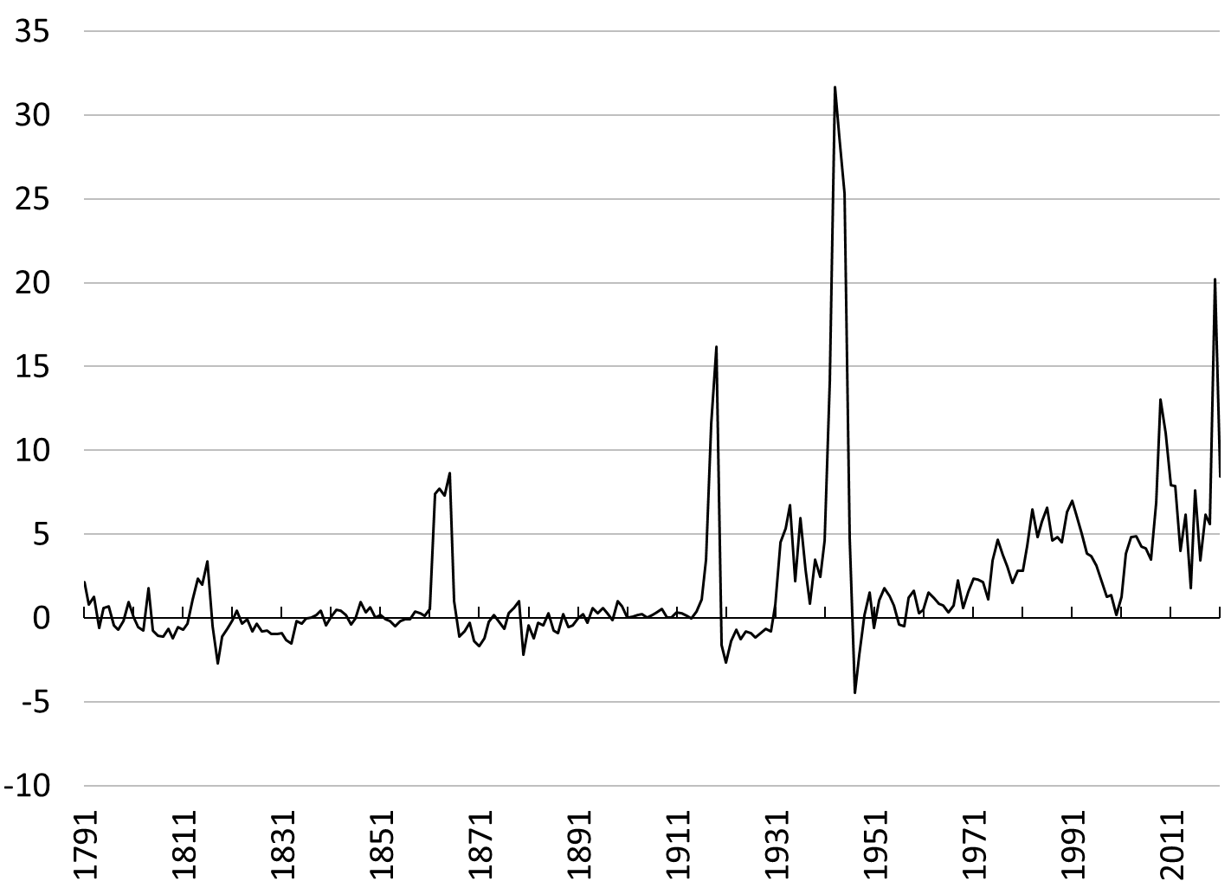
 | Change is |  | Average Size of Change in Gross Public Debt
Time Period | Positive | Negative | (% of GDP)
1791 to 1930 | 66 | 74 | 0.31
1931 to 2021 | 86 | 5 | 4.46
1791 to 2021 | 152 | 79 | 1.94
Figure 1. Change to Gross Public Debt relative to GDP: 1791-2021, Percent of GDP
Sources: Treasury Direct, Bureau of Economic Analysis.
Note: Division by GDP does not influence the type of changes (positive or negative) in the absolute gross public debt.

In other words, fiscal deficits are a normal state of affairs for the U.S. government since the Great Depression. The same stylized fact exists abroad, which can be illustrated by representing the sectoral balance accounting identity in a two-dimension graph (Figure 2) (FINANCIAL BALANCE ENTRY). By combining the National Income and Product Accounts (NIPA) and the U.S. International Transactions Accounts, the following macroeconomic accounting identity applies (CAB_{F} is the current account balance of the foreign sector, T is taxes, G is government spending on goods and services, S is domestic private gross saving, and I is domestic private gross investment):
(T – G) + (S – I) + CAB_{F} ≡ 0
Thus, at least one of the sectoral balance—either the domestic private sector balance (S – I), the government sector balance (T – G), or the foreign sector balance (CAB_{F})—must be in deficit if another balance is in surplus. Data for many countries shows that usually the government sector runs a deficit and the domestic private sector is in surplus, while the foreign sector balance can vary depending on the country and the time.

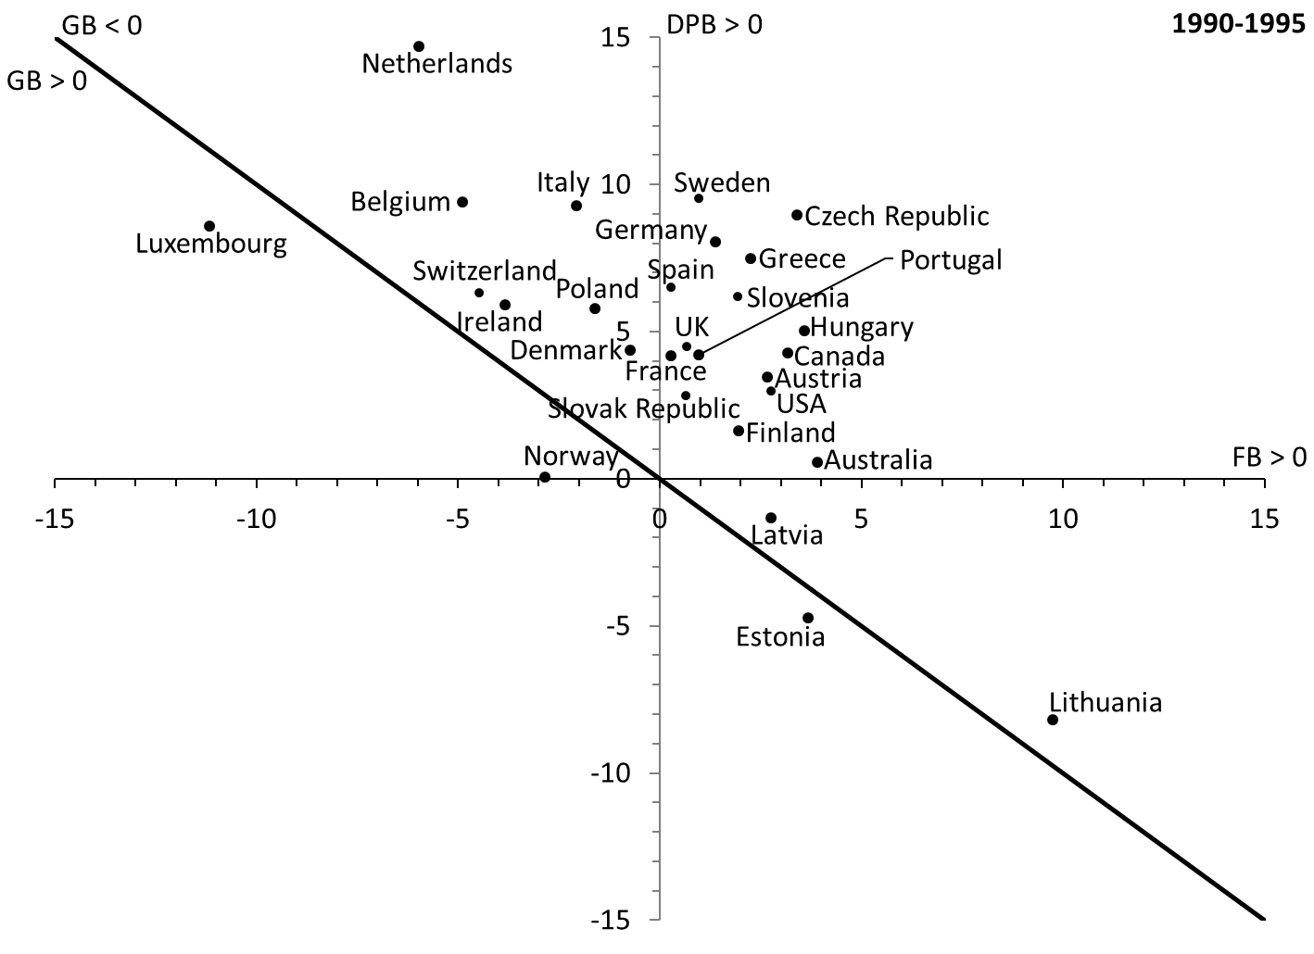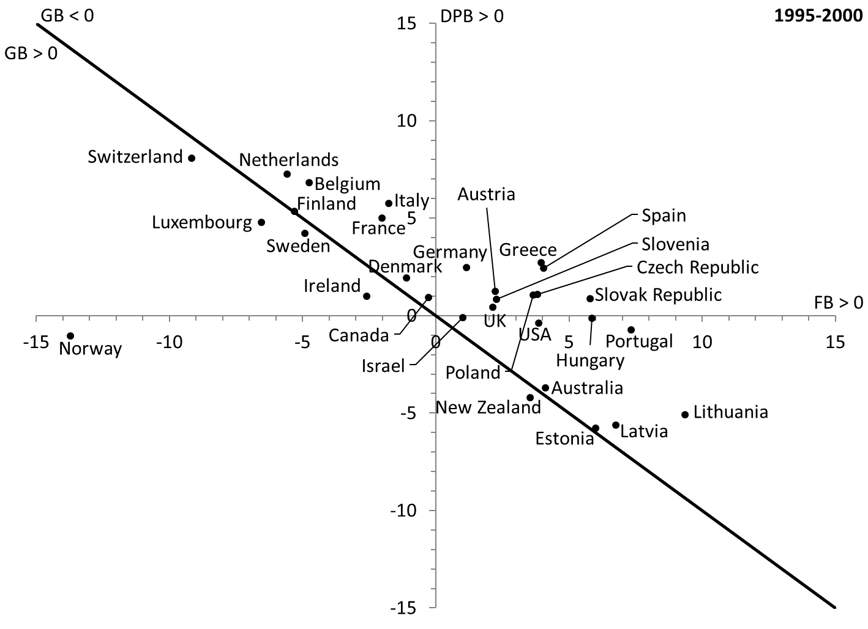
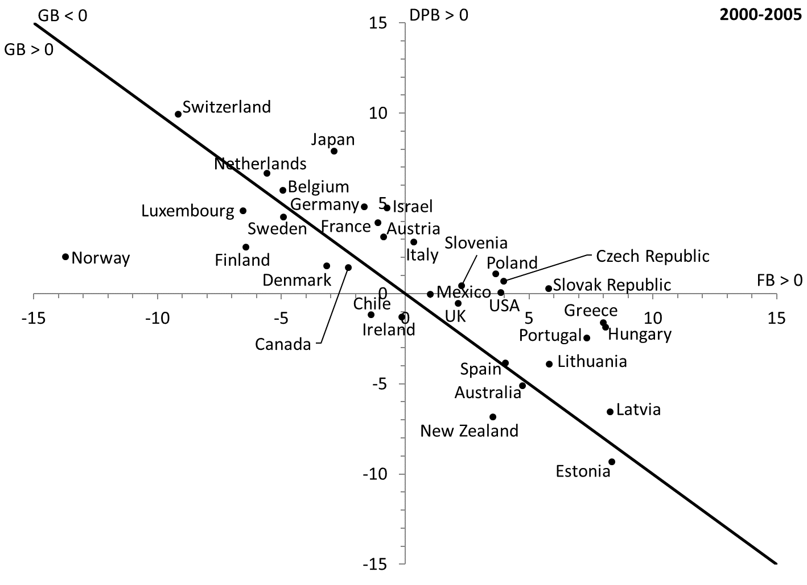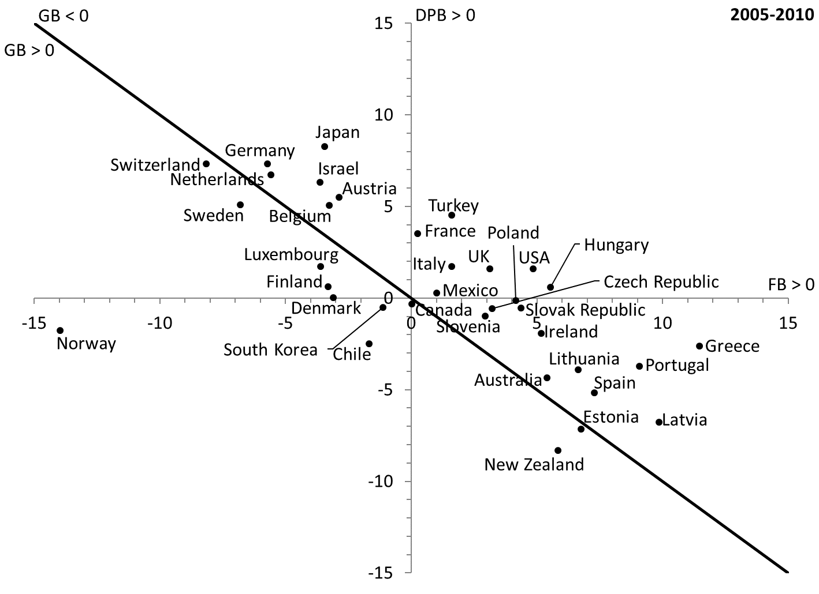
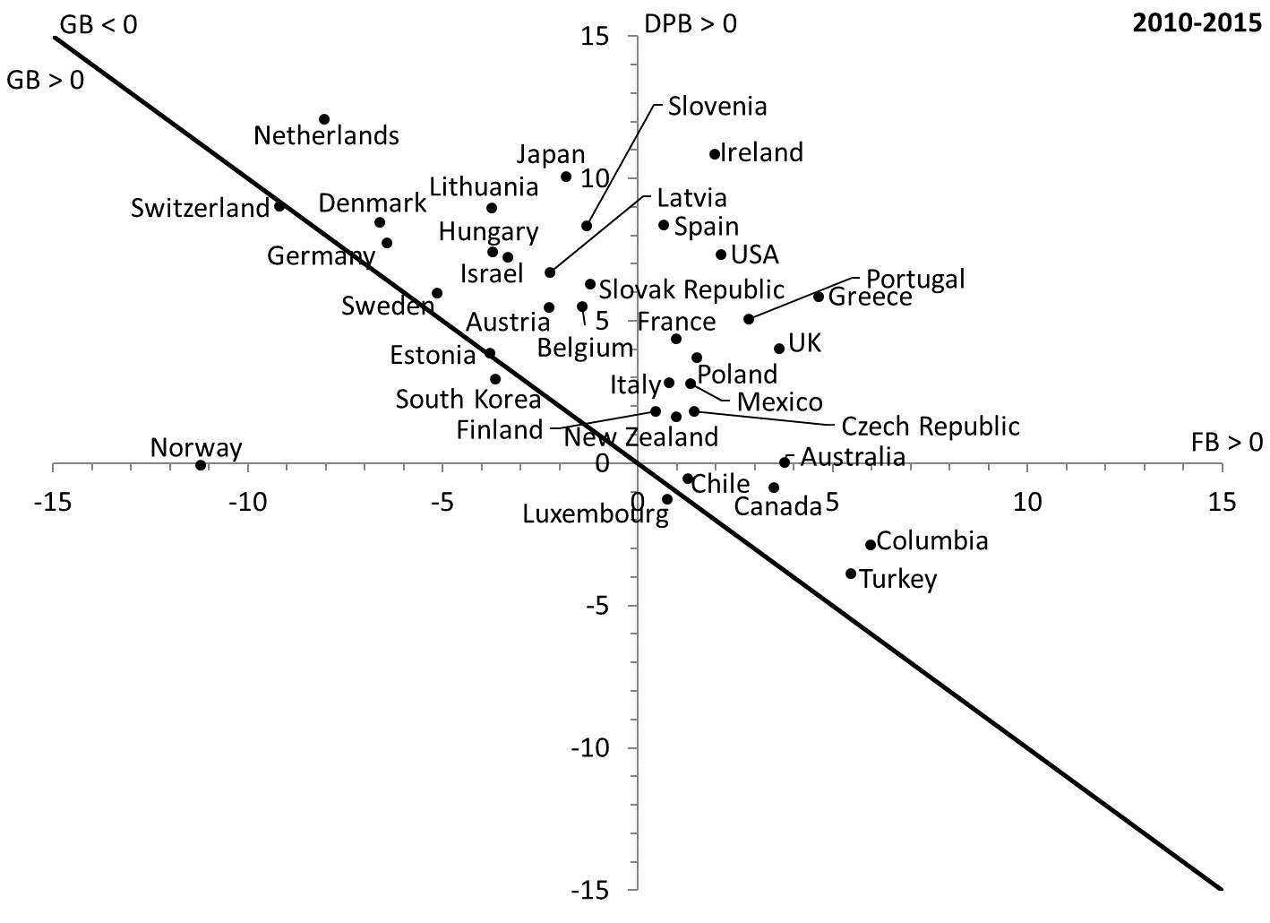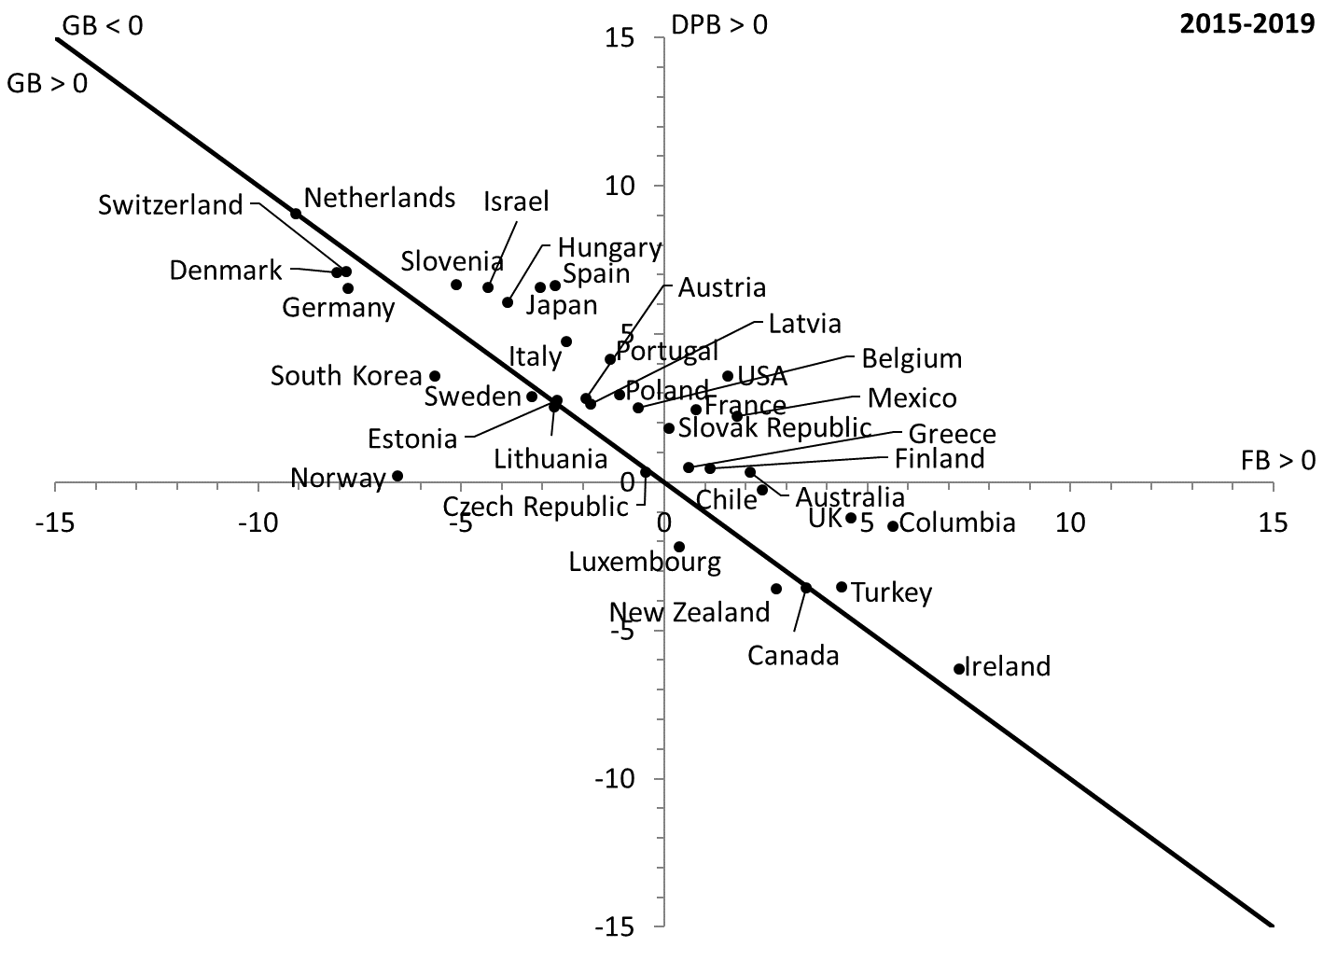
Figure 2. Sectoral balances in OECD countries, percent of GDP.
Source: Organisation for Economic Co-operation and Development (National Accounts at a Glance, Net Lending/Borrowing).
Note: GB is the government balance (T – G), DPB is the domestic private sector balance (S – I) and FB is the foreign balance (CAB_{F}). So GB = - (DPB + FG).

Explaining the stylized fact: Endogenous fiscal balance and recessionary austerity
In order to explain this stylized fact, MMT uses theoretical claims that introduce desires and causalities into the accounting framework. A central theoretical conclusion is that the fiscal balance (surplus, balanced, or deficit) is not under the control of policymakers but rather adapts to the needs of the economic system. Most government spending is not discretionary and tax revenues are heavily influenced by the state of the economy. While policymakers do set some spending (discretionary spending represents about 30 percent of the budget in the United States), do determine tax rates and can make some predictions about total spending and tax revenues at the end of the year, they have no control over budgetary dynamics during the year. Like private aggregate saving, the fiscal balance is a residual outcome of the economic process and any attempt by the government to proactively influence the balance will most likely fail. When left alone automatic stabilizers make the fiscal position behave countercyclically and, if a private-sector led economic expansion lasts long enough, a fiscal deficit may turn into a surplus as it did during the late 1990s in the United States (but then quickly turned to a deficit with the mild 2001 recession).
While all sectors may want to record a surplus, not all sectors can do so simultaneously. Usually the non-federal sector (that includes state and local governments, the domestic private sector, and the foreign sector) desires to record a surplus so the federal sector must be in deficit. This assumption of a desired positive surplus reflects the stylized fact that the domestic private sector usually records a positive net financial accumulation. Within the domestic private sector, some sectors may record a surplus (usually households) while others may be in deficit (e.g., nonfinancial noncorporate businesses). If the federal government has a financial balance that is not consistent with the desired financial balance of the non-federal sector, national income will adjust upward or downward as subsets of the non-federal sector change their spending level. Automatic stabilizers will move the fiscal balance to the level desired by the non-federal sector. For example, if the non-federal sector desires to have a surplus equivalent to 5 percent of GDP but the fiscal deficit represents 7 percent of GDP, state and local governments, the domestic private sector and/or the foreign sector will spend more—consumption, non-federal government spending, investment and/or exports will rise—and so national income will rise. The proportion of the rise in nominal income that comes from inflation and economic growth depends on how far the economy is from full employment. MMT notes that full employment is rare, that economic growth is demand led and that inflation has other major sources than aggregate demand pressures (Fullwiler et al. 2019; Wray 2001; Lavoie 2014; Davidson 1992, 165ff.). As nominal GDP rises, tax revenues rise and government expenditures fall until the fiscal deficit represents 5 percent of GDP. At this point, the economy reaches a state of rest; it is at an equilibrium point even though the financial balances of each sector may not be balanced. At this point, the fiscal balance is neither too high, nor too low but rather accommodates the needs of the economy.
The previous dynamics are complicated by the fact that policymakers may also want to reach a fiscal surplus (or a fiscal deficit that is less than the desired surplus of the non-federal sector) in order to show that the government is “fiscally responsible.” Often, this goal reflects a confusion of private finances with public finances that exists in the public debt rhetoric. As President Obama put it:
The hard truth is that getting that deficit under control will require some broad sacrifices. That sacrifice must be shared by the employees of the federal government. After all, small businesses and families are tightening their belts. The government should too. And that’s why, on my first day as President, I froze all pay for my senior staff. This year I’ve proposed extending that freeze for senior political appointees throughout the government and eliminating bonuses for all political appointees. And today I’m proposing a two-year pay freeze for all civilian federal workers. This would save $2 billion over the rest of this fiscal year and $28 billion in cumulative savings over the next five years. (President Obama in Lee 2010)
The belief is that the US government needs to learn to save like the rest of us. At the top of the policy agenda of most presidents is usually the goal of reaching a fiscal surplus over a given number of years; President Clinton was widely acclaimed for achieving the feat:
For 29 years, the last day of the fiscal year was not a day of celebration, but a day we were handed a powerful reminder of our government's inability to live within its means. In the 12 years before this administration took office, the debt quadrupled, partisan gridlock intensified, and a crushing debt was being imposed upon our children. These deficits hobbled economic growth, spiked interest rates, robbed too many people of their chance at the American dream. […] Tonight at midnight, America puts an end to three decades of deficits and launches a new era of balanced budgets and surpluses. It is a landmark achievement, not just for those in this room who have played a role in it, but indeed for all the American people. And it will be a gift-giving achievement for generations to come. (Clinton 1998)
This way of thinking is not only incorrect but also counterproductive. The main reason the US Treasury runs a deficit is not deliberately reckless policies or politicians who do not know how to put the US government finances in order. Policymakers actually has little control over the size of federal expenditures and federal tax revenues. Proactive policies to reach a fiscal surplus at the federal level will impede the ability of the non-federal sector to reach its desired surplus; more simply, a government sector surplus agenda (“the government must be fiscally responsible”) is implicitly a private deficit agenda and/or foreign deficit agenda (“the private sector or the foreign sector must deficit spend”). Thus, austerity policies are recessionary and amplify the business cycle, unless at least one subset of the non-federal sector is willing to deficit spend enough to counter the economic drag generated by fiscal austerity. However, deficit spending by the non-federal sector is prone to financial instability because its subsets lack monetary sovereignty and so are revenue constrained (Tymoigne and Wray 2014). As such, fiscal surpluses tend to be destabilizing. On the contrary, fiscal deficits are sustainable because a monetarily sovereign government has the financial flexibility to meet the demands of such deficits. Fiscal deficits also promote financial stability because they allow the other sectors to record a surplus.
Monetary sovereignty gives one degree of freedom in the tight rules of national accounting. It allows the fiscal balance to be whatever the non-federal sector desires and usually it desires to be in surplus so the federal government must be in deficit. Deficit hawks and deficit doves both want to have some form of austerity commitment by the national government; they just disagree on the pace and timing of that commitment. MMT are deficit owls, there is no need for such austerity commitment and it is counterproductive; the fiscal balance self-corrects to a deficit that is neither too large nor too small. The self-defeating nature of fiscal austerity has gained some attention outside MMT following the 2008 Great Recession (De Long and Summers 2012; Fatás and Summers 2018; Agnello et al. 2013).
If policymakers understand sectoral balances and their interaction, they could be tempted to try to measure the desired non-federal surplus in order to set a target fiscal balance. This is not an appropriate way to proceed. Not only does that conflict with the policymaking praxis of MMT, but also the desired non-federal surplus changes over the business cycle and is impossible to measure properly. As income and wealth grow during an expansion, the willingness of the private sector to spend increases, and so the fiscal balance falls. The only clue policymakers have is the state of the economy at a point in time. If the fiscal deficit is too large relative to the desired surplus of the non-federal sector, inflation may emerge; if the fiscal deficit is too small relative to the desired surplus of the non-federal sector, a recession may occur and financial fragility grows. In both cases, the fiscal balance will tend to self-correct through automatic stabilizers and MMT wants to put in place structural programs that reinforce these automatic stabilizers by directly tackling unemployment and price stability (Wray et al. 2018).
Government finances: An alternative understanding of taxation, government-security issuance and monetary creation.
The second theoretical point in terms of public finances is that government spending and/or the provision of credit by the government must come before taxes or bond offerings. A government imposes tax liabilities and is the monopoly supplier of what can be used to complete the payment of such liabilities and the purchase of government securities. Government spending is done through monetary creation ex-nihilo in the same way a bank provides credit by crediting bank accounts; taxes and offerings of government securities lead to monetary destruction in the same way that the servicing of debts owed to banks destroys bank accounts. The issuance of government securities is not a fiscal tool but a monetary policy tool. As such the identity ∆M + ∆B + T ≡ G + iB is not interpreted as a budget constraint in which government spending of government on goods and services (G) and interest payments on government securities (iB) can be financed alternatively by monetary creation (∆M), issuance of government securities (∆B), or tax revenues (T). Instead, it is an expost identity that shows how the gross injection of domestic currency via government spending (G + iB) was used by the private sector to make tax payments (T), to settle auctions of government securities (∆B) and to hoard (resulting in an net change in the monetary base (∆M)).
Monetary creation is not a substitute for the issuance of government securities or taxes, instead monetary creation is a complementary operation. While this is quite straightforward when merging the central bank and Treasury into a government sector, similar conclusions can be reached by separating the fiscal and monetary branches of a government (Tymoigne 2014, 2016, 2020; Fullwiler et al. 2012) (CONSOLIDATION ENTRY). Through the coordination of their fiscal and monetary branches, monetarily sovereign governments issue the domestic currency to spend and then collect taxes and issue securities. As such, MMT rejects the terminology of “deficit financing”, “deficit spending”, or “monetizing deficits” when applied to monetarily sovereign governments. All federal government spending is financed by monetary creation. Tax liabilities critically create a demand for the national currency and so willing sellers of goods and services to the government. However, the enforcement of these liabilities via tax payments merely return the domestic currency to the government (hence the term tax “revenue” a noun based on the French verb “revenir” meaning “to come back”) and so do not finance anything. The fact that government spending is greater than taxes does not represent a shortage of funds that the government must find somewhere else, but rather a fiscal deficit represents a surplus of funds for the non-federal sector that can be used to buy government securities or to hoard. A fiscal deficit generates a net injection of reserves in the banking system and, if the policy rate set by the central bank is above zero, the government intervenes to remove that net injection by issuing interest-earning government securities (Treasuries or central bank securities). The government may alternatively decide to let the extra reserves stay in the banking system and to pay interest on reserves. Both methods are functionally the same.
Functional finance
This leads to the practical point of MMT in terms of public finances. MMT follows the policymaking principles laid out by functional finance and rejects the sound finance approach to policymaking. In the sound finance approach, a central goal of policymaking is to ensure that the fiscal balance stays balanced. The deficit hawks want this to apply every year, pushing as far as amending the US Constitution to make sure it happens, while the deficit doves are fine if it occurs on average over a period of time (meaning that periods of fiscal deficits must be offset by periods of fiscal surpluses). Regardless, the main point is that the fiscal balance is at the center of the policymaking process and that the only sound means to finance government spending is taxes, because the issuance of Treasuries crowds out private investment and monetary creation is inflationary.
MMTers are deficit owls. They reject the sound-finance approach to policymaking when applied to monetarily sovereign governments. Instead, functional finance puts non-financial goals at the center of policymaking while the fiscal balance accommodates the needs of the economic system. However, MMT wants to implement functional finance differently from Lerner (1943) because MMT rejects pump priming and stop-go policies à la Neoclassical Synthesis of the post-war period (Wray 2018; Tcherneva 2014; Tymoigne 2010). MMT also rejects the tax-financing versus bond-financing versus monetary financing framework of public finances and emphasizes a decoupling of spending policy and tax policy.
MMT, Mathematics and Realism
Finally, a criticism of MMT is that there is no mathematical model that corroborates the ideas advanced by MMT. This is simply incorrect. Tymoigne (2006) builds a stock-flow Minskian model to analyze the impact of different types of monetary policies and concludes that leaving the policy rate stable at zero is the most stabilizing policy. Fullwiler (2007) and Wray et al. (2018) use a modified version of the Fair macroeconomic model to analyze the macroeconomic impact of a Job Guarantee program on the economy and conclude that such a program has an overall beneficial impact while moderately and temporarily raising inflation. Godley and Lavoie (2007) include some insights of MMT in their models and again show that using monetary sovereignty does not mean instability. Rochon and Setterfield (2011: 132) mathematically studied the impact of different monetary policy rules and showed that a permanent zero central-bank rate “always yields the highest rate of growth and the lowest rate of inflation”. This result is reached by narrowly studying the impact of interest rates. One may argue that taking the full financial implications of interest rates on balance sheets and aggregate demand into account would reinforce this result.
Regarding realism, it is important to make a difference between the logic followed in the consolidation technique (when MMT uses the “federal/national government” sector) and the logic followed in the unconsolidated analysis (when a split is made between the Treasury and the central bank). Critiques are not always clear on that difference. A central conclusion of MMT is that regardless of the logic, the end result is the same. This is so not only for theoretical reasons but also because, in a monetarily sovereign government, the central bank and the Treasury always closely coordinate their financial operations to maintain the stability of the financial system. While the politics surrounding this cooperation have sometimes been heated, the economics is straightforward and well understood by insiders (U.S. Senate 1952; MacLaury 1977; Meulendyke, 1998; Newman 2013; Garbade 2004, 2008, 2021; Allen 2019; Silva et al. 2010; Sundararajan et al. 1997). Even when the central bank can set its policy independently, it must account for the financial needs of the Treasury to maintain financial stability. For example, in the United States, Congress delegated some of the Treasury’s monetary power to the central bank but, in exchange, the central bank must cooperate with the Treasury. The Federal Reserve has always helped the US Treasury when needed; either by purchasing unwanted treasuries in the primary market, by providing advances directly to the US Treasury, by advancing funds to primary dealers who are required to purchase treasuries, by providing advances to banks to ensure that taxes can be settled, and/or by providing a refinancing source to the US Treasury. In addition, the Treasury has other goals in mind than merely budgetary concerns when it issues treasuries and, at times, these goals are at odds with such concerns (CONSOLIDATION ENTRY).
Thus, if one wants to account for the institutional aspects of government finances in order to be more descriptive, one should account for all of them, namely those that constrain Treasury-central bank operations, and those that allow the Treasury and the central bank to bypass these constraints (Tymoigne 2014; Juniper et al. 2014; Felipe et al. 2020). The theoretical implication that MMT draws from this is that one can simplify the economic analysis without loss of generality by merging the central bank and the Treasury into one entity called “the federal/national government.” Lavoie (2013) recognizes this but he prefers not to use the consolidated government. MMT argues that the added complexity is counter-productive because it leads to poor understanding among economists, poor modeling, and incorrect policy choices. Were economists and policymakers to understand that the consolidated case explains the underlying nature of the unconsolidated government financial operations, MMT suggests that all three could be markedly improved. One may note that policymakers, such as Chairman Greenspan, do commonly use the consolidation technique in policy discussions. It is an effective rhetorical tool that is a good first approximation of operational realities and that brings forward the underlying causalities at play that otherwise are hidden by institutional complexities.
Conclusion
Like all economic frameworks, MMT builds on past theoretical developments to improve our understanding of how the economy operates. Through this framework, MMT proponents arrived at some well-known conclusions, but to argue that there is nothing new is a mistake. Among the most striking conclusions of MMT is that taxes and issuances of securities are not a source of funds for government spending, deficit financing is not an appropriate terminology, and government-spending proposals should not be scored and voted on based on their impact on the public debt. MMT completely changes the way of thinking about government budgeting procedures and changes the approach to taxes and government spending. This alone ought to be considered innovative although it builds on the macroeconomic work of Lerner and Ruml in the 1940s, the credit theory of money developed by, among others, Innes in the 1910s, Thomas Smith in the 1830s, Barbon in the 1790s, Potter in the 1650s well as the monetary experiments and observations of economists and politicians and the US colonies in the 17th and 18th centuries.
Overall, there is a rich theoretical framework behind MMT that uses premises and methodological tools that are quite different from current standard economic thinking. It is not a simple matter of tool preferences for policymaking and slopes of the IS and LM curves, but rather a completely alternative framework with a specific policymaking praxis that emphasizes reaching full employment regardless of the state of economic growth (Mitchell 2018; Mitchel et al 2019). While this framework has Keynesian roots, it rejects the pump priming and fine-tuning views of economic management and prefers a more direct and targeted management of economic activity. It may not be the one most economists like to use; nevertheless, it is there. Naturally, the framework used by MMT proponents, broadly the Post Keynesian framework, leads academics who use it to ask different questions and to use different methods to answer them. This framework emphasizes two central points, productive capacities are elastic and finance is elastic, which means that both of them usually have significant ability to accommodate the needs of the economic for output and finance. This does not mean that government spending can grow limitlessly relative to the size of the economy, but rather that productive capacities (especially labor) are usually flexible enough to respond quickly, and ultimately adapt, to the requirements of rapidly growing expenditures. While this has been well understood in the Keynesian literature, both heterodox and mainstream (hysteresis effect), it rarely enters policymaking discussions except when facts stubbornly show that the economy can operate far beyond what is at the time considered to be full employment. For example, Greenspan noted in 1999—after years when the unemployment rate fell below the supposed NAIRU and inflation did not accelerate much to the dismay of other FOMC members and prompting estimates of NAIRU to be revised down—that:
Let me just say very simply – this is really a repetition of what I’ve been saying in the past – that we have all been brought up to a greater or lesser extent on the presumption that the supply side is a very stable force. […] In my judgment our models fail to account appropriately for the interaction between the supply side and the demand side largely because historically it has not been necessary for them to do so. (Federal Open Market Committee 1999, 46-47)

References
Agnello, L., Castro, V. and Sousa, R.M. (2013) "What determines the duration of a fiscal consolidation program?” Journal of International Money and Finance, 37 (C): 113-134.
Allen, W.A. (2019) The Bank of England and the Government Debt: Operations in the Gilt-Edged Market, 1928-1972. Cambridge, UK: Cambridge University Press.
Cachanosky, N. (2021) “Modern Monetary Theory: Nothing new under the sun” last accessed on August 2, 2021 at https://www.econlib.org/library/Columns/y2021/Cachanoskymodernmonetarytheory.html#_ftn1
Clinton, W.J. (1998) “President Clinton announces the first budget surplus in a generation” White House, Press Release, September 30. Assessed on July 13, 2021 at https://clintonwhitehouse4.archives.gov/WH/New/html/19980930-11446.html
Curtis, A. (2002) The Century of the Self, Part 1: Happiness Machines. London: British Broadcasting Corporation.
Davidson, P. (1978) Money and the Real World, 2nd edn, London: Macmillan.
_____. (1986) “Finance, funding, saving, and investment” Journal of Post Keynesian Economics, 9 (1): 101-110.
_____. (1992) International Money and the Real World. 2nd edition. London: Palgrave Macmillan.
De long, B. and Summers, L.H. (2012) “Fiscal policy in a depressed economy” Brookings Papers on Economic Activity, Spring: 233-274.

Fatás, A. and Summers, L.H. (2018) “The permanent effects of fiscal consolidations” Journal of International Economics, 112 (May): 238-250.
Federal Open Market Committee (1999b) Transcript of the October 5th meeting. Website of the Board of Governors of the Federal Reserve System. Accessed November 18, 2021 at https://www.federalreserve.gov/monetarypolicy/files/FOMC19991005meeting.pdf

Felipe, J., Fullwiler, S., Faye Bajaro, D., Yusoph, Al-H., Alec Askin, S. and Alexander Cruz, M. (2020) “An analysis of the worldwide response to the COVID-19 pandemic what and how much?” Asian Development Bank, Working Paper No. 626.
Ferri, P. and Minsky, H.P. (1992) “Market processes and thwarting systems” Structural Change and Economic Dynamics, 3 (1): 79-91.
Fisher, I. (1932) Booms and Depressions. New York: Adelphy.
_____. (1933) “The debt-deflation theory of great depressions” Econometrica, 1 (4): 337-357.
Friedman, M. (1962) Capitalism and Freedom. Chicago: University of Chicago Press.
Fullwiler, S.T. (2006) “Setting interest rates in the modern money era” Journal of Post Keynesian Economics, 28 (3): 495-525.
_____. (2007) “Macroeconomic stabilization through an Employer of Last Resort” Journal of Economic Issues, 41 (1): 93-134.
_____. (2013) “An endogenous money perspective on the post-crisis monetary policy debate” Review of Keynesian Economics, 1 (2): 171-194.
_____. (2017) “Modern central-bank operations: The general principles” in Rochon, L.-P. and Rossi, S. Advances in Endogenous Money Analysis, 50-87. Northampton: Edward Elgar.
Fullwiler, S.T., Grey, R. and Tankus, N. (2019) “An MMT response on what causes inflation” Financial Times, March 10, 2019 10:00 am. Accessed on July 23, 2021 at https://www.ft.com/content/539618f8-b88c-3125-8031-cf46ca197c64
Fullwiler, S.T., Kelton, S.A., and Wray, L.R. (2012) “Modern Money Theory: A response to critics” Political Economy Research Institute Working Paper No. 279. Amherst: University of Massachusetts Amherst.
Galbraith, J.K. (1958) The Affluent Society. Cambridge, MA: The Riberside Press.
_____. (1967) The New Industrial State. Boston: Houghton-Mifflin.
Garbade, K.D. (2004) “The institutionalization of Treasury note and bond auctions, 1970-75” Federal Reserve Bank of New York Economic Policy Review May: 29-45.
_____. (2008) “Why the U.S. Treasury began auctioning Treasury bills in 1929” Federal Reserve Bank of New York Economic Policy Review July: 31-47.
_____. (2021) After the Accord: A History of Federal Reserve Open Market Operations, the US Government Securities Market, and Treasury Debt Management from 1951 to 1979. New York: Cambridge University Press.
Godley, W. and Lavoie, M. (2007) Monetary Economics: An Integrated Approach to Credit, Money, Income, Production and Wealth. New York: Palgrave Macmillan.
Government Accountability Office (2001) FINANCIAL AUDIT: Bureau of the Public Debt’s Fiscal Years 2000 and 1999 Schedules of Federal Debt. Last accessed August 2, 2021 at https://www.treasurydirect.gov/govt/reports/pd/feddebt/feddebt_ann2000.pdf
Graziani, A. (1990) “The theory of monetary circuit” Economies et Sociétés, 24 (6), MP 7: 7-36.
_____. (2003) The Monetary Theory of Production, Cambridge: Cambridge University Press.
Hahn, F.H. (1982) Money and Inflation. Oxford: Basil Blackwell.
Hein, E. (2012) “Financialization, distribution, capital accumulation, and productivity growth in a post-Kaleckian model” Journal of Post Keynesian Economics, 34 (3): 475-496.
Hoover, H. (1952) Memoirs of Herbert Hoover: The Great Depression, 1929-1941. New York: Macmillan.
Juniper, J., Sharpe, T.P. and Watts, M.J. (2014) “Modern Monetary Theory: contributions and critics” Journal of Post Keynesian Economics, 37 (2): 281-307.
Kaldor, N. (1982) The Scourge of Monetarism, Oxford: Oxford University Press.
Kalecki, M. (1933) “Outline of a theory of the business cycle” in M. Kalecki (ed.) Selected Essays on the Dynamics of the Capitalist Economy, 1-14. Cambridge: Cambridge University Press.
Keynes, J.M. (1933) “The characteristics of an entrepreneur economy” reprinted in Moggridge, D.E. (ed.) The Collected Writings of John Maynard Keynes, vol. 29, 87-101, London: Macmillan. 1979.
_____. (1936) The General Theory of Employment, Interest and Money. London: Macmillan.
Lavoie, M. (1987) “Monnaie et production: Une synthèse de la théorie du circuit” Economies et Sociétés, 20 (9), MP 4: 65-101.
_____. (2006) “Endogenous money: Accomodationist” in Arestis, P. and Sawyer, M.C. (eds) A Handbook of Alternative Monetary Economics, 17-34, Northampton: Edward Elgar.
_____. (2010) “Changes in central bank procedures during the subprime crisis and their repercussions for monetary theory” International Journal of Political Economy 39 (3), 3-23.
_____. (2013) “The monetary and fiscal nexus of Neo-Chartalism: A friendly critique” Journal of Economic Issues, 47 (1): 1-31.
_____. (2014) Post-Keynesian Economics: New Foundations. Northampton: Edward Elgar.
_____. (2019) “A System with zero reserves and with clearing outside of the central bank: The Canadian case” Review of Political Economy, 31 (2): 145-158.
Lee, J. (2010) “President Obama on the federal pay freeze: ‘Getting this deficit under control is going to require broad sacrifice’” White House Blog, November 10 at 4:32PM. Accessed on August 2, 2021 at https://obamawhitehouse.archives.gov/blog/2010/11/29/president-obama-federal-pay-freeze-getting-deficit-under-control-going-require-broad
Lerner, A.P. (1943) “Functional finance and the federal debt” Social Research, 10 (1): 38-51.
Maclaury, B.K. (1977) “Perspectives on Federal Reserve independence - A changing structure for changing times” in Federal Reserve Bank of Minneapolis 1976 Annual Report, 1-16. Minneapolis: Federal Reserve Bank of Minneapolis.
Meulendyke, A.-M. (1998) U.S. Monetary Policy and Financial Markets. New York: Federal Reserve Bank of New York.
Minsky, H.P. (1967) “Money, other financial variables, and aggregate demand in the short run” in G. Horwich (ed.) Monetary Process and Policy, 265-293. Homewood: Richard D. Irwin.
_____. (1977) “The financial instability hypothesis: An interpretation of Keynes and an alternative to ‘standard’ theory” Challenge, 20 (1): 20-27.
_____. (1978) “The financial instability hypothesis: A restatement” Thames Papers in Political Economy, Autumn. Reprinted in Arestis, P. and Skouras, T. (eds) (1985) Post Keynesian Economic Theory, 24-55, Armonk: M.E. Sharpe.
_____. (1990) “Sraffa and Keynes: Effective demand in the long run” in Bharadwaj, K. and Schefold, B. (eds) Essays on Piero Sraffa: Critical Perspectives on the Revival of Classical Theory, 362-371. London: Unwin Hyman.
_____. (1993) “On the non-neutrality of money” Federal Reserve Bank of New York Quarterly Review, 18 (1): 77-82.
Mitchell, W.F. (2018) “The divide between mainstream macro and MMT is irreconcilable - Part 1” accessed July 24, 2021 at http://bilbo.economicoutlook.net/blog/?p=40313
Mitchell, W.F., Wray, L.R. and Watts, M. (2019) Macroeconomics. London: Red Globe Press.
Moore, B.J. (1988) Horizontalists and Verticalists: The Macroeconomics of Credit Money, Cambridge: Cambridge University Press.
Newman, F.N. (2013) Freedom from National Debt. Minneapolis: Two Harbors Press.
Oranan, Ö. and Galanis, G. (2013) “Is aggregate demand wage-led or profit-led? A global model” in Lavoie M., Stockhammer, E. (eds) Wage-led Growth, 71-99. London: Palgrave Macmillan.
Palley, T.I. (2014) “Modern Money Theory (MMT): The emperor still has no clothes” mimeograph, February.
Rezende, P. (2009) “The nature of government finance in Brazil” International Journal of Political Economy, 38 (1): 81-104.
Robbins, R.H. (2014) “Constructing the consumer” chapter 1 in Global Problems and the Culture of Capitalism. New York: Pearson Education.
Rochon, L.-P. and Setterfield, M. (2011) “Post-Keynesian interest rate rules and macroeconomic performance: A comparative evaluation” in Gnos, C. and Rochon, L.-P. (eds) Credit, Money and Macroeconomic Policy: A Post-Keynesian Approach, 116-141. Northampton: Edward Elgar.
Selgin, G. (2019) “The modern new deal that's too good to be true” accessed on August 2, 2021 at https://www.alt-m.org/2019/02/08/the-modern-new-deal-thats-too-good-to-be-true/
Silva, A.C., Richard, B.J.P.G. (2010) Primary dealer systems: Draft Background Note. Washington, DC: World Bank Group.
Sloan, A. (1963) My Years with General Motors. Garden City: Doubleday and Co.
Sundararajan, V., Dattels, P., Bloomestein, H.J. (eds) (1997) Coordinating Public Debt and Monetary Management: Institutional and Operational Arrangements. Washington, D.C: International Monetary Fund.
Tavani, D. and Zamparelli, L. (2017) “Endogenous technical change in alternative theories of growth and distribution” Journal of Economic Surveys, 31 (5): 1272-1303.
Tcherneva, P.R. (2014) “Reorienting fiscal policy: A bottom-up approach” Journal of Post Keynesian Economics, 37 (1): 43-66.
Tymoigne, E. (2006) Central Banking, Asset Prices and Financial Fragility. New York: Routledge.
_____. (2010) “Minsky and Economic Policy: ‘Keynesianism’ all over again?” in Papadimitriou, D. and L.R. Wray (eds.) The Elgar Companion to Hyman P. Minsky, 47-83. Northampton: Edward Elgar.
_____. (2011) “Financial stability, regulatory buffers, and economic growth after the great recession: Some regulatory implications” in Whalen, C.J. (ed.) Financial Instability and Economic Security after the Great Recession, 114-140. Northampton: Edward Elgar.
_____. (2014) “Modern Money Theory and the Interrelation between the Treasury and the Central Bank: The case of the United States” Journal of Economic Issues, 48 (3): 641-662.
_____. (2016) “Government monetary and fiscal operations: Generalizing the endogenous money approach” Cambridge Journal of Economics, 40 (5): 1317-1332.
_____. (2020) “Monetary sovereignty: Nature, implementation, implications” Public Budgeting and Finance, 40 (3): 49-71.
Tymoigne, E. and Wray, L.R. (2014) The Rise and Fall of Money Manager: Minsky's half century from world war two to the great recession. London: Routledge.
U.S. Senate. (1952) Monetary Policy and the Management of the Public Debt: Their Role in Achieving Price Stability and High-Level Employment. Replies to Questions and Other Material for the Use of the Subcommittee on General Credit Control and Debt Management, Part 1. 82th Congress, 2nd Session. Washington, DC: Government Printing Office.
Veblen, T.B. (1898) “Why is economics not an evolutionary science?” Quarterly Journal of Economics, 12 (4): 373-397.
_____. (1899) The Theory of the Leisure Class. New York: Macmillan.
_____. (1901) “Industrial and pecuniary employments” Publications of the American Economic Association, 3rd Series, 2 (1): 190-235.
_____. (1904) The Theory of Business Enterprise, New York: Charles Scribner’s Sons.
Wachtel, H.M. (1990) The Money Mandarins: The Making of a Supranational Economic Order. New York: M.E. Sharpe.
Wray, L.R. (1990) Money and Credit in Capitalist Economies: The Endogenous Money Approach, Aldershot: Edward Elgar.
_____. (1992) “Alternative theories of the rate of interest” Cambridge Journal of Economics, 16 (1): 69-89.
_____. (2001) “Money and inflation” in Pressman, S. and Holt, R. (eds) New Guide to Post-Keynesian Economics, 79-91. London: Routledge.
_____. (2018) “Functional Finance: A comparison of the evolution of the positions of Hyman Minsky and Abba Lerner” Levy Economics Institute, Working Paper No. 900.
Wray, L.R., Dantas, F., Fullwiler, S.T., Tcherneva, P.R. and Kelton, S.A. (2018) Public Service Employment: A Path to Full Employment. Levy Economics Institute, Research Project Report, April.

